Version 1.1
Contents
1 Our Beliefs 1
2 Our Responsible Investment Policy 1
3 Our policy in more detail 1
4 What does our policy mean in practice? 2
4.1 Passive Funds 3
5 The portfoliometrix Sustainable World Portfolios (formerly Ethical Emphasis) 3
6 Appendix 1: Definitions 4

Our Beliefs
At PortfolioMetrix, we believe in putting our clients at the centre of all we do. Our investment goal is to achieve the best long-term, risk-adjusted, after-all-costs returns for clients subject to their unique needs, constraints, and preferences.
Maximising after-cost returns is essential because it is the key to helping our clients meet their financial goals. At the same time, adhering to individual client circumstances is crucial to assisting clients to maintain composure over time, so that they can stick to their financial plans during difficult market environments.
Working for the benefit of our clients cannot, however, be viewed solely through the lens of financial returns. Client benefit must be considered in the context of the society in which clients live, and the world they inhabit. Social and environmental awareness is thus not only an important component of risk management when it comes to choosing and blending investments, but also a moral imperative in serving our clients, their families and the wider community.

Our Responsible Investment Policy
At a firm-wide level, PortfolioMetrix believes in, and adheres to, the principles of Stewardship. And although we don’t practice any firm-wide exclusions, we do seek to integrate ESG (Environmental, Social and Governance) considerations into our investment process.

Our policy in more detail
The UK’s Investment Association (IA), in their “2019 IA Responsible Investment Framework Final Report”, uses the term Responsible Investment to encompass the following five components:
- Stewardship
- ESG Integration
- Exclusions
- Sustainability Focus
- Impact Investing
PortfolioMetrix has chosen to adopt both Stewardship and ESG Integration, and to use the same definitions the IA uses for these which are taken from two well known external bodies.

The definition of Stewardship comes from The Financial Reporting Council in The UK Stewardship Code 2020:
“Stewardship is the responsible allocation, management and oversight of capital to create long-term value for clients and beneficiaries leading to sustainable benefits for the economy, the environment and society.”
PortfolioMetrix would especially highlight the following key attributes of Stewardship:
- A long-term focus
- Being client-centric
- Engaging with the companies or funds invested in

As defined by the UN PRI, ESG Integration is:
“The systematic and explicit inclusion of material ESG factors into investment analysis and investment decisions”.
PortfolioMetrix would particularly highlight the following key attributes of ESG Integration:
- The identification of environmental, social and governance risks and opportunities
- The incorporation of these risks and opportunities into our investment process
Note, however, that ESG Integration doesn’t prohibit any specific investments, as long as material ESG risks are identified and taken into account as part of the investment decision.

We include definitions for the three other components in Appendix 1. Whilst there is a certain amount of overlap in these 5 components, they can usefully be thought of as lying in a spectrum of increasing positive impact:
Figure 1: PortfolioMetrix Spectrum of Responsible Investment
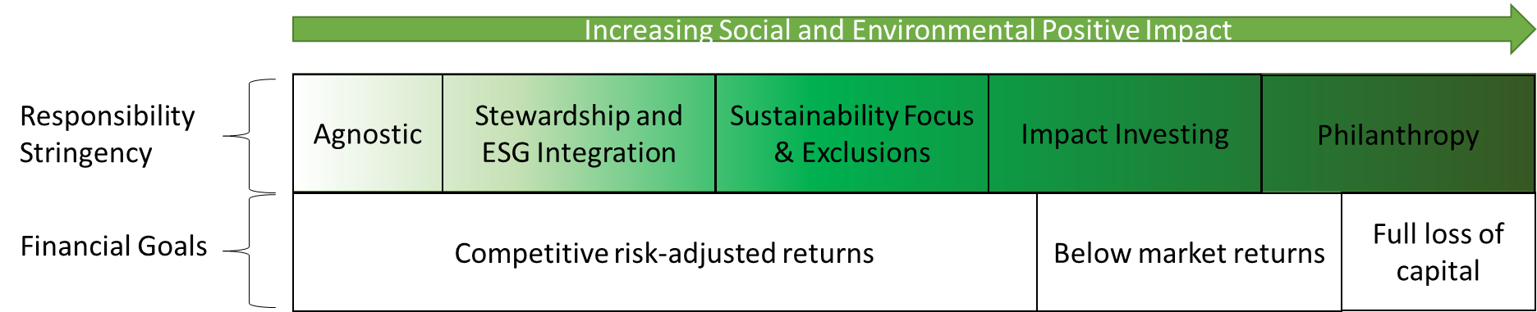
Source: PortfolioMetrix, adapted from Bridges Fund Management’s Spectrum of Capital and The IA’s Responsible Investment Framework

What does our policy mean in practice?
For our Core portfolios, as well as for any other investment approach that we offer, we commit to:
- Evaluate the responsible investment policies and processes of the funds we use in client portfolios and those we are thinking of using
- Use only those funds who demonstrate adequate levels of Stewardship
- All else equal, prefer funds who demonstrate better levels of ESG integration in their investment processes

Passive Funds
One risk we have identified is that PortfolioMetrix as a firm does use passive (index) funds. This is particularly the case for clients who have, in conjunction with their adviser, mandated us to tilt towards more passive exposure in their portfolios.
Passive funds are not intrinsically ‘irresponsible’. But whilst passive funds can demonstrate a good level of stewardship (for example by speaking to the index constituents they passively invest in and by voting in their shares responsibly at company meetings), it is harder for them to demonstrate truly outstanding stewardship characteristics than for active managers. Amongst other reasons, this is because indices usually contain a lot of companies, too many for passive managers to monitor closely. Active managers, on the other hand, invest in a smaller number of companies and so have the potential to invest a lot more time in engaging with them.
Likewise, passive managers tracking broad indices clearly cannot incorporate ESG into their investment process, because they need to track their benchmark regardless of the ESG characteristics of the companies in the index.
In future, as they become available, we may be able to include passive funds that track ESG indices. For now PortfolioMetrix will continue to use regular index funds where we cannot find an appropriate active fund or where instructed by clients to tilt to more passive in their portfolios. Any tilt towards passives is likely to decrease the level of stewardship and ESG integration in our portfolios.
The above comments are also true for most systematic factor/smart beta funds that target value, small-caps, momentum, quality and minimum volatility. Like with passive funds, including factor funds in a portfolio (like in PortfolioMetrix’s Enhanced Indexing Approach) will likely decrease its level of stewardship and ESG integration.
For clients who want to move in the other direction and increase the positive social and environmental impact of their investments, in certain jurisdictions we offer our Sustainable World approach.

The portfoliometrix Sustainable World Portfolios (formerly Ethical Emphasis)
The Sustainable World portfolios aim to meet client financial goals whilst also explicitly helping drive positive social and environment change. Very simply, it expands on the responsible investment strengths of our Core portfolios by incorporating where possible funds that:
- focus on companies that deliver a clear positive net benefit to society and the environment
- focus on sustainability of product, service and operations when selecting companies to invest in
- seek to improve the behaviour of the companies they invest in
- exclude industries and specific companies with negative social or environmental impacts
The relationship between the PortfolioMetrix approaches can be viewed through the PortfolioMetrix Spectrum of Responsible Investing as follows:
Figure 2: The PortfolioMetrix Approaches
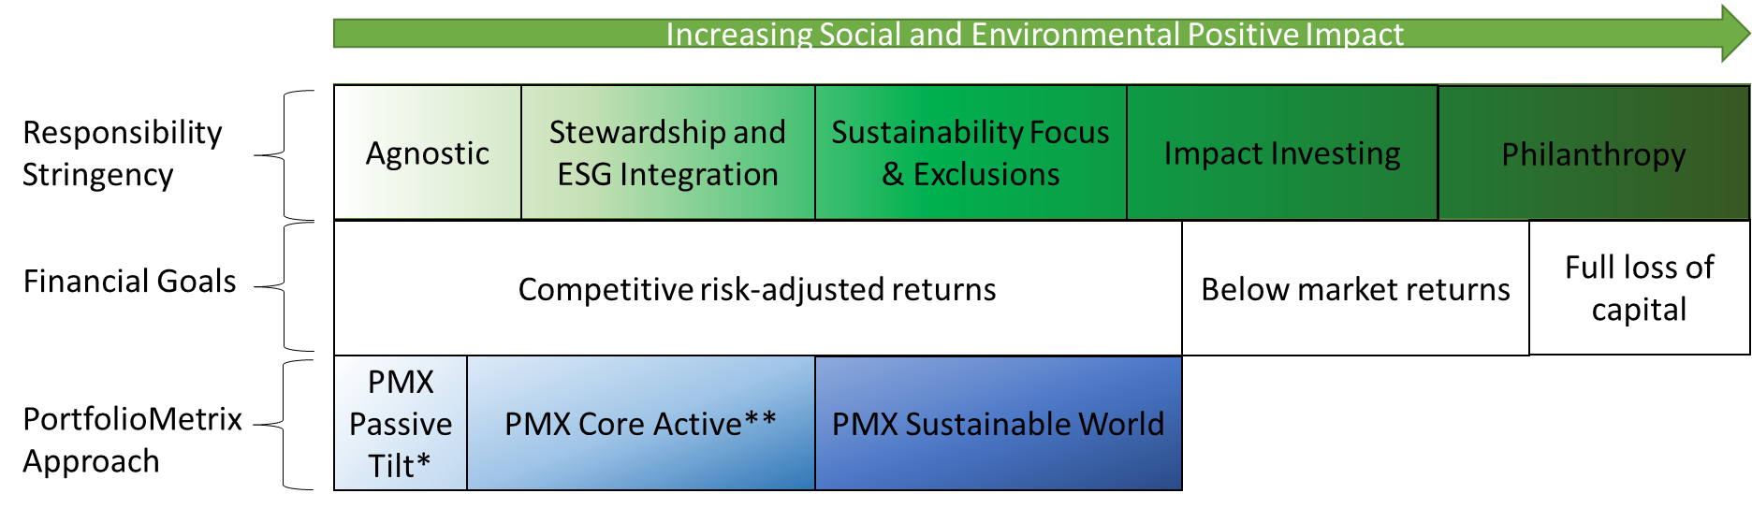
* PMX Enhanced Indexing would also fit here, **PMX Income Oriented and PMX Absolute Oriented would also fit here
Source: PortfolioMetrix, adapted from Bridges Fund Management’s Spectrum of Capital and The IA’s Responsible Investment Framework

Appendix 1: Definitions
Stewardship and ESG Integration are defined above. Below we define Exclusions, Sustainability Focus and Impact Investing.
Exclusions:
“Exclusions prohibit certain investments from a firm, fund or portfolio. Exclusions may be applied on a variety of issues, including to align with client expectations. They may be applied at the level of:
- Sector
- Business activity, products or revenue stream
- A company; or
- Jurisdictions/countries.”
(AKA: Negative Screening)
Examples: Ethical/values-based/religious (e.g. alcohol, pork, tobacco etc), norms-based (e.g. controversial weapons), sustainability (e.g. fossil fuels), ESG assessment (e.g. any company with an ESG rating lower than a certain value)

Sustainability Focus:
“Investment approaches that select and include investments on the basis of their fulfilling certain sustainability criteria and/or delivering on specific and measurable sustainability outcome(s). Investments are chosen on the basis of their economic activities (what they produce/what services they deliver) and on their business conduct (how they deliver their products and services).”
Examples: Sustainability themed (e.g. clean water), positive tilt (e.g. reduced carbon emissions), best in class (e.g. most sustainable company in sector)

Impact Investing:
“Investments made with the intention to generate positive, measurable social and environmental impact alongside a financial return.”
Key Elements: Intentionality, Financial Returns (range from below market rate to risk-adjusted market rate), Range of Asset Classes, Impact Measurement
Adopted from: Global Impact Investing Network (GIIN)
Examples: Social Bond Funds, private impact investing, Sustainable Development Goal (SDG) Funds

PortfolioMetrix Asset Management Ltd is authorised and regulated by the Financial Conduct Authority (FCA) in the United Kingdom. PortfolioMetrix Asset Management SA (Pty) Ltd is an Authorised Financial Services Provider in South Africa. The information contained is given for information purposes only and is not intended to constitute financial, legal, tax, investment or other professional advice and should not be relied upon as such. Investments can go down as well as up and past performance is not a reliable guide to the future.

https://www.theia.org/sites/default/files/2019-11/20191118-iaresponsibleinvestmentframework.pdf
https://www.frc.org.uk/getattachment/5aae591d-d9d3-4cf4-814a-d14e156a1d87/Stewardship-Code_Final2.pdf , p. 4.
https://d8g8t13e9vf2o.cloudfront.net/Uploads/d/t/z/maindefinitionstoprireportingframework_127272.pdf p.5.
Adapted by IA from GSIA definitions (Global Sustainable Investment Alliance) https://www.theia.org/sites/default/files/2019-11/20191118-iaresponsibleinvestmentframework.pdf
Adapted by IA from GSIA definitions (Global Sustainable Investment Alliance) https://www.theia.org/sites/default/files/2019-11/20191118-iaresponsibleinvestmentframework.pdf
Global Impact Investing Network (GIIN), “What you need to know about impact investing” https://thegiin.org/impact-investing/need-to-know/#what-is-impact-investing

