Improving Business Analysis Competencies for Civil Servants
 | The Brief  The client, a Government entity, known for high level of financial activities and tourism  , briefed Adaptive US to assist it improve business analysis capabilities for its civil servants. It wanted the civil servants to be knowledgeable about business analysis practices to improve their systems for better service delivery to citizens. It also wanted the civil servants to get certified on the Entry Level Certification (ECBA) from IIBA Canada. |  | The Challenge  The client had initiated a major transformation project to overhaul its operations and move to eGovernance. However, the project was moving at slower pace due to lack of business analysis knowledge and skills on business analysis. The client decided engage with a firm which can help improve business analysis skills for civil servants.
Our Approach  With 100+ years of combined business analysis experiences, Adaptive US understands and is proficient in building business analysis capabilities within organizations.  Adaptive has developed significant content and competency in business analysis training.  Our training sessions are delivered as per client need, are highly interactive. Adaptive supports its students till they get certified. |  |  | The Outcome  Some of the key successes included:  - Improved competency of civil servants on Business analysis  - Improved project delivery  - improved stakeholder engagement by the civil service organization  - improving delivery quality and outputs.

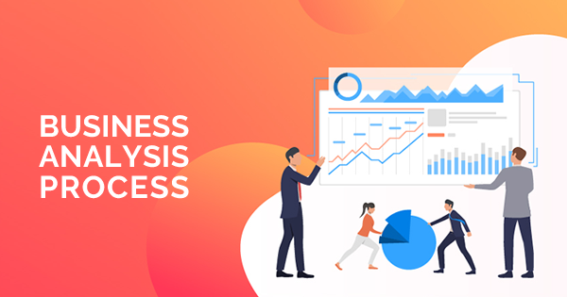 |  | The Conclusion  After delivering the program on IT business analysis, the client has discussed the need to develop business analysis for private sector employees within the state. Adaptive is collaborating with the state university to offer courses on business analysis to other professionals in the country.  The state government has also asked Adaptive to develop business analysis which is broader and encompasses the needs of Government entities. The project is in good speed and likely to be released in Q1 2021.

