Vascular access

|  |  |
| --- | --- |
| **Key Teaching Objectives** | |
|  | |
| Each candidate should receive practical instruction on the following: | |
|  | |
| 1. Intraosseous access and infusion including EZ-IO use | |
| 1. Umbilical Vein Catherterisation 2. Demonstration of scalp vein access | |
|  | |
| Some overseas centres may wish to include the following: | |
|  | |
| 1. Venous cutdown | |
|  | |
|  | |
| During the course of this station the indications for and complications of each of the manoeuvres should be revised. | |
|  | |
| **Equipment Required** | |
|  | |
| 1. **Intraosseous access** | |
| Intraosseous trainer or ALS baby with leg pads | |
| 5ml syringes x 3 | |
| 50ml syringes x 2 | |
| Intraosseous needles x 3 | |
| Blue food dye x 1 | |
| Jug | |
| 0.9% Saline 500ml | |
| Intraosseoustrainer [Humerus and tibia]. | |
| EZ-IO Driver | |
| 10ml syringes x 2 | |
| 10ml amp normal saline | |
| EZ-Connect® extension tubing | |
| EZ-IO needle sets | |
| Giving set | |
| Pressure bag | |
| 3 way tap | |
|  | |
| 1. **Umbilical vein access** | |
| Artificial Umbilical cords x 3 | |
| Baby Umbi X3 | |
| Umbilical catheters x 6 | |
|  | |
| Umbilical tape x 2 | |
| Large waterproof trays x 1 | |
| Gloves | |
| Plastic aprons | |
|  | |
|  | |
| **Environment** | |
|  | |
| The room should be divided into two: one station should be set-up for intraosseous access and infusion, and one for umbilical access. Care should be taken to protect floor and tables where food dye is being used. Each station will require one or two tables, which should be set-up in such a way as to allow free access on all sides. | |
|  | |
| **Plan** | |
|  | |
| **Set** | |
|  | |
| “During this session you are going to be taught the sites and equipment available for intraosseous and umbilical vein access and you will be given the opportunity to practice these skills.” | |
|  | |
| **Dialogue** | |
|  | |
| This station is taught using the 4-part technique described in the Pocket Guide to Teaching for Medical Instructors. The following techniques should be taught: | |
|  | |

|  |  |
| --- | --- |
| Intraosseous Insertion | |
|  | |
| **A Using a hand held needle** | |
|  | |
| **Note: This is the preferred technique in neonates** | |
|  | |
|  | |
| 1. Identify the infusion site. The landmarks for the upper tibial and lower femoral sites are shown below: | |
|  | |
| **Tibial** | **Femoral** |
| Anterior surface, 2-3 cm below the tibial tuberosity | Anterolateral surface, 3 cm above the lateral condyle |
| ez-io-presentation-at-fca-18-728 | |
| 2. Clean the skin over the chosen site | |
|  | |
| 3. Insert the needle at 90o to the skin, emphasise the rotational motion | |
|  | |
| 4. Continued to advance the needle until a give is felt as the cortex is penetrated, a clear give is felt | |
|  | |
| 5. Attach the 5 ml syringe and aspirate or infuse to confirm correct positioning with as minimal movement as possible. Flush is usually required to achieve good flow. | |
|  | |
|  | |

|  |
| --- |
| **B Using a Powered Device** |
|  |
| The EZ-IO drill is a powered device which enables rapid insertion of an intraosseous needle. The same landmarks are used as for manual insertion and the procedure is less painful for the conscious victim due to its rapidity. The EZ-IO needles are in three sizes - under 30 kg and over 30-50 kg and adult. |
|  |
| **Note: Hand held needle is the preferred technique in neonates** |
| The procedures for insertion is as follows: |
|  |
| 1. Universal precautions. Prime connection line. |
|  |
| 1. Clean site. |
|  |
| 1. Choose appropriate size needle and attach to drill - it will fix magnetically. |
|  |
| 1. Hold the drill and needle at 90 degrees to the skin surface and push through the skin without drilling, until bone is felt. |
|  |
| 1. Push the drill button and drill continuously and push until there is loss of resistance - there is a palpable give as the needle breaches the cortex. |
|  |
| 1. Remove drill and unscrew trochar (holding the needle in place with as minimal movement as possible). |
|  |
| 1. Aspirate marrow if possible. |
|  |
| 1. Attach pre-prepared (primed with NS) connection tube. Flush is usually required to achieve good flow |
|  |
| 1. There is an optional device to secure the needle but this is not essential. |
|  |
| 1. Proceed with required therapy. |
|  |
| **Intraosseous Fluid Infusion** |
| * Fluid will not run through the IO by gravity |
| * Attach a 3 way tap. To this tap attach the filled 50 ml syringe and a fluid giving set attached to a bag of normal saline |
| * + Turn the tap so fluid is drawn into the syringe from the bag |
| * + Turn the tap so the fluid bolus can be pushed though the cannula |
|  |
| It should be noted that rapid infusion of fluid may be painful for the conscious patient and if this proves to be the case 0.5mg/kg of 2% lignocaine may be infused slowly to combat this*.* |

|  |
| --- |
|  |
| **Intraosseous access** |
|  |
| **Humeral access** |
|  |
| **Place the patient’s hand over the umbilicus:** Causes medial rotation of elbow and humerus |
|  |
| **Adduct the arm:** Provides greater prominence of insertion site |
|  |
|  |
|  |
|  |
|  |
|  |

|  |
| --- |
| **Proximal Tibia Insertion Site Identification – Infant/Child**  C:\Users\Mike\Documents\My Dropbox\Vidacare Team\Projects Folder\Training Development\EZ-IO Workshop\Diagrams\Pediatric tibia-thin bone.jpg    Hand.png  **Distal Femur Insertion Site Identification - Infant/Child**  Distal femur insertion.jpg |

**Distal Tibia Insertion Site Identification – Infant/Child**

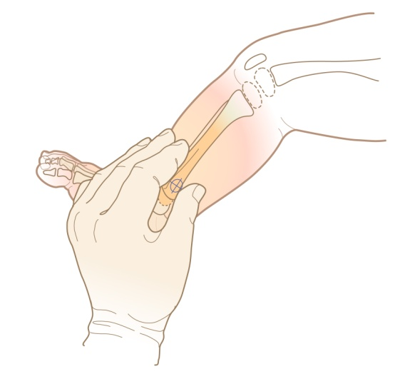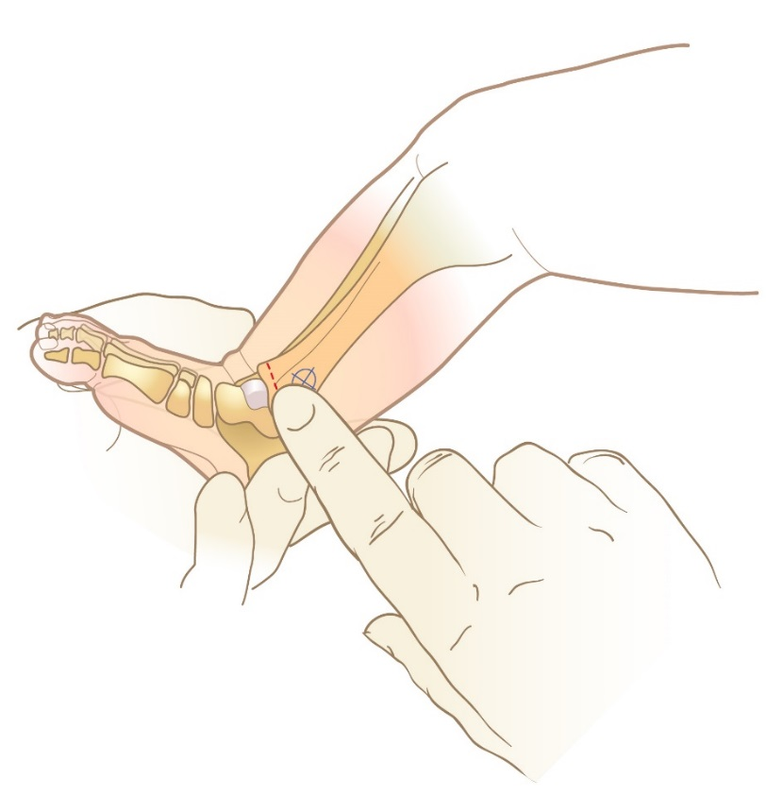

|  |
| --- |
| Umbilical Vein Access |
|  |
| 1. Loosely tie the umbilical tape around the artificial cord. |
|  |
| 1. Cut the cord with a scalpel, leaving a 1cm strip distal to the tape. (this can be demonstrated but not practiced) |
|  |
| 1. Identify the umbilical vein. 3 vessels will be seen in the stump. Two will be small and contracted (the arteries sited inferiorly), and one at the head end will be dilated (the vein). |
|  |
| 1. Fill a 5 fr gauge catheter with 0.9% saline. |
|  |
| 1. Insert the catheter into the vein, and advance it approximately 5cm. |
|  |
| 1. Tighten the umbilical tape to secure the catheter. A purse string suture may be used later to stitch the catheter in place. |
|  |
|  |
| Optional |
| **Scalp vein cannulation** |
| Scalp vein trainer (optional) |
| IV cannulae 18-25 g x 2 |
| Rubber tubing x 1 |
|  |
| **Venous cutdown** |
| Venous cutdown feed x 2 |
| Small BP Scalpel handles x 2 |
| Scalpel blades size 15 (boxes) x 1 |
| Curved haemostats x 6 |
| Strong black cotton x 3 |
| Cannulae 14-25 x 2 |
|  |
| **Assessment Technique** |
|  |
| A record of candidates’ performance during the station should be kept for faculty reference. |

**Resources in kits:**

<https://www.rch.org.au/uploadedFiles/Main/Content/neonatal_rch/clinical_practice_guidelines/UVC%20Newborn(2).pdf>

<http://www.slhd.nsw.gov.au/rpa/neonatal/html/docs/uvc.pdf>