Spinal Immobilisation

Key Teaching Objectives
Each candidate should receive practical instruction on the following
- Spinal immobilisation
- In-line cervical stabilisation
- Considered application of collars to immobilise c-spine
- Log-rolling
- Spine Boards and Other Adjuncts (mention only, NO practical instruction)

Equipment Required
Practical application can be demonstrated on candidates if consent obtained (gives them opportunity to move and be interactive prior to trauma plenary)

Resusi Junior
Resusi Infant

Environment
Plenary / lecture theatre – instructor provides initial overview of teaching objectives. 4x groups in each corner with 1x instructor per group

Spinal immobilisation
Log roll – taking turns in various roles

Plan
Set
"In this station, you will discuss the relative indications and contraindications for applying both manual in-line cervical stabilisation and application of a c-spine collar as well the clinical criteria for clearing the c-spine and removing of a collar. The current variations in practice regarding use of soft/ semi-rigid collars will be discussed together with the overall need to maintain vigilance regarding c-spine”

“You will be taught how to perform cervical manual in-line stabilisation and you will then be shown how to safely and effectively perform a log-roll, both on the small child and infant and the larger child”

“In the trauma scenarios it is essential that you remember that the c-spine is “not cleared”. To ensure c-spine safety there must either be a soft (foam) collar in situ or manual in-line stabilisation at all times”

Dialogue
After discussion of the principles and concepts outlined above, this station is taught using the 'real time demonstration' as described in the Preface to Practical Procedures. The following techniques should be taught:

Cervical Collar

There is a lack of evidence for the efficacy of spinal immobilisation in the prevention of spinal cord injury (SCI). However, there is evidence that rigid collars can lead to significant complications and morbidity.

Complications can include
Patient discomfort
Pressure areas
Raised ICP
Worsening SCI
Increased Aspiration risk
Masking of occipital injuries
Increased extrication time or delay to definitive treatment

Evidence indicates that we are unable to completely immobilise the cervical spine in any collar and there is no data to support that any additional movement of an injured cervical spine causes more damage.
I. In-line Cervical Stabilisation
The aim of in-line cervical stabilisation is to maintain the child’s head in a neutral position aligned with the body, thus avoiding side-to-side movements

Figure 1.1 In-line cervical stabilisation

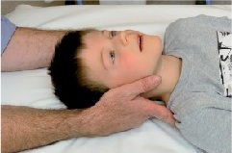 | 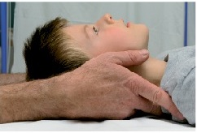

- Stand behind the child

- Place your hands either side of the child’s head with your fingers resting along the neck and just underneath the child’s shoulders

- Holding the child’s head, stabilize your arms by either locking in at the elbows or resting your elbows on the ground/bed. The aim is to maintain the child’s head in a neutral position aligned with the body, thus avoiding side-to-side movements

Exceptions/Variation

An injured child may be uncooperative for many reasons including fear, pain and hypoxia. Manual stabilisation should be maintained and contributing factors addressed.

Overzealous immobilisation of the head and neck may paradoxically increase the leverage on the neck as the child struggles. The infant or child who is too small for a hard collar should have manual stabilisation supported throughout.

Consider – Sometimes the best form of immobilisation is NO immobilisation at all.

Children with traumatic torticollis should be manually immobilized in their current position.

In 2019 there is significant variation in practice regarding soft foam collars and semi-rigid collars between different Australian states. Candidates should be familiar with practice in their locale.
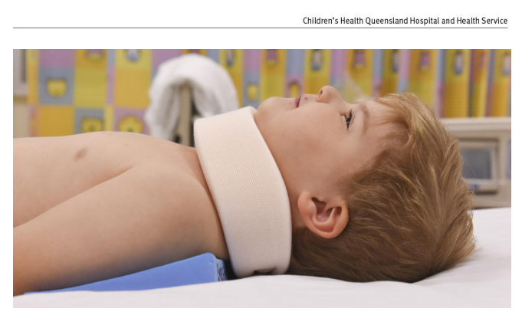
© Children’s Health Queensland Hospital and Health Service 2019
Soft collars should be used to immobilise the cervical spine. If needed, soft collars can be cut along the lower edge to ensure a snug fit under the chin.

2. Log-rolling

In order to minimise the chances of exacerbating unrecognized spinal cord injury, non-essential movement of the spine must be avoided until adequate examination and investigation have excluded it.

If manoeuvres that might cause spinal movement are essential, then log-rolling should be performed. The aim of log-rolling is to maintain the alignment of the spine during turning of the child. The log-roll rotation should allow sufficient exposure for appropriate examination.

The basic requirements are an adequate amount of carers and good control

Procedure
- Gather together enough staff to roll the child. In larger children four people will be required; three will be required in smaller children and infants.

- Place the staff as shown in Table 1.1

- Ensure staff members know what they are going to do as shown in Table 1.2

- Carry out essential manoeuvres as quickly as possible
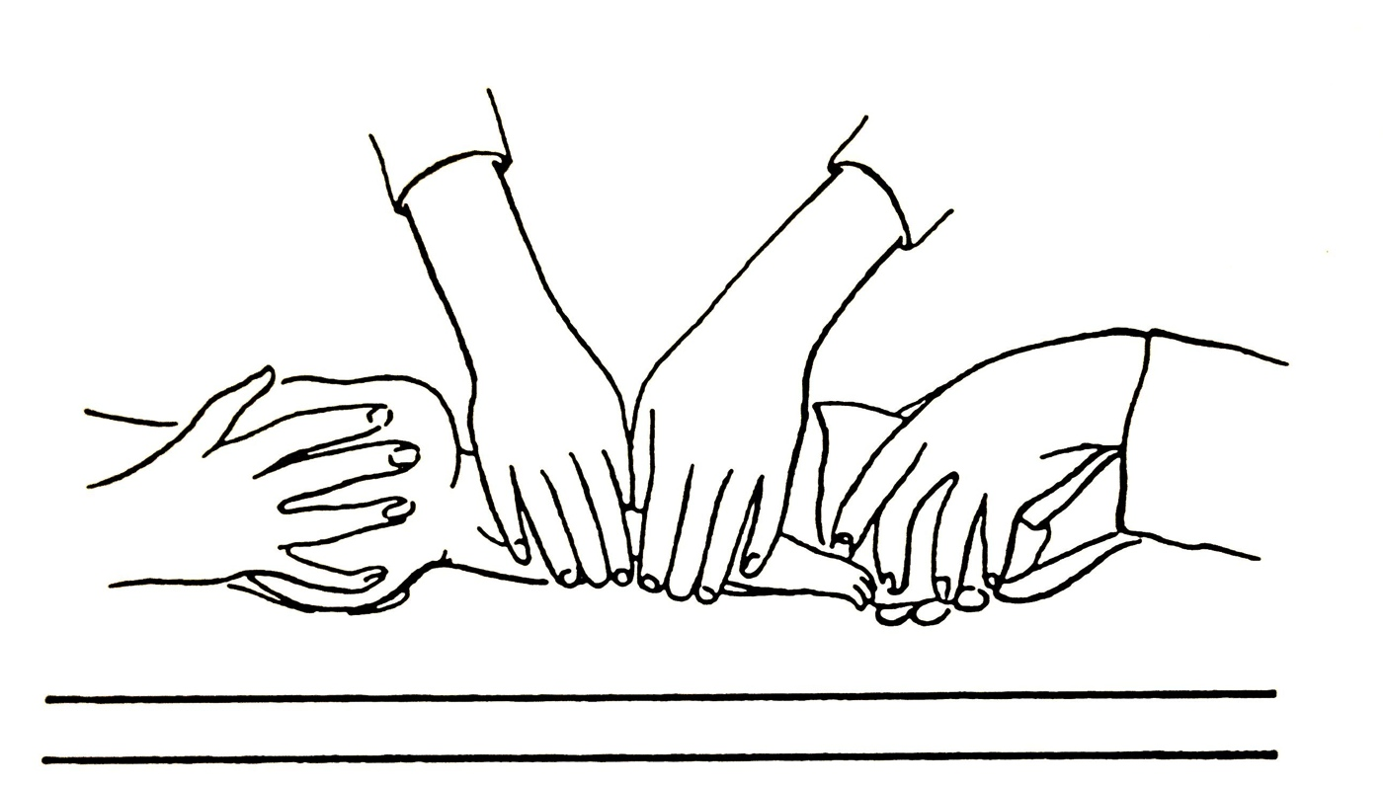
Log – rolling small child or infant: three-person technique

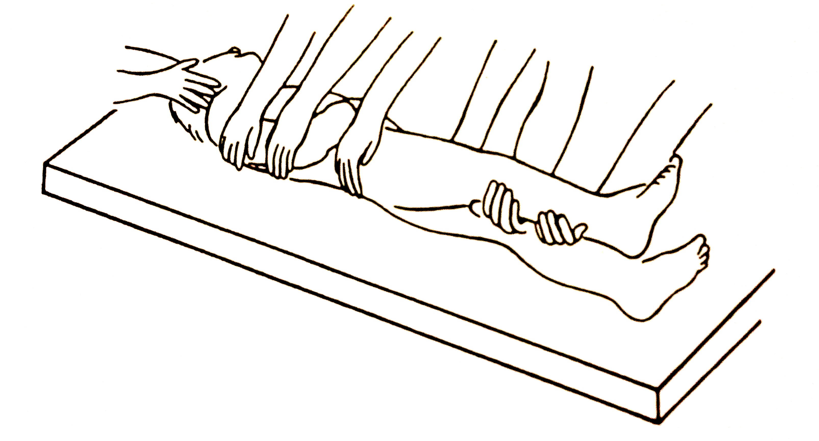
Log – rolling a larger child: four-person technique

Table 1.1 Position of staff for log-rolling

Staff Member | Size of Child
 | Smaller Child and Infant | Larger Child
1 | Head | Head
2 | Chest | Chest
3 | Legs and Pelvis | Pelvis
4 |  | Legs

Table 1.2 Position of staff for log-rolling & Tasks of individual members of staff

Staff Member  Position | Task
Head | Hold either side of the head (as for in-line cervical stabilisation), and maintain the orientation of the head with the body in all planes during turning. Control the log-roll by telling other staff when to roll and when to lay the child back onto the trolley
Chest | Reach over the child and carefully place both hands over the chest. When told to roll the child, support the weight of the chest, and maintain stability. Watch the movement of the head at all times and roll the chest at the same rate
Pelvis and Legs | This only applies to smaller children and infants. If it is not possible to control the pelvis and legs at the same time get additional help immediately. Place one hand either side of the pelvis over the iliac crests. Cradle the child’s legs between the forearms. When told to roll the child, grip the pelvis and legs and move them together. Watch the movement of the head and chest at all times and roll the pelvis and legs at the same rate
Pelvis | Place one hand either side of the pelvis over the iliac crests. When told to roll the child, grip the pelvis and roll it. Watch the movement of the head and chest at all times and roll the pelvis the same rate.
Legs | Support the weight of the far leg by placing both hands under it. When told to roll the child, watch the movement of the chest and pelvis and roll the leg at the same rate.

3. Use of a long spine board
Children being transported between institutions may require additional immobilisation. This may involve a spine board, head blocks or a vacuum mattress and where possible, axial loading must be avoided

Children who arrive to hospital on a spinal board MUST be removed from it as soon as possible. Young children have disproportionately larger heads and lie with the neck in a position of flexion when immobilized flat. There is an increased risk of developing kyphosis and anterior translation of the upper cervical segment in an unstable fracture pattern

There is no evidence that spine boards are better than using the bed
Closure
Candidates should be given a formal opportunity to ask any questions, when these have been answered to the candidates' satisfaction, the session can be closed by summarising the key teaching points and objectives
Assessment Technique
A record of candidates’ performance during the station should be kept for faculty reference

