* see below
Pre-brief faculty to minimise their contributions to the small group discussion, to promote candidate interaction/participation.
Slide No. | Activity | Resources/Action | Time (mins)
1 & 2 | Introduction & Objectives | Nominate spokesperson & scribe/group | 1
3 | 3 reasons for structured approach | Question on candidate activity sheet * | 1-2
 | Whole group answers | 1-2 from faculty | 3
5 | Arranging algorithms  (this is recall - don’t dwell – be quick) | Packs of laminated sections of BLS & ALS algorthim | 5
5 | Tap/clap 110/min | Use CPR rate on ALSi – set at 110 | 1
6 & 7 | Check BLS in correct sequence | Note differences for children | 1
8 & 9 | Check ALS in correct sequence | Group Questions on ppt notes.  - worksheet included in packs* | 5
10 |  | Highlight similarity with ARC, & rationale for not re-charging in subsequent cycles of asystole | 1 min
11 | Causes of serious illness leading to bradycardia | Image of bradycardia on sheet with table of causes & relevant treatment * | 3 mins
 |  | Shared feedback | 1-2min
12 | Causes of serious illness leading to SVT | Image of SVT on sheet with question * | 3 mins
13 | SVT algorithm | Complete the missing gaps* | 2 mins
15 | Skills for working in a team | Scope of team work at APLS  - communication/accountability | 2 mins
16-18 | Newborn resuscitation | Scope of APLS - Skill stations for intubation/umbilical catheter | 5 mins
19/20 | Questions and Closure |  | 2 mins
40 mins

Candidate activity packs and A3 clipboards
Co-ordinators often prepare this, but always pays to check everything you need is there and in order so that group work goes smoothly.
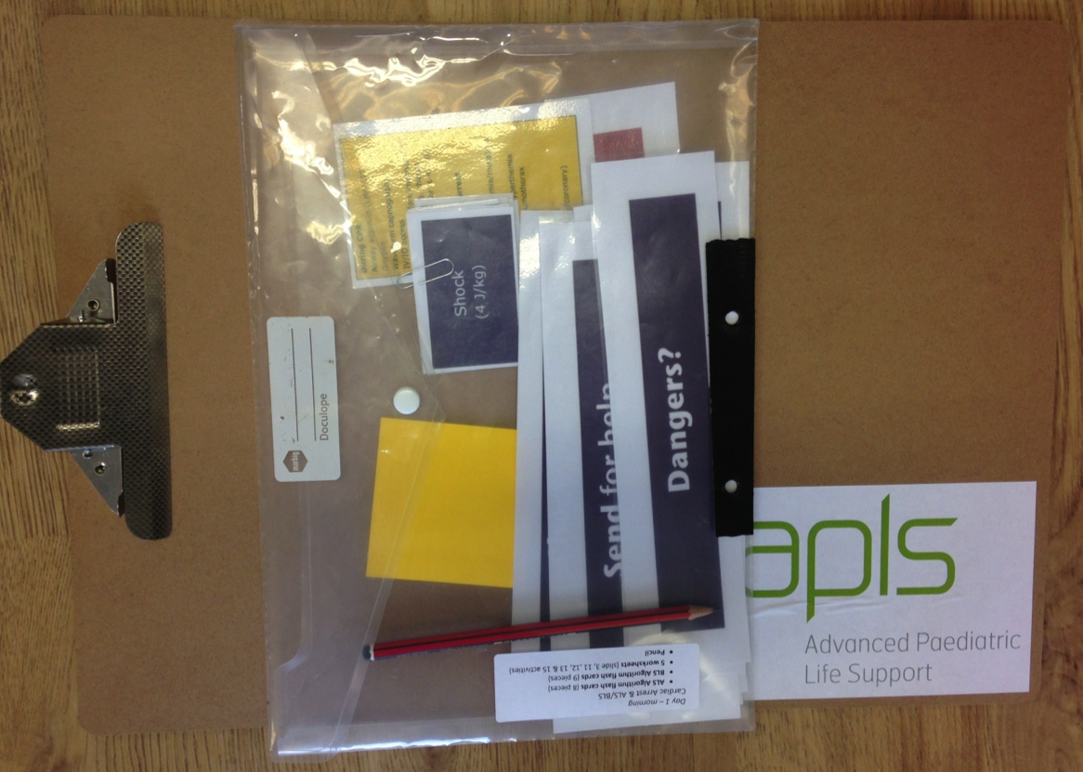

Slide 3 Activity Sheet
Write down three reasons to have a structured approach to a serious ill child.

Slide 5
Next activity in candidate packs
Laminated cards for BLS and ALS to be arranged into algorithms
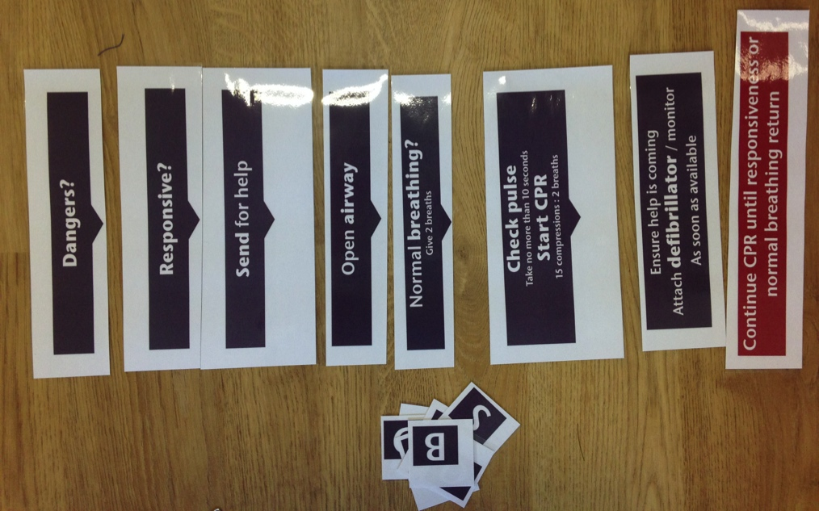
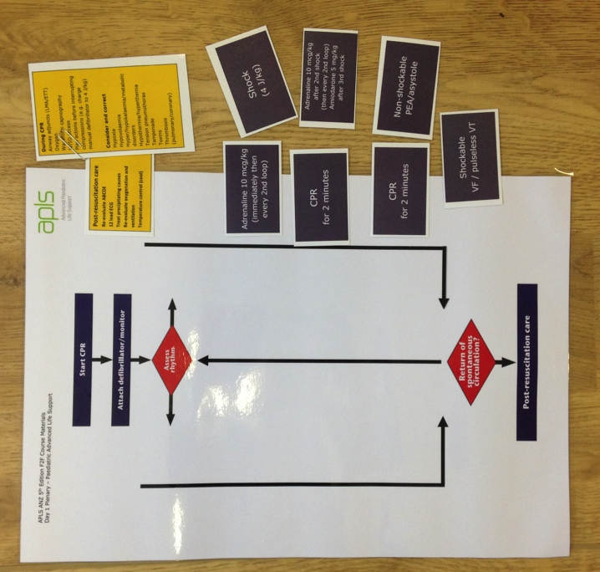

Slide 9 Activity* (These questions are on a worksheet)
How long is a cycle?
What do you do during the 2 minute cycle?
When is adrenaline given? VT/VF vs asystole?
Which of the Hs and Ts are of particular importance in asystole?
hypoxia
hypovolaemia
anything else suggested by history of child’s illness/injury
Which of the Hs and Ts are of particular importance in PEA?
hypovolaemia
hypocalcaemia
tension pneumothorax
cardiac tamponade
hypothermia
pulmonary embolus
How is ROSC assessed? – why feel for a pulse? And or Where do you feel for a pulse in a child?

Slide 11 Activity sheet on A3

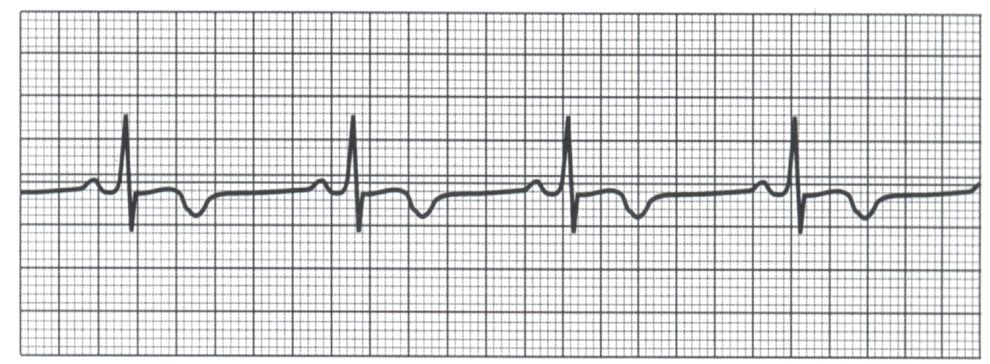

List treatment options for these common causes of bradycardia

 | Cause of Bradycardia | Most appropriate treatment
 | pre-terminal in respiratory / circulatory failure
 | vagal stimulation
 | raised intra-cranial pressure
 | poisons, eg digoxin, beta-blockers
 | complete heart block

Slide 12 Activity on reverse side of previous activity
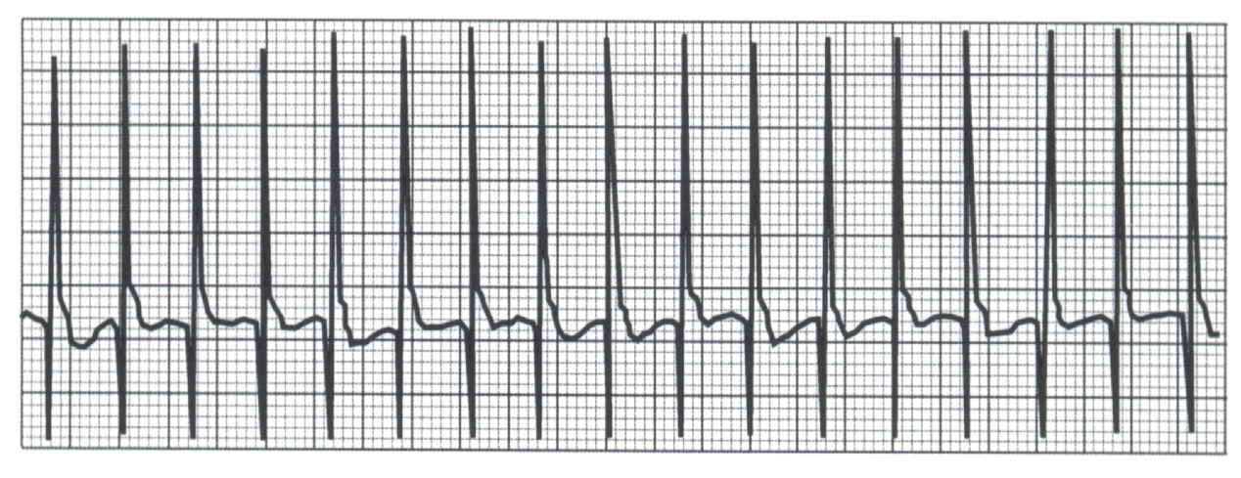
Name 5 clinical features that assist you differentiate between SVT and Sinus tachycardia?

Slide 13 Activity
Fill in the missing gaps – post it notes in packs
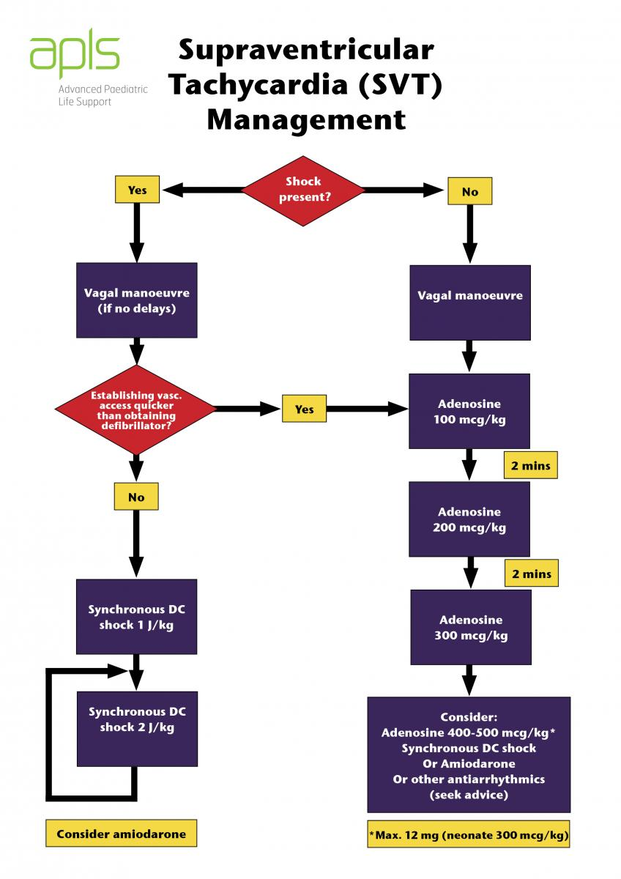
Describe vagal manoeuvres used in paediatrics

