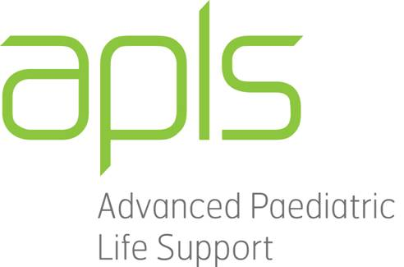

Paediatric Life Support Course

Helpful Formulae

Knowing the following formulae will be beneficial for participation in the PLS course. You will find this & more detailed information in the APLS manual.

- A – Airway
ETT size:
3.0 – 3.5 Newborn up to 6 months
4.0 for 6-12 months
(Age/4) + 4 for over 12mths

- B – Breathing
High-flow O₂

- C – Circulation
Adrenaline dose:
0.1 mL/kg 1:10 000 IV or IO (= 10mcg/kg)
Defibrillation: 4 J/kg
Fluids: 20 mL/kg Normal Saline
(In trauma, consider 10 mL/kg of normal saline)
Blood: 10mL/kg or O negative

- DEFG – Don’t ever forget glucose
Glucose dose: 2 mL/kg of 10% Dextrose IV

