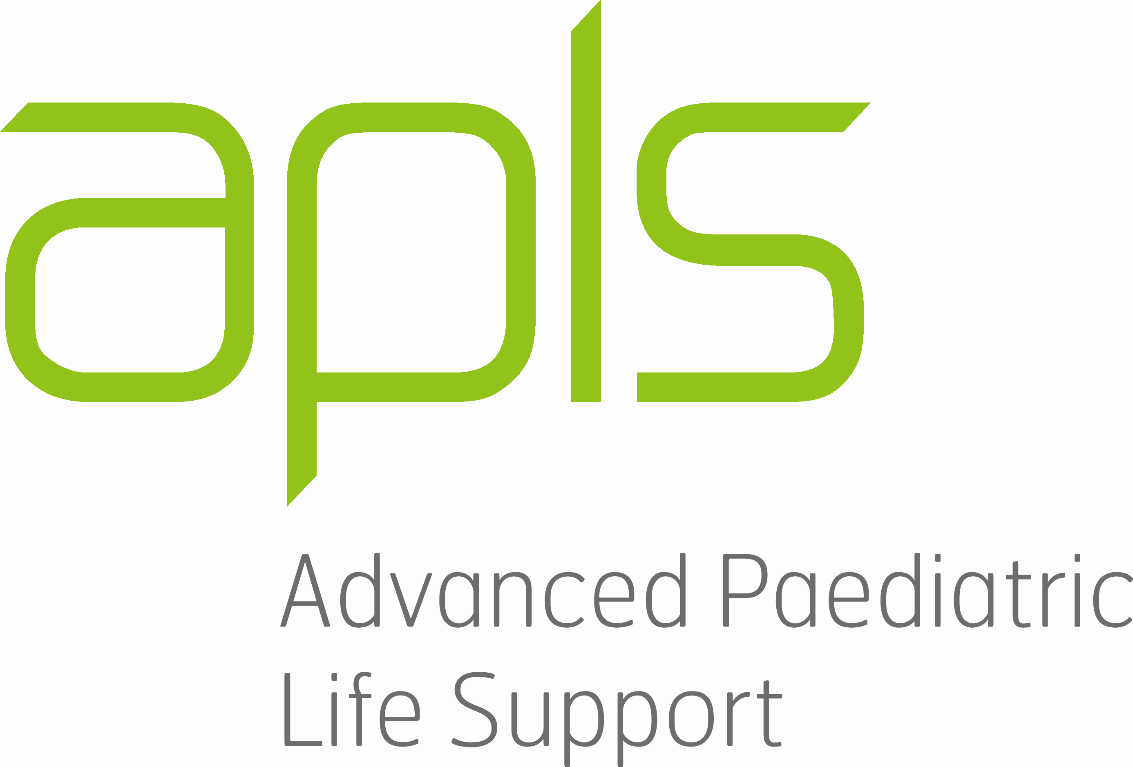

ADVANCED PAEDIATRIC LIFE SUPPORT COURSE 2024

APLS COURSE PROGRAM: [LOCATION] - DAY 1 – [DATE]

0830 – 1000 | FACULTY MEETING _ Update to REALITi  & Instructor Development | All faculty
0945 - 1000 | Registration | Candidates
1000 - 1030 | Welcome and Aims
1030 - 1115 | Interactive Plenary:  Cardiac Arrest and Advanced Life Support (instructor notes)  Including approach to neonatal resuscitation  Aims:  -Early interaction between faculty and candidates  -To recall and consolidate online learning and demonstrate:  - Knowledge of sequence of BLS/ALS algorithms  - Knowledge of key priorities in neonatal resuscitation | Led by:  Candidates in their colour groups  Min 1 instructor per group - allocate as mentor group
1115 - 1215 | Basic & Advanced Life Support Skill Stations  Airway Patency & Ventilation (A) (revised)  Airway Patency & Ventilation (B) (revised)  BLS/AED/Defib & Rhythms (C) – Group 1  BLS/AED/Defib & Rhythms (D) – Group 2  BLS/AED/Defib & Rhythms (E) – Group 3 | X 3  X 3  Pre allocate: Lead Facilitator(F) & Choke/BLS/Defib Demonstrators  X 2  X 2  X 2
1215 - 1300 | LUNCH
1300 - 1400 | Basic & Advanced Life Support  Skill Stations  Cont’d as above | Cont’d
1400 - 1430 | Demonstration  Cardiac Scenario  Including “ground rules” and orientation to scenarios  (Instructor resources: Facilitating Scenarios; Scenario Teaching Instructor Guide; Post-Scenario Debriefing) | Instructor:  Debriefer  Candidate:  Assistants x2:
1430 - 1630 | Cardiac Scenario Teaching Stations  (3 x 40 mins)  Cardiac Scenario A - scenario 1 / 2  Cardiac Scenario B - scenario 3 / 4  Cardiac Scenario C - scenario 5 / 6  Cardiac Scenario D - scenario 7 / 8
1630 - 1640 | Meet with mentor/mentee TEA/COFFEE | All faculty & candidates
1640 - 1700 | FACULTY MEETING | All faculty
1700 - 1800 | Practical skills testing  - BLS  Defibrillation (2 instructors/station)  - Airway | 1.  2.  3.
1815 | FACULTY MEETING | All faculty

ADVANCED PAEDIATRIC LIFE SUPPORT COURSE 2024

APLS COURSE PROGRAM: [LOCATION] - DAY 2 – [DATE]

0800 - 0845 | Serious Illness Interactive Plenary:  Structured approach to serious illness  Aim: To recall and consolidate online learning and demonstrate:  - The structured approach to the seriously ill child  - The clinical assessment sequence to identify life-threatening illness in a child. (instructor notes) (activity) | Led by:  Assistant:
0845 - 0945 | Workshops on Seriously Ill Child (2x 30 mins)  1. Pain Management  2. Fluid and Electrolytes  3. Sepsis  4. Transfer and Communication (ppt) (word) | 1.  2.  3.  4.
0945 - 1000 | TEA/COFFEE
1000 - 1100 | Workshops on Seriously Ill Child (2x 30 mins)  Cont’d | Cont’d
1100 - 1120 | Demonstration  Illness Scenario | Instructor:  Debriefer:  Candidate:  Assistants x2:
1120 - 1240 | Illness Scenario Teaching Sessions (2x 40 mins)  Serious Illness A - scenario 1 / 2  Serious Illness B - scenario 3 / 4  Serious Illness A - scenario 1 / 2  Serious Illness B - scenario 3 / 4 | 1.  2.  3.  4.
1240 - 1320 | LUNCH
1320 - 1440 | Illness Scenario Teaching Sessions (2x 40 mins)  Serious Illness C - scenario 5 / 6  Serious Illness D - scenario 7 / 8  Serious Illness E - scenario 9 / 10  Serious Illness F - scenario 11 / 12 | 1.  2.  3.  4.
1440 - 1450 | BREAK
1450 - 1610 | Illness Scenario Teaching Sessions (2x 40 mins)  Serious Illness C - scenario 5 / 6  Serious Illness D - scenario 7 / 8  Serious Illness E - scenario 9 / 10  Serious Illness F - scenario 11 / 12 | 1.  2.  3.  4.
1610 - 1630 | TEA/COFFEE Faculty Meeting/Mentor meetings | All faculty
1630 - 1720 | Interactive Plenary:  Structured Approach to Trauma  (activity sheet) Aim: To recall and consolidate online learning and demonstrate:  - The structured approach to the seriously injured child  - The identification of life-threatening injuries in a child | Led by:  Assistant:

ADVANCED PAEDIATRIC LIFE SUPPORT COURSE 2024

APLS COURSE PROGRAM: [LOCATION] - DAY 3 – [DATE]

0800 - 1000 | Emergency Skills Stations  (3 x 40 mins)  - Vascular Access (IO / UVC)  - Chest procedures (ICC, Pericardiocentesis)  - Safe Emergency Airway Management  (+ SEAM video link)  - Radiology | 1.  2.  3. x 3  4.
1000 - 1020 | MORNING TEA/MEET YOUR MENTOR/MENTEE
1020 - 1100 | Emergency Skill Stations  (1 x40 mins)  - Vascular Access (IO / UVC)  - Chest procedures (ICC, Pericardiocentesis)(anatomy)  - Safe Emergency Airway Management  (+ SEAM video link)  - Radiology | Cont’d
1100-1120 | Demonstration Trauma Scenario | Instructor:  Debriefer:  Candidate:  Assistants x2:
1120 - 1125 | SHORT BREAK
1125 - 1325 | Trauma Scenario Teaching Session  (3x 40 mins)  1. Trauma Scenario A - run them scenario 2 / 1  2. Trauma Scenario B - scenario 3v2 / 4  3. Trauma Scenario C - scenario 5 / 6  4. Trauma Scenario D - scenario 7 / 8 | 1.  2.  3.  4.
1325 - 1410 | LUNCH/FACULTY MEETING | All faculty
1410 - 1530 | Testing Stations  1. MCQ  2. Scenarios 1  2  3  Retesting | Allocated on day 3
1530 - 1600 | FACULTY MEETING | All faculty
1600 - 1615 | Feedback to candidates and course closure. | All faculty

