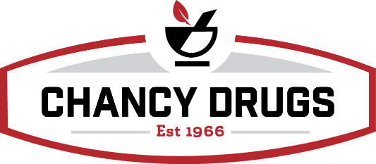

Diabetic Test Strip Club & Discount Test Strips

Criteria for Diabetic Test Strip Club:
- Patients must fill all medications with Chancy Drugs.
- Patients must be insured with Medicare or Medicare Advantage Plan.

***Patients with private insurance or uninsured patients are not eligible for free strips with the diabetic test strip club, however, they are eligible for discounted test trips. See below.***

How to bill Medicare plans:

- Always bill Medicare plans first. If Medicare Part D plan does not cover and requests claims to be submitted to Medicare Part B, the patient will be eligible for free and discounted strips. (Do not bill Medicare Part B.)
- Patients with a $20 co-pay or higher with Medicare Advantage plans will be eligible for free and discounted strips.

What a diabetic test strip club patient receives:

- Non-insulin dependent patients receive 50 FREE strips monthly. (Additional strips $9.95/per box of 50)
- Insulin dependent patients receive 100 FREE strips monthly. (Additional strips $9.95/per box of 50)
- TrueMetrix Brand ONLY dispensed (Unless Medicare plan has a preferred brand.)
Private insurance and uninsured test strip eligibility:
- Patients with $10 copay or higher with private insurance will be eligible to receive a discount on testing strips at $9.95 per box of 50. (Do not bill insurance.)
- TrueMetrix Brand ONLY dispensed.

