Raise Your Hand
Email Templates

- Mid-Point Reminder:

Subject: Because Change Doesn’t Happyen Alone

Body:
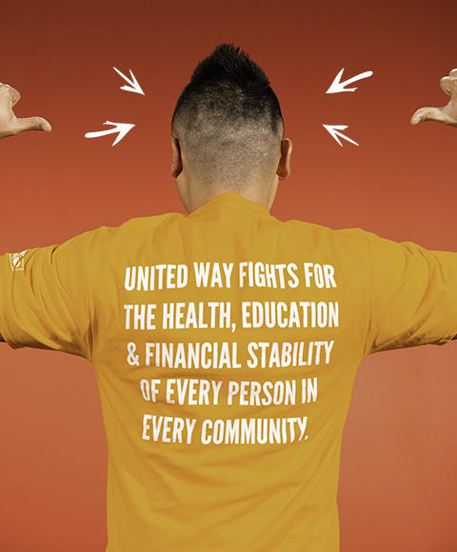

We are already halfway through our United Way Workplace Giving Campaign! Thank you to all of you who have already submitted your pledge form (or made your pledge on-line); you understand how important it is to Raise Your Hand and your investment in our community means you understand United Way’s mission of advancing the common good in our community.
We LIVE UNITED when we give, advocate and volunteer. United Way helps to create opportunities for a better life by focusing on quality education that leads to a stable job, an income to support a family through retirement, and creating the support seniors need for financial stability. Together, united, we can inspire hope and create opportunities for a better tomorrow.
Our campaign will wrap up on [date]. If you haven’t already, please complete your pledge form (or on-line pledge) and return them before then. We hope to announce our total campaign results by [date].
Thank you again for your attention to this important community investment. I am proud to say [company’s name] LIVES UNITED!

