Raise Your Hand
Email Templates

- Day 2 Email:

Subject: Reading shouldn’t be a privledge

Body:

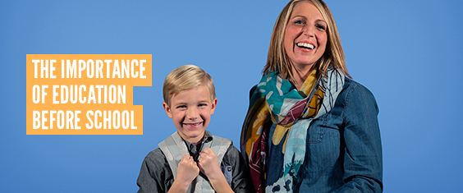

In Central Minnesota 51% of children entering kindergarten are not prepared. These students are behind before they even start. They often come from low-income families whose parents can’t afford books and don’t have time to read to them because they work multiple jobs. They might speak more than one language, learning English only at school. Or they could be dealing with health problems, mental health issues, trauma, or food insecurity that makes it difficult to concentrate in the classroom.
United Way of Central Minnesota Fights for every child in our community. The United Way Imagination Library program delievers free books once a month to children from birth to age 5 to help stay on track. In 2019, over 85,000 were delievered to children right here in Central Minnesota. This program is possible thanks to people like you who decide to Raise Your Hand and make a donation that continues this program as well as many like it.
Learn More: www.unitedwayhelps.org

