Raise Your Hand
Email Templates

- Day 3 Email:

Subject: Everyone deserves a chance at financial stability

Body:
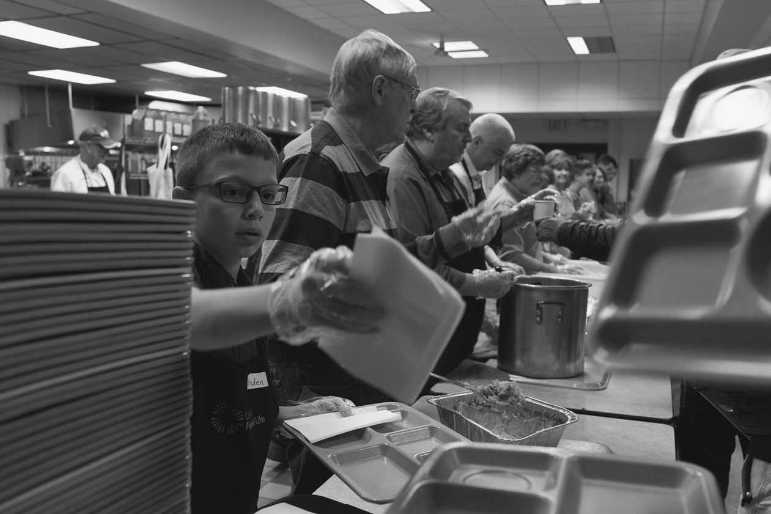

A Flat Tire or ER Visit Away from a Financial Crisis
Nearly ¼ of the working age population in Central Minnesota is living below the poverty line. This means one unexpected expense, like we all face, can force them to choose between food and medical bills or even force them onto the streets.
In Central Minnesota last year:
40% of the clients to visit the food pantry were brand new clients. People who have never needed this service before.
40% of those clients visiting the food pantry were also working full-time and still not making enough to feed their families.
During these difficult times these people are just looking for a little support. They are doing all they can do get by and it’s just not enough. Will you Raise Your Hand and show your community that when things get tough we pull together not apart?
Learn More: www.unitedwayhelps.org

