2020/2021 EPledge Instructions
Locate the ePledge website at the following link: https://uwcm.unitedwayhelps.org/crm/Start.jsp
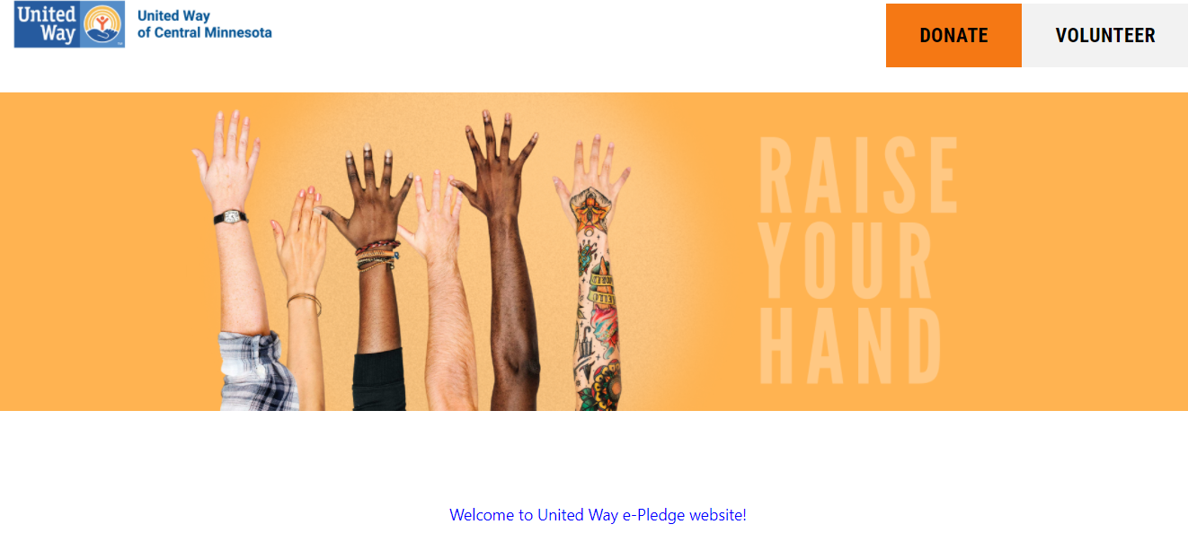
Scroll down and log in. User and Password are not case sensitive.
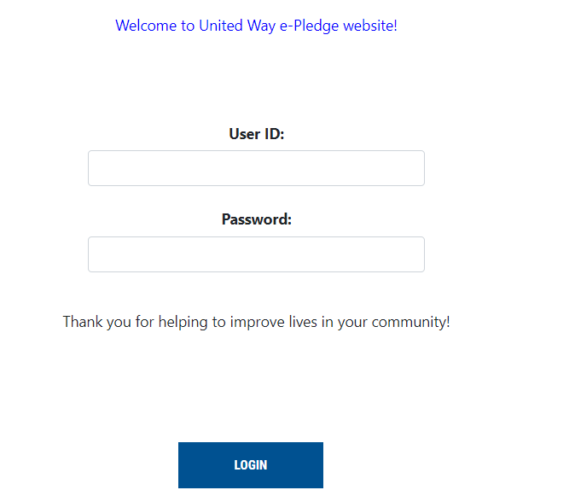

Click on the Donate or Pledge tab
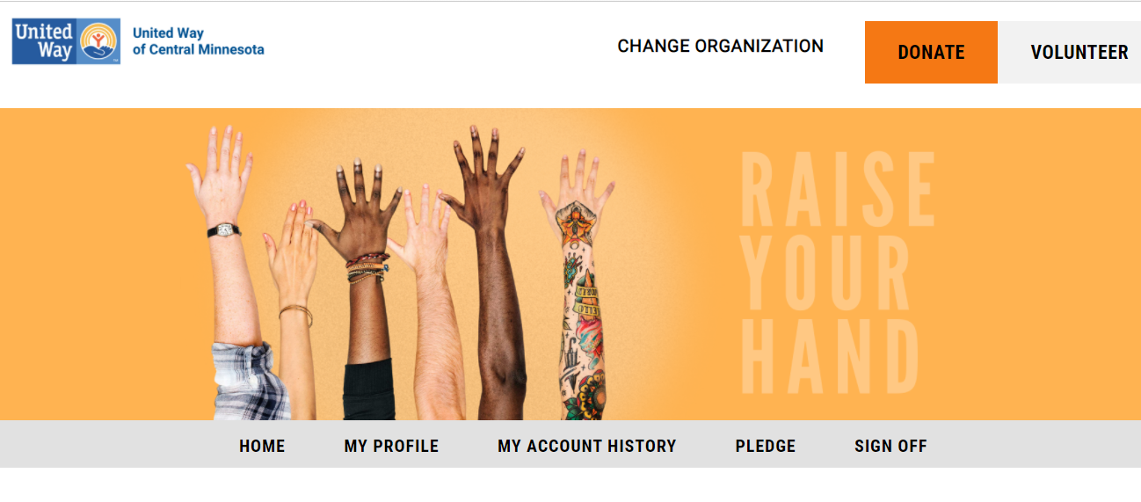
Choose your Pledge Type and the Amount per Pay Period for the Total Annual Pledge
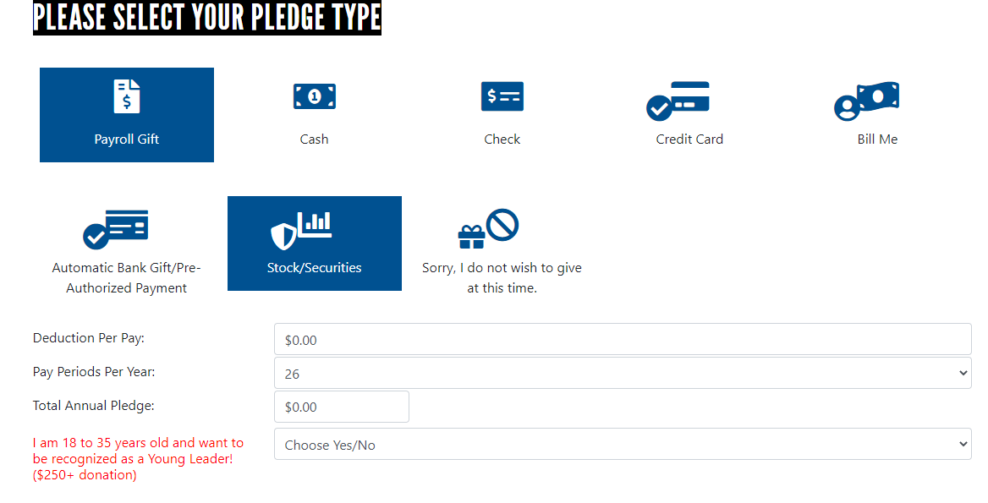

Select any Agencies you would like your pledge to go to. (Optional)
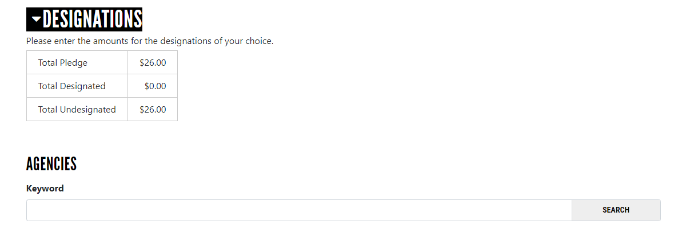
Check any information below and Click Confirm. If you would like an email confirmation click here.
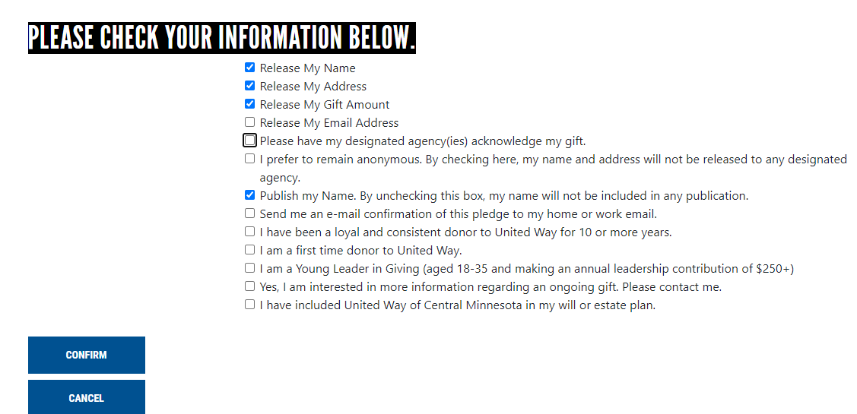

Please contact our Donor Portal Administrator with any questions at 320-229-3516 or processing@unitedwayhelps.org

