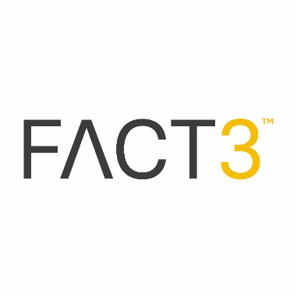
People: Important Changes in claiming furlough during Notice Periods – Effective 1st December 2020
Whilst we suspected that being able to claim furlough for periods of notice was unlikely to continue, we can now confirm the current position.
As suspected following the extension of the Furlough scheme there have been important changes in relation to employer’s eligibility to be able claim furlough for an employee who is serving a period of notice (either statutory or contractual) – in a nutshell, this has now ceased.
Here are the Detailed #FACTS:
For claim periods relating to November 2020, you can continue to claim for a furloughed employee who is serving a statutory notice period.
However, for claim periods starting on or after 1 December 2020, you cannot claim for any days on or after 1 December 2020 during which the furloughed employee was serving a contractual or statutory notice period for the employer (this includes people serving notice of retirement or resignation).
If an employee subsequently starts a contractual or statutory notice period on a day covered by a previously submitted claim, you will need to make an adjustment.
Information relating to “Adjustments to claim” can be made found at https://www.gov.uk/guidance/pay-coronavirus-job-retention-scheme-grants-back
Reminder……….
If you make an employee redundant, you should base statutory redundancy and statutory notice pay on their normal wage rather than the reduced furlough wage.
For claim periods relating to November 2020, whilst you could continue to claim for a furloughed employee who was serving a statutory notice period, you must not use the grants to substitute redundancy payments.

