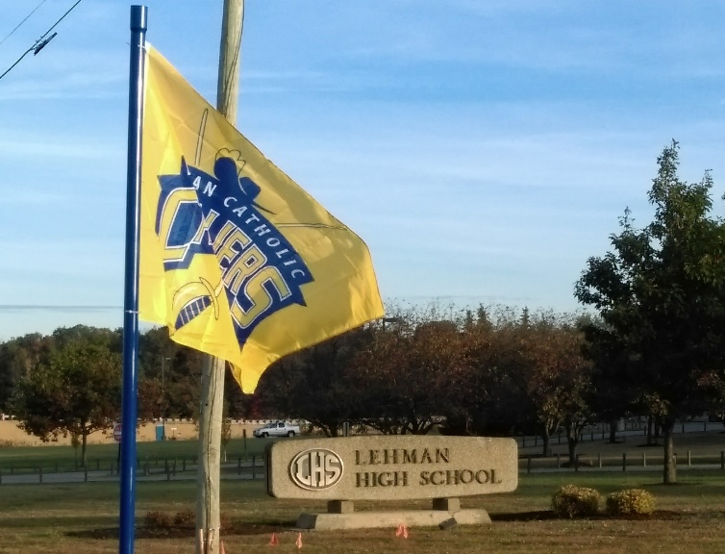
Lehman Alumni Assoc. Flag Fundraiser!
Show your Lehman Cavalier Spirit and support Our Lehman Alumni Scholarships & Events.
This is our 5th year and we are excited to for another great season!
We were able to give out TEN $750 Scholarships this year to incoming Lehman Freshman Students!
FLY A LEHMAN FLAG IN YOUR FRONT YARD FOR THE ENTIRE 2020 FALL SEASON!
We will put a flag up in a location of your choosing and it will not come down until the end of the season!
Any of our teams make playoff, we will proudly keep our flags waiving proudly to the end of playoffs!
$100 for the season!
Please fill out the enclosed information form and send it with your $100 donation to:
Jerry Vanderhorst, 1591 Westlake Drive Sidney OH 45365
For information contact Jerry Vanderhorst at 937-489-0611 or jerryva@woh.rr.com
YOU MUST LIVE IN SIDNEY, PIQUA OR TROY AREA!!!
Due to Covid-19 restrictions please help us distribute this form to other Lehman Supporters!
Thank you for Supporting Lehman Alumni Association!

_________________________Cut here and send in___________________________
Name:_____________________________________# of Flags______
Address:_________________________________________
Phone#:______________________ Email:__________________________
Checks made payable to: Lehman Alumni Association

