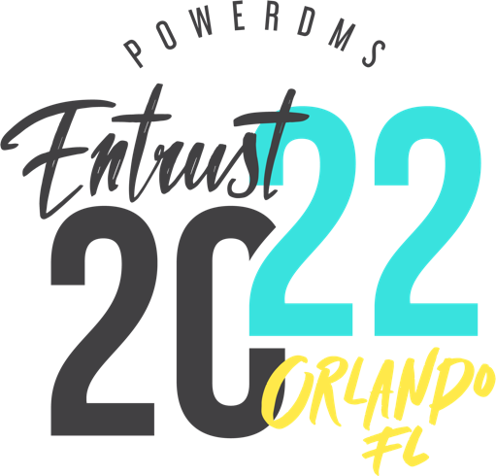

Sponsor Entrust 2022

Interested in sponsoring Entrust?

Please email Entrust@PowerDMS.com and provide answers to the following questions:
1. What's your name?
2. What's the best email address for you?
3. What is the best phone number to reach you at?
4. What organization are you with?

Once we receive your message we will send you over sponsorship/exhibitor package details.

