Social Sharing Kit for ISAGCA Members
“Leveraging ISA 62443-3-2 For IACS Risk Assessment and Risk Related Strategies” Work Product
---
In this white paper, "Leveraging ISA 62443-3-2 For IACS Risk Assessment and Risk Related Strategies," author Hal Thomas provides the reader with an overview of ISA 62443-3-2, “Security Risk Assessment for Design,” as well as a summary of some methodologies that can be used to assist execution of the industrial automation control system (IACS) cyber security risk assessment work process requirements detailed in the standard.
As a member of ISAGCA, your company may wish to share this product of our efforts on social media. We’ve created a few sample posts across various platforms that you’re welcome to share if you’re interested in doing so. Please feel free to change the wording of these posts to fit your branding, or simply copy and paste. Don’t forget to tag the International Society of Automation in your posts and/or use the #ISAGCA hashtag!

1. Leveraging ISA 62443-3-2 For IACS Risk Assessment and Risk Related Strategies
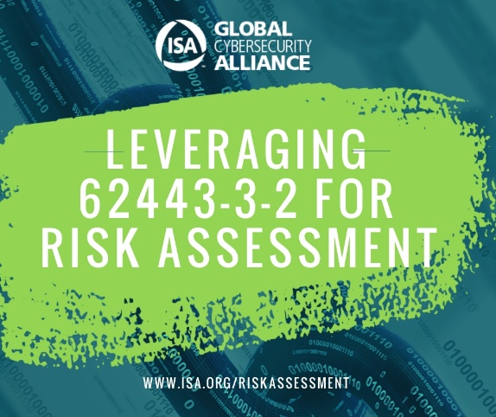
LinkedIn and Facebook: As a member of the International Society of Automation’s Global Cybersecurity Alliance, [Company Name] is committed to a building a resilient, cybersecure world, and standardization is one key aspect. Download this guide on an overview of ISA 62443-3-2, “Security Risk Assessment for Design,” at www.isa.org/riskassessment. #ISAGCA
(continued next page)

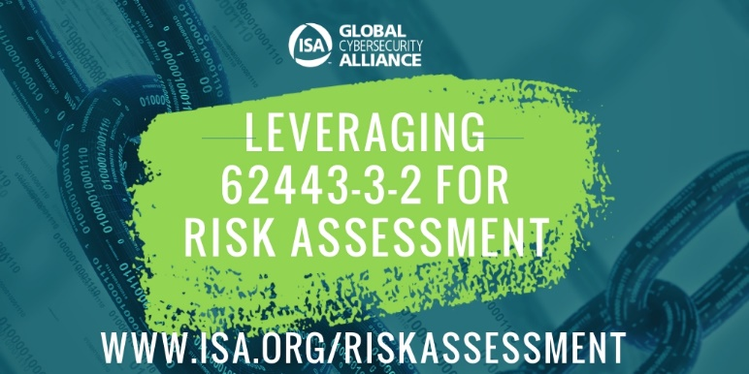
Twitter: We believe in the importance of automation cybersecurity standards. That’s why we’re members of @ISA_Interchange’s Global Cybersecurity Alliance. Download this guide on an overview of ISA 62443-3-2, “Security Risk Assessment for Design,” at www.isa.org/riskassessment. #ISAGCA
Instagram: We’re members of the International Society of Automation’s Global Cybersecurity Alliance, which just released a guide on an overview of ISA 62443-3-2, “Security Risk Assessment for Design.” Download at www.isa.org/riskassessment. #ISAGCA

