Social Sharing Kit for ISAGCA Members
“ISA Global Cybersecurity Alliance Position on Automation Cybersecurity Requirements in Public Policy” Work Product
---
Recent discussions have surfaced in the United States and in other world governments about how to best secure automation and control systems that affect our everyday lives, especially in critical infrastructure. US President Biden issued Executive Order 14028 on May 12, 2021, addressing securing automation in critical infrastructure; and the ISA Global Cybersecurity Alliance submitted a formal response. We hope this executive order and other measures will encourage those who support the nation’s critical infrastructure to develop and implement automation cybersecurity capabilities that will ensure the security of our way of life. This position paper describes the public policies and associated reference standards supported by the ISA Global Cybersecurity Alliance (ISAGCA).
As a member of ISAGCA, your company may wish to share this product of our efforts on social media. We’ve created a few sample posts across various platforms that you’re welcome to share if you’re interested in doing so. Please feel free to change the wording of these posts to fit your branding, or simply copy and paste. Don’t forget to tag the International Society of Automation in your posts and/or use the #ISAGCA hashtag!

1. ISA Global Cybersecurity Alliance Position on Automation Cybersecurity Requirements in Public Policy
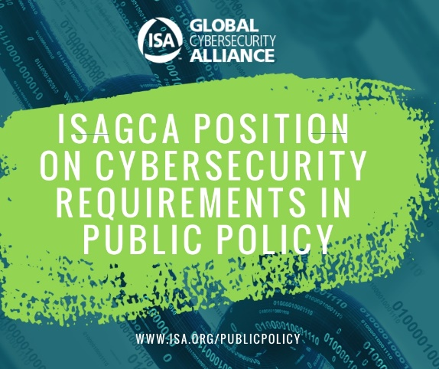
LinkedIn and Facebook: As a member of the International Society of Automation’s Global Cybersecurity Alliance, [Company Name] is committed to a building a resilient, cybersecure world, and standardization is one key aspect. Download this position paper that describes the public policies and associated reference standards supported by the ISAGCA at www.isa.org/publicpolicy. #ISAGCA
(continued next page)

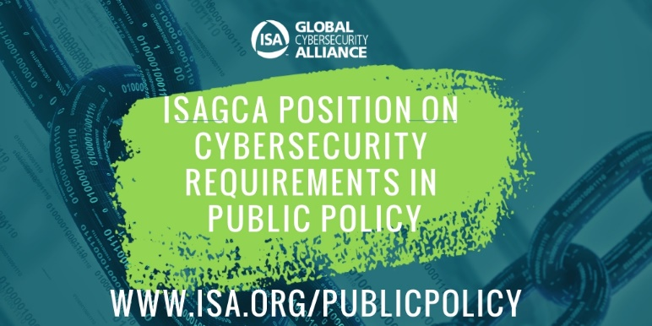
Twitter: We believe in the importance of automation cybersecurity standards. That’s why we’re members of @ISA_Interchange’s Global Cybersecurity Alliance. Download this position paper on our supported policies and reference standards at www.isa.org/publicpolicy. #ISAGCA
Instagram: We’re members of the International Society of Automation’s Global Cybersecurity Alliance, which just released a position paper that describes the public policies and associated reference standards supported by the alliance. Download at www.isa.org/publicpolicy. #ISAGCA

