Social Sharing Kit for ISAGCA Members
“Applying ISO/IEC 27001/2 and the ISA/IEC 62443 Series for Operational Technology Environments” Work Product
---
This white paper offers guidance for organizations familiar with ISO/IEC 27001 and interested in protecting the OT infrastructure of their operating facilities based on the ISA/IEC 62443 series. It describes the relationship between the ISA/IEC 62443 series and ISO/IEC 27001/2 and how both standards may be effectively used within one organization to protect both IT and OT.
As a member of ISAGCA, your company may wish to share this product of our efforts on social media. We’ve created a few sample posts across various platforms that you’re welcome to share if you’re interested in doing so. Please feel free to change the wording of these posts to fit your branding, or simply copy and paste. Don’t forget to tag the International Society of Automation in your posts and/or use the #ISAGCA hashtag!

1. Applying ISO/IEC 27001/2 and the ISA/IEC 62443 Series for Operational Technology Environments
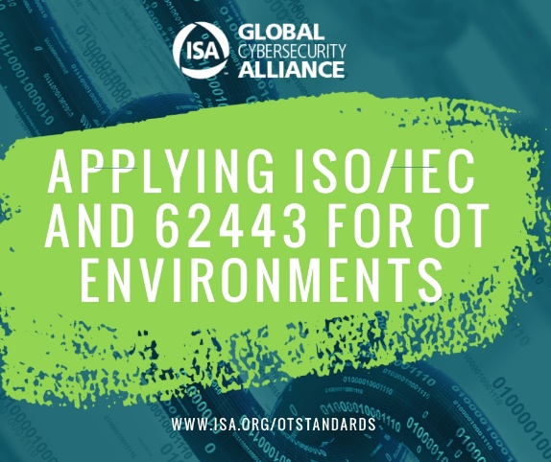
LinkedIn and Facebook: As a member of the International Society of Automation’s Global Cybersecurity Alliance, [Company Name] is committed to a building a resilient, cybersecure world, and standardization is one key aspect. Download this white paper on the guidance for organizations familiar with ISO/IEC 27001 and interested in protecting the OT infrastructure of their operating facilities based on the ISA/IEC 62443 series at www.isa.org/otstandards. #ISAGCA
(continued next page)

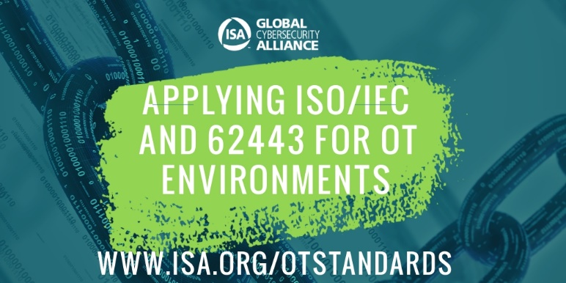
Twitter: We believe in the importance of automation cybersecurity standards. That’s why we’re members of @ISA_Interchange’s Global Cybersecurity Alliance. Download this guide on the relationship between the ISA/IEC 62443 series and ISO/IEC 27001/2 at www.isa.org/otstandards. #ISAGCA
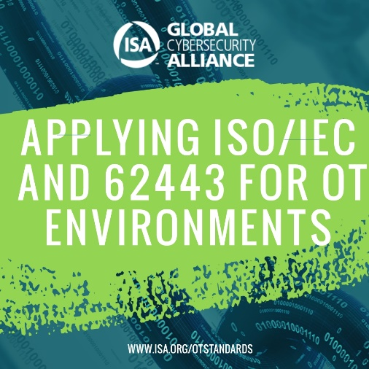
Instagram: We’re members of the International Society of Automation’s Global Cybersecurity Alliance, which just released a guide on the relationship between the ISA/IEC 62443 series and ISO/IEC 27001/2 at www.isa.org/otstandards. #ISAGCA

