Social Sharing Kit for ISAGCA Members
“IIoT Component Certification Based on the 62443 Standard” Work Product
---
The ISA Global Security Alliance (ISAGCA) and the ISA Security Compliance Institute (ISCI) recently released a co-sponsored Industrial Internet of Things (IIoT) certification study entitled, “IIoT Component Certification Based on the 62443 Standard.” The study addresses the urgent need for industry-vetted IIoT certification programs, with the goal of determining the applicability of the ISA/IEC 62443 series of standards and certifications to IIoT components and systems. This included examining whether existing 62443 requirements and methods for validating these requirements under existing certification programs are necessary and sufficient for the IIoT environment.
As a member of ISAGCA, your company may wish to share this product of our efforts on social media. We’ve created a few sample posts across various platforms that you’re welcome to share if you’re interested in doing so. Please feel free to change the wording of these posts to fit your branding, or simply copy and paste. Don’t forget to tag the International Society of Automation in your posts and/or use the #ISAGCA hashtag!

1. IIoT Component Certification Based on the 62443 Standard
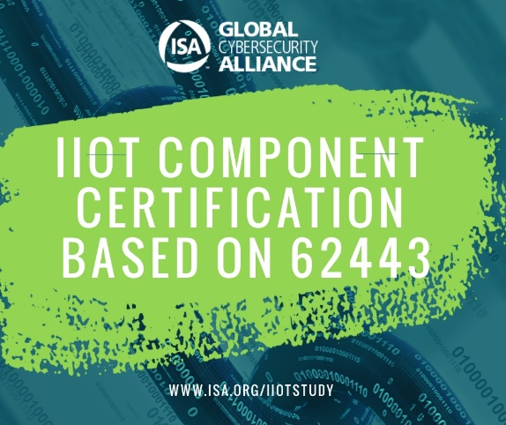
LinkedIn and Facebook: The ISA Global Security Alliance (ISAGCA) recently released a co-sponsored Industrial Internet of Things (IIoT) certification study entitled, “IIoT Component Certification Based on the 62443 Standard.” Download the study at www.isa.org/iiotstudy. #ISAGCA
(continued next page)

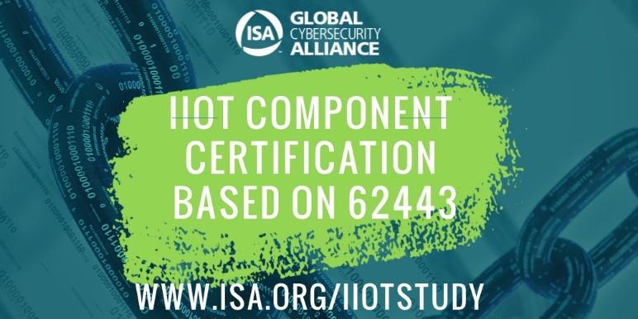
Twitter: Members of @ISA_Interchange’s Global Cybersecurity Alliance recently released a co-sponsored Industrial Internet of Things (IIoT) certification study entitled, “IIoT Component Certification Based on the 62443 Standard.” Download the study at www.isa.org/iiotstudy. #ISAGCA
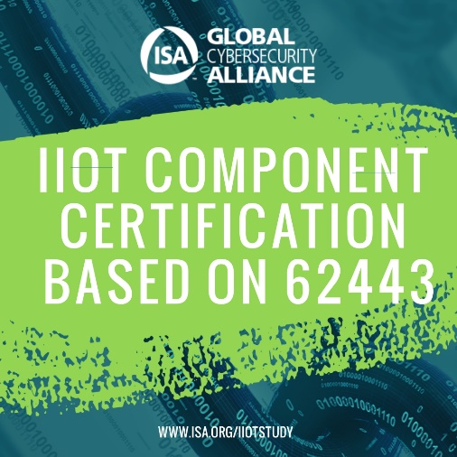
Instagram: The ISA Global Security Alliance (ISAGCA) recently released a co-sponsored Industrial Internet of Things (IIoT) certification study entitled, “IIoT Component Certification Based on the 62443 Standard.” Download the study at www.isa.org/iiotstudy. #ISAGCA

