Social Sharing Kit for ISAGCA Members
“Guide to Security Lifecycles in ISA/IEC 62443” Work Product
---
ISAGCA's Training and Education Work Group has coordinated the development of a guide to the security lifecycles outlined in the ISA/IEC 62443 series of standards. The guide defines principal roles and responsibilities in industrial automation and control systems (IACS), and it explores how to apply specific standards documents to each phase within the security lifecycles.
As a member of ISAGCA, your company may wish to share this product of our efforts on social media. We’ve created a few sample posts across various platforms that you’re welcome to share if you’re interested in doing so. Please feel free to change the wording of these posts to fit your branding, or simply copy and paste. Don’t forget to tag the International Society of Automation in your posts and/or use the #ISAGCA hashtag!

1. Guide to Security Lifecycles in ISA/IEC 62443
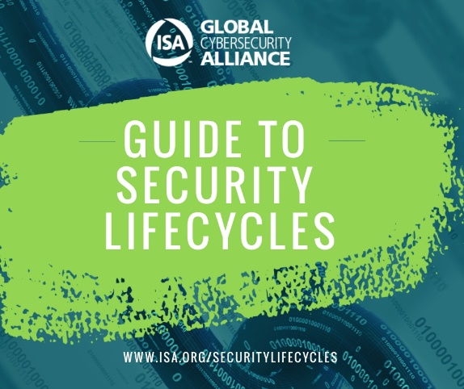
LinkedIn and Facebook: As a member of the International Society of Automation’s Global Cybersecurity Alliance, [Company Name] is committed to a building a resilient, cybersecure world, and standardization is one key aspect. Download this guide on the security lifecycles outlined in the ISA/IEC 62443 series of standards at www.isa.org/securitylifecycles. #ISAGCA
(continued next page)

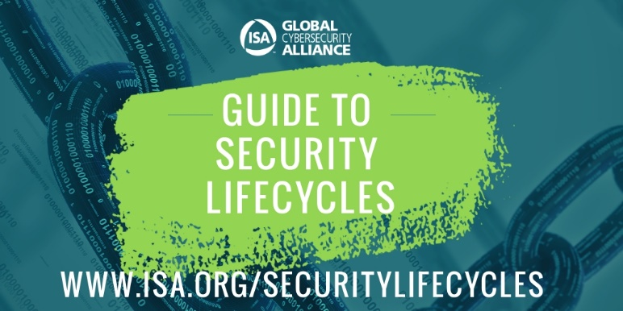
Twitter: We believe in the importance of automation cybersecurity standards. That’s why we’re members of @ISA_Interchange’s Global Cybersecurity Alliance. Download this guide on the security lifecycles outlined in the ISA/IEC 62443 series of standards at www.isa.org/securitylifecycles. #ISAGCA
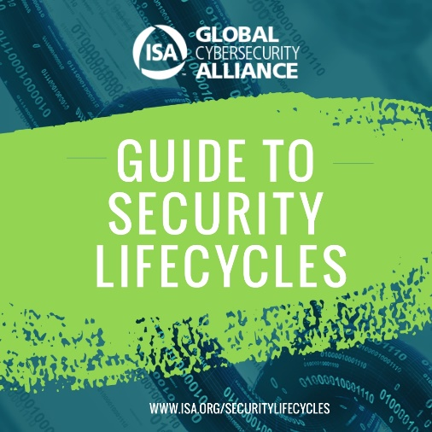
Instagram: We’re members of the International Society of Automation’s Global Cybersecurity Alliance, which just released a guide on the security lifecycles outlined in the ISA/IEC 62443 series of standards. Download at www.isa.org/securitylifecycles. #ISAGCA

