Revised Guidance for Aboriginal Community Controlled Health Services on COVID-19 Vaccines Advertising
The following information and communication materials have been provided to support your patient communications during the COVID-19 vaccines rollout. This should help providing information about which vaccine is available at your premises and support your conversations with patients as to which vaccine they can expect to receive.
You can now mention which vaccines you offer
The Therapeutic Goods Administration (TGA) advises it is now acceptable to mention which brand of vaccine or vaccines your health organisation offers to patients. You still cannot make statements about one vaccine being better than another, and information should be accurate and balanced. You can find out more by visiting the TGA website.
Available resources
Below are some resources that you can use at your clinic, including posters, social content and web banners. Other supporting information about the COVID-19 vaccines, and the vaccine rollout, has also been provided.
These resources are reviewed regularly and will be updated as new information becomes available. More information for Aboriginal and Torres Strait islander people and clinics can be found on the website.
Posters
These posters are available for download from our website in PDF and Word format.
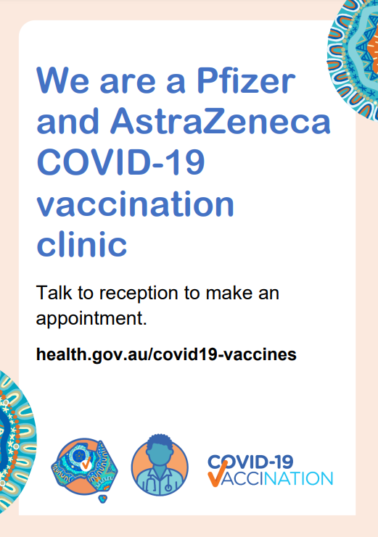 | We are a Pfizer and AstraZeneca COVID-19 Vaccination Clinic  Other information  The Pfizer vaccine can be offered to people aged 16 to 59 years old, as well as pregnant and breastfeeding women.  The AstraZeneca vaccine is the preferred option for people aged 60 years and over. It is recommended that people under the age of 60 who would like to receive AstraZeneca discuss the vaccine options with their doctor. Second doses of the AstraZeneca vaccine can be offered to anyone who did not experience serious side effects from their first dose.
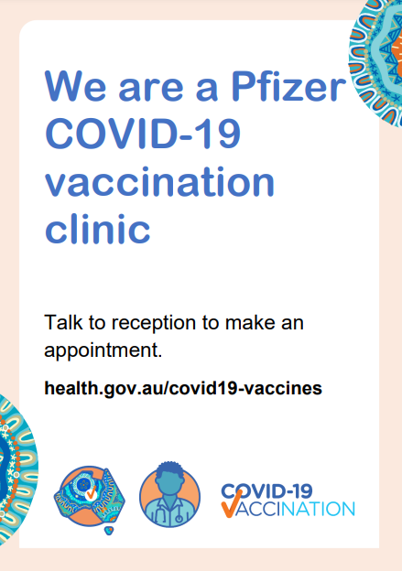 | We are a Pfizer COVID-19 Vaccination Clinic  Other information  The Pfizer vaccine can be offered to people aged 59 years and under, including pregnant and breastfeeding women.
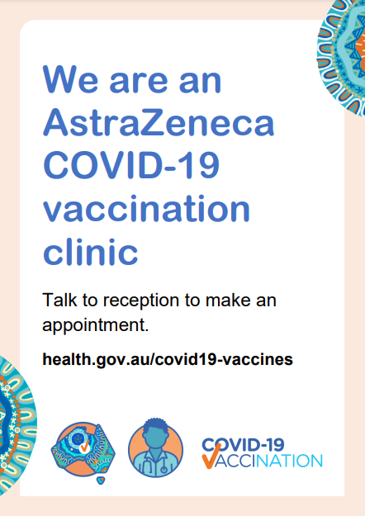 | We are an AstraZeneca COVID-19 Vaccination Clinic  Other information  The AstraZeneca vaccine is the preferred option for people aged 60 years and over. It is recommended that people under the age of 60 who would like to receive AstraZeneca discuss the vaccine options with their doctor.  Second doses of the AstraZeneca vaccine can be offered to anyone who did not experience serious side effects from their first dose.
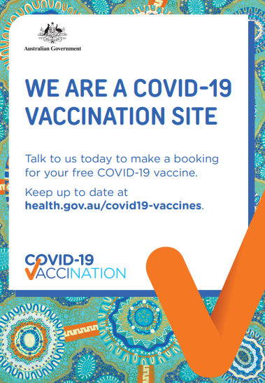 | We are a COVID-19 Vaccination Clinic – with a link to the Australian Department of Health  Other information  Display this poster with any of the other posters depending on which  COVID-19 Vaccines your clinic offers.
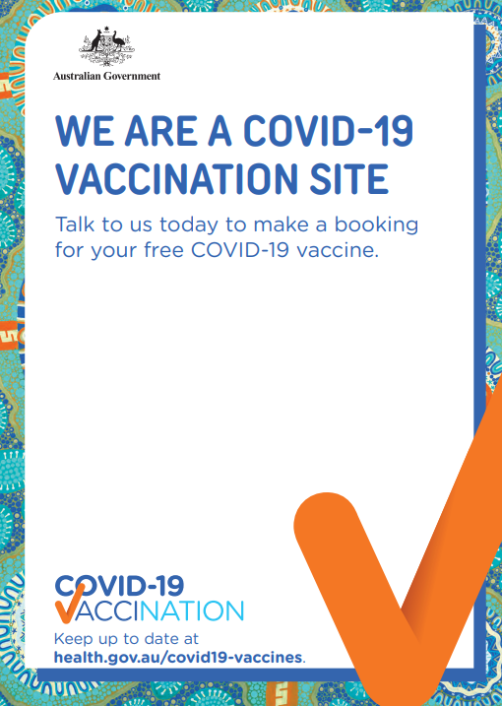 | We are a COVID-19 Vaccination Clinic – add your own links  Other information  Display this poster with any of the other posters depending on which  COVID-19 Vaccines your practice offers.
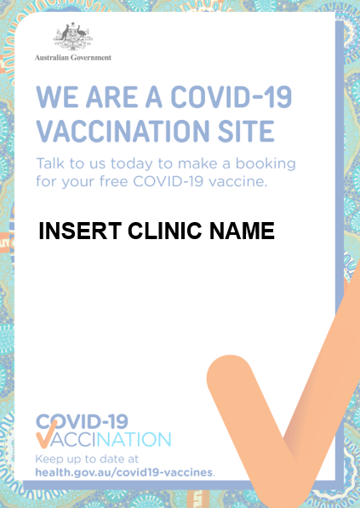 | We are a COVID-19 Vaccination site – enter your clinic’s name  Other information  Display this poster with any of the other posters depending on which  COVID-19 Vaccines your clinic offers.

Social content
Find below several different social media resources that you can use across your channels. These are available for download from the website.
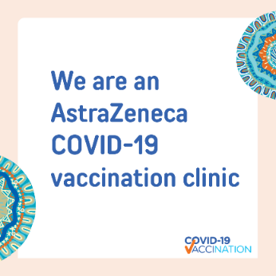 | 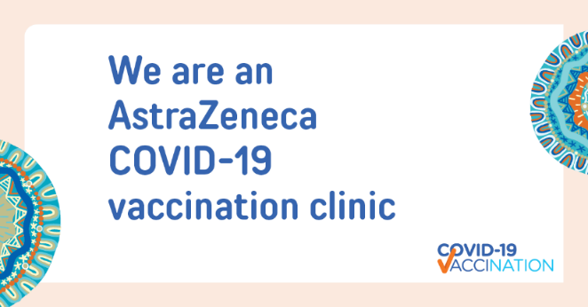
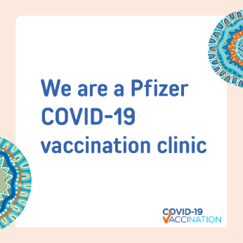 | 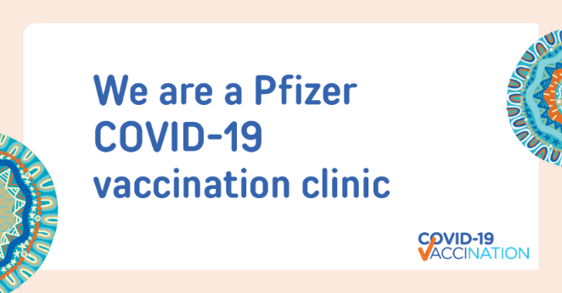
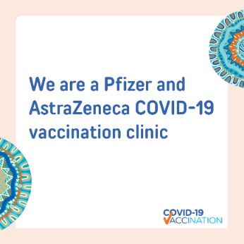 | 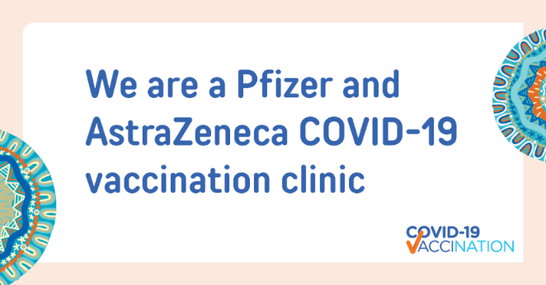

Web banners
Below you will find a selection of web banners that you can use on your website. These are available for download from the website.
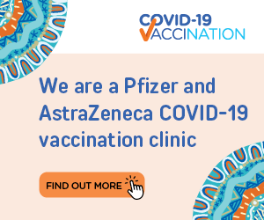 |  | 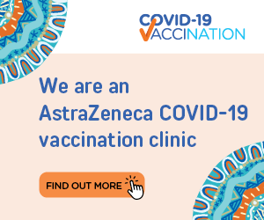

The Department of Health appreciates everything that ACCHS are doing to keep people in Australia safe during this time. Please let us know if you need any of these resources in a different format, or if there is something new that you need by contacting covidvaccinecomms@health.gov.au.

