COVID-19 important information
In this pack, you’ll find suggested social tiles and captions, two posters and a community announcement radio script, reminding everyone on the importance of keeping two big steps away from others, washing hands regularly, getting tested if you’re unwell, and following state and territory guidelines and restrictions.
Please use these assets as you see fit and adapt to your local requirements.

Social tiles and captions
Tile | Suggested caption
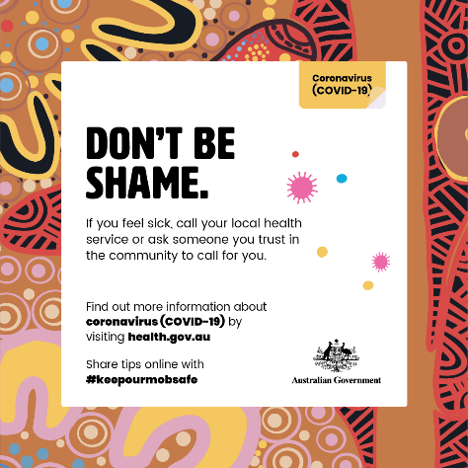 | #COVID19 #outbreaks are still happening throughout insert state/territory name. If you feel unwell or have been at an exposure site, go get a COVID-19 test.  When you’re feeling fit and healthy, make an appointment to get your COVID-19 vaccine!  The COVID-19 #vaccine is now available to all Aboriginal and Torres Strait Islander people aged 16 years and over. To make an appointment, have a yarn with your healthcare worker, or visit covid-vaccine.healthdirect.gov.au/eligibility insert state booking system, if applicable
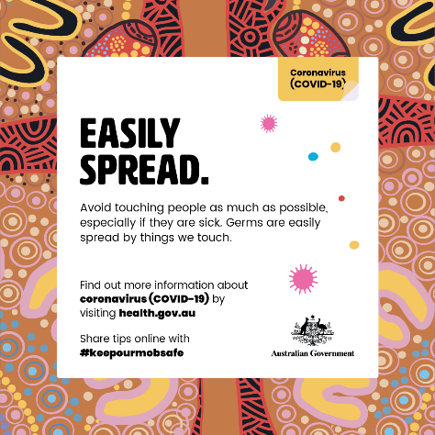 | Stay safe by staying informed. Current outbreaks mean rules are changing quickly. Stay up to date by visiting insert your state or territory government’s social pages and website.  When you need to go out into the community, do your best to keep as much distance between you and others as possible. A good way to do that is to keep at least two big steps away.
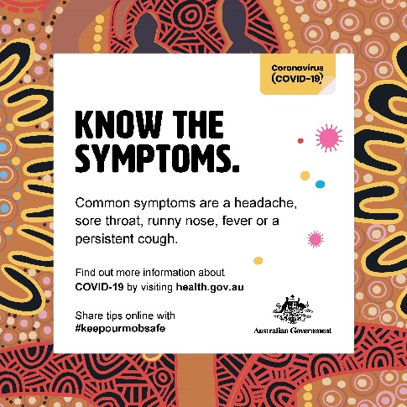 | #COVID19 symptoms often look the same as cold or flu symptoms. Keep an eye out for a headache, runny nose, sore throat, or a fever.  If you feel unwell, go and get a COVID-19 test and stay home till you get your results. Find out where you can get a COVID-19 test near you at insert state/territory health website
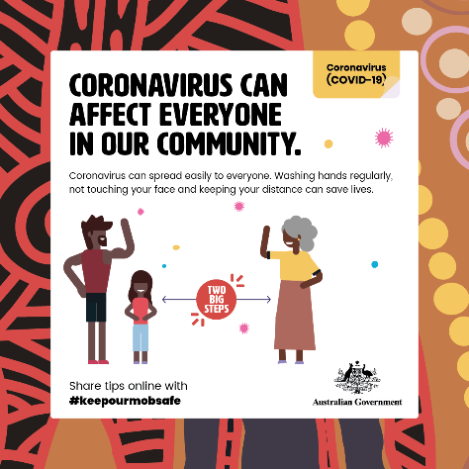 | Everyone in our community can be affected by #COVID19, but the elderly are most at risk from getting really sick from the virus.  The best way to protect yourself from COVID-19 is to get vaccinated. The COVID-19 #vaccine is now available to all Aboriginal and Torres Strait Islander people aged 16 years and over. To make an appointment, have a yarn with your healthcare worker, or visit covid-vaccine.healthdirect.gov.au/eligibility insert state booking system, if applicable
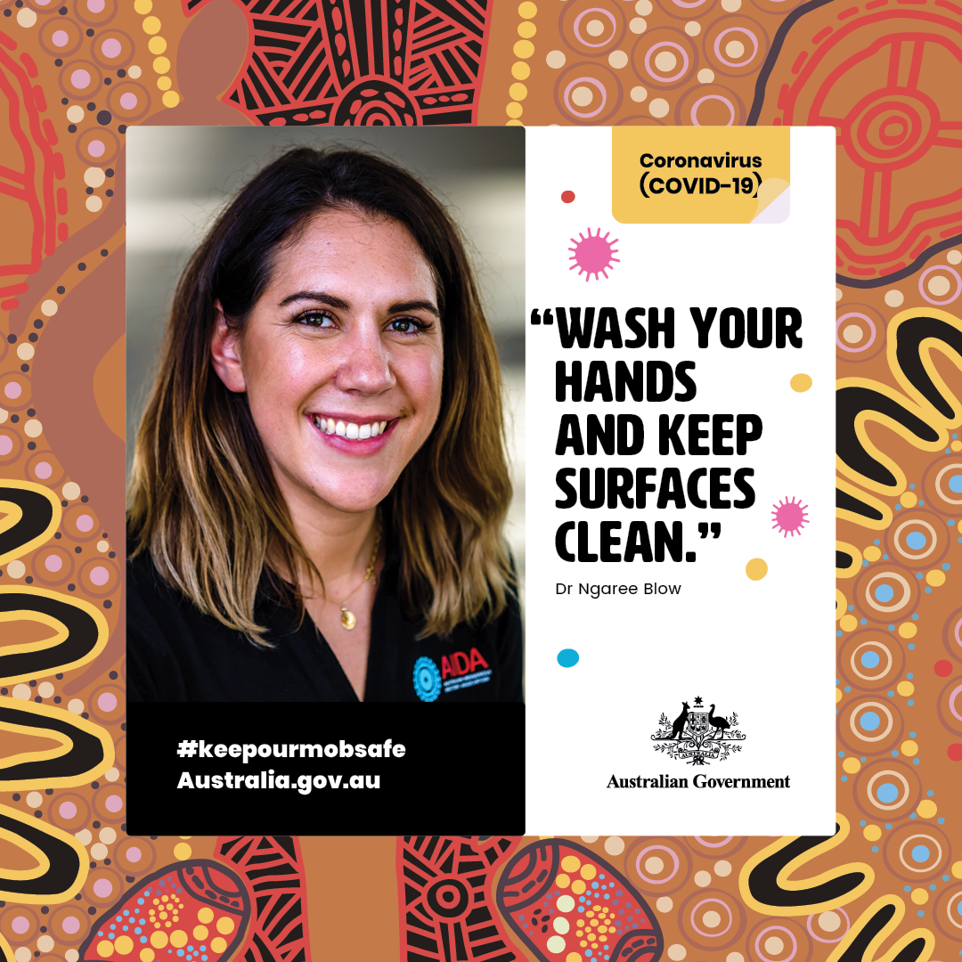 | You can keep #COVIDSafe by washing your hands regularly. Another important way to keep your hands clean is to clean the surfaces you touch regularly, like your phone, and the surfaces that lots of people touch, like door handles and water taps.  For more information, visit insert state/territory health website
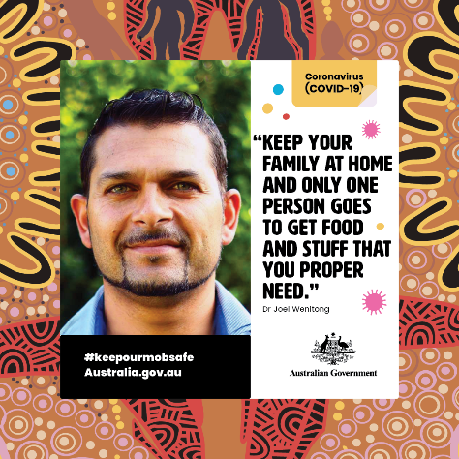 | While #lockdowns are happening, avoid going out into the community as much as possible. A great way to do that is to have one person who picks up groceries and other essential items, while the rest of the house stays home.  When you do have to go out, make sure you wear your mask, and keep two big steps away from other people.  For more information, visit insert state/territory health website
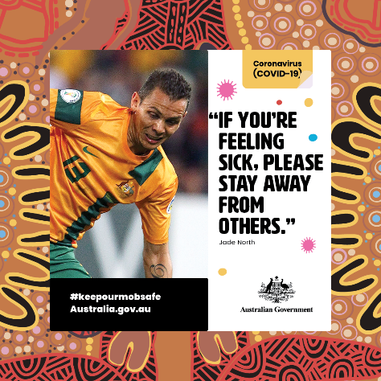 | New variants of #COVID19 are spread even more easily between people out in the community.  It’s more important than ever that if you have any symptoms, like a sore throat or runny nose, go and get a COVID-19 test straight away. While you’re waiting for your test results, stay home, away from others.  For more information, visit insert state/territory health website
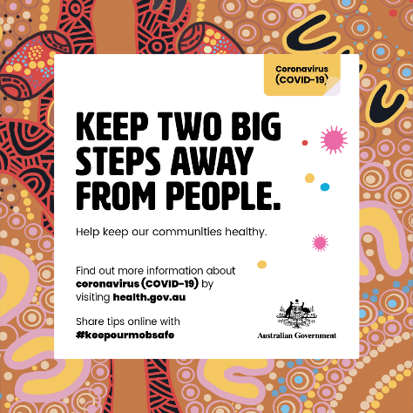 | When you need to go out into the community, do your best to keep as much distance between you and others as possible. A good way to do that is to keep at least two big steps away.  Remember: one of the ways that #COVID19 is spread is through the air, when one person breathes out, and the other person breathes in the same air. By keeping your distance, you can reduce your risk of being infected by COVID-19.
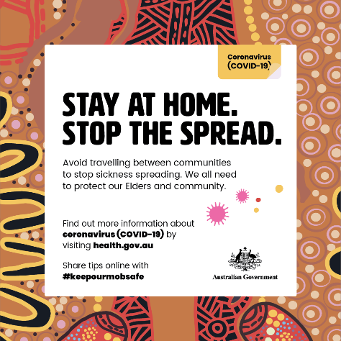 | If you feel unwell, go and get a COVID-19 test. It’s important to stay at home till you get your results, to #stopthespread.  Find out where you can get a COVID-19 test near you at insert state/territory health website
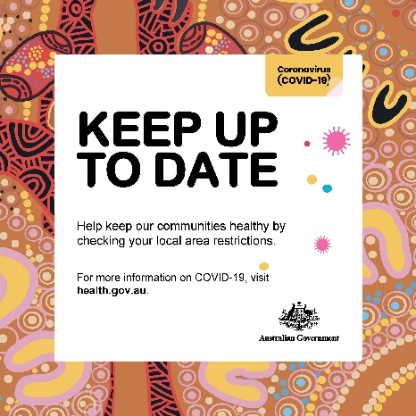 | #COVID19 restrictions are popping up in different areas, as we try to #stopthespread.  Check insert state/territory health website for the most up to date information on what restrictions your local community has. This could include wearing a mask in some places or limiting the amount of people allowed in your home.
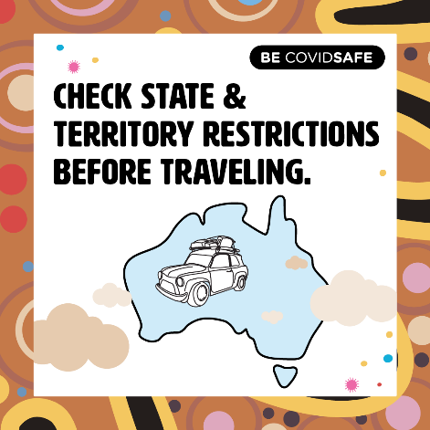 | Things can change quickly in different states and territories, as #COVID19 #outbreaks happen. Before leaving home, check the restrictions for where you’re going, to make sure you don’t get stuck.  If you live in an area that’s been labelled a COVID-19 hotspot, please follow any stay-at-home orders by your state, to keep #stopthespread of the virus. (add if relevant to your state)

Community announcement radio script
- COVID-19 cases have increased again and the virus is an active threat and risk to our communities. It is important to keep safe and keep up to date with information from your local area.
- With more cases occurring around the country, this is not the time to let our guard down.

- COVID-19 is a very dangerous virus, and there have been more than 30,000 people in Australia that have caught it including more than 150 cases in Aboriginal and Torres Strait Islander people.

- So remember simple behaviours that can help keep the virus away:
  - Staying two big steps apart from others in the community,
  - Keep hands clean, washing your hands regularly for about 20 seconds
  - staying home when you’re feeling sick,
  - and getting tested for the virus if you have symptoms.

- Clean items and surfaces that are touched by a lot of people, such as door handles and phones.
- New COVID-19 variants can spread more easily among people. If you have any symptoms like a headache or runny nose, or have been in a risk location identified by State and Territory governments, go get tested straight away. For information about ___ (insert state/territory), visit ____ (insert Government health website – see list below).

- The best way to protect yourself and your community from COVID-19 is to get vaccinated. The COVID-19 vaccines are very effective at preventing you from getting seriously sick or needing to go to hospital if you were to catch the virus.

- To book your appointment, have a yarn with your local health care worker, or visit health.gov.au.

Northern Territory: https://coronavirus.nt.gov.au/
Queensland: https://www.health.qld.gov.au/
South Australia: https://www.covid-19.sa.gov.au/
Western Australia: https://www.healthywa.wa.gov.au/coronavirus
Australian Capital Territory: https://www.covid19.act.gov.au/
New South Wales: https://www.health.nsw.gov.au/
Tasmania: https://coronavirus.tas.gov.au/

Posters
