Aboriginal and Torres Strait Islander vaccine communication materials
In this pack, you’ll find suggested social tiles and captions that you could use across your social media platform - as well as a social media template to personalise and share.
It includes editable and printable posters and fact sheets that you can use and distribute regarding information about the vaccine and a collection of videos that you can share within the community and answer any questions they may have.
Also, two community announcement radio scripts, reminding everyone on the importance of keeping two big steps away from others, washing hands regularly, getting tested if you’re unwell, and following state and territory guidelines and restrictions.
Please use these assets as you see fit and adapt to your local requirements.
- Social media content
- Social media template
- Fact sheets
- Posters
- Newsletter
- Videos
- Community announcement radio scripts
See all communication resources here, and all resources for COVID-19 vaccine providers here.

Social media content

Here are some examples of social media posts that you could use across your social media platform. Please feel free to change the content as you see fit. See all social media tiles and captions on the website.
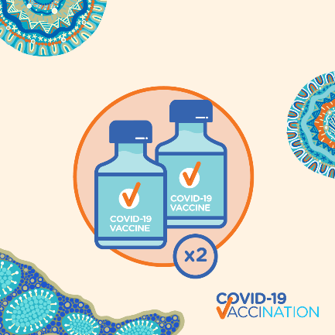 | If you’ve had your first dose of the #COVID19 #vaccine, you’re halfway there! The vaccines are most effective when you’ve received two doses within the recommended timeframe. That’s 3 weeks for #Pfizer, and between 4 and 12 weeks for #AstraZeneca.  Without the second dose, your body will not be able to fight COVID-19 as effectively. Have a yarn with your healthcare worker today to make an appointment for your #seconddose.
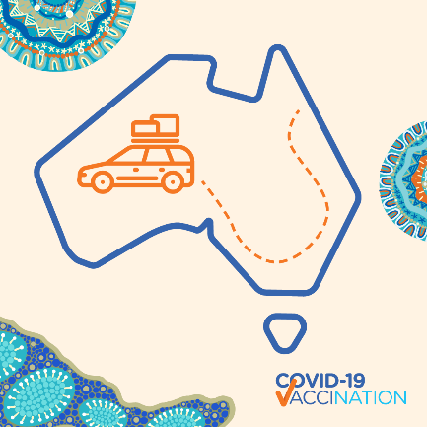 | #Australia is working hard to keep state borders open, so that we can travel to different parts of our beautiful country! Even if there are no cases in your community, with people coming and going in your area, it’s important to do what you can to keep safe.  Keep washing your hands regularly, stay two big steps away from others, stay home if you don’t feel well, and get tested if you have any #COVID19 symptoms. Most importantly, when you have a chance to, get your COVID-19 #vaccine.
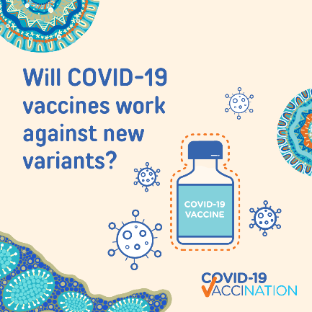 | All viruses change or mutate slightly over time. The longer that #COVID19 goes around communities across the world, the more chances it has to mutate. This is why #stoppingthespread of the virus is so important.  The COVID-19 vaccines available in #Australia will still be effective against new variants of the virus. If COVID-19 continues to mutate, it may mean that people will need to be vaccinated again in the future.  Visit the ‘Is it true?’ page on health.gov.au to get the most up to date information.
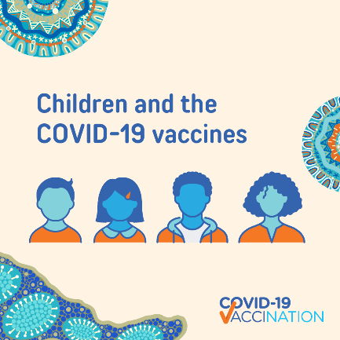 | #COVID19 vaccines are available for Aboriginal and Torres Strait Islanders 16 years and over. Children 15 and younger are not able to get a COVID-19 vaccine. This is because children were not included in the initial clinical trials of the vaccines – which is very common practice.  More studies and trials are taking place in other countries with children included. The Therapeutic Goods Administration (TGA) will continue to look at the results, and make recommendations based on the information available.
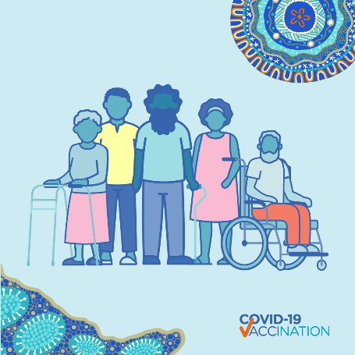 | #COVID19 vaccines are available to all Aboriginal and Torres Strait Islander people aged 16 years and over. The vaccines are free and will help protect you from getting really sick from COVID-19. Have a yarn with your local healthcare worker, or visit covid-vaccine.healthdirect.gov.au/eligibility to find out where you can get your vaccine.
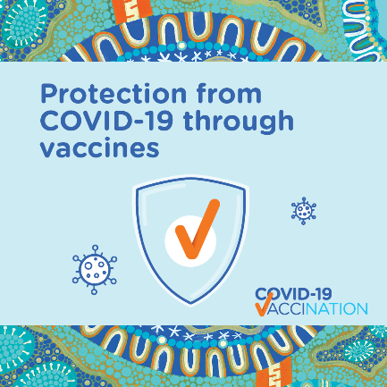 | Getting the #vaccine helps protect you, your community and your loved ones from getting really sick from #COVID19 and needing to go to hospital. Vaccines work by training your body to recognise and fight the virus that causes COVID-19.  Have a yarn with your local healthcare worker about where you can get your vaccine or visit health.gov.au
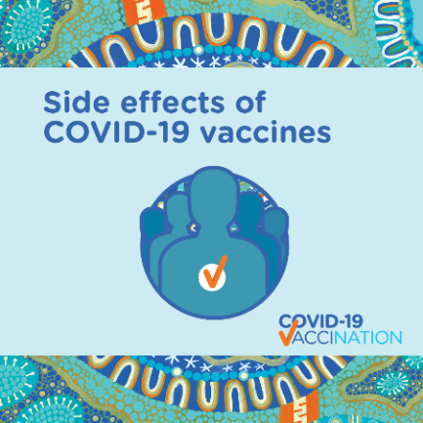 | Even though not everyone gets them, mild side effects such as feeling sick, a sore arm, fever, muscle aches or headaches are a sign that the #vaccine is working to create an immune response. For most people, symptoms usually last for a couple of days.  If you have a side effect that worries you, please yarn to your healthcare worker or call your health clinic.
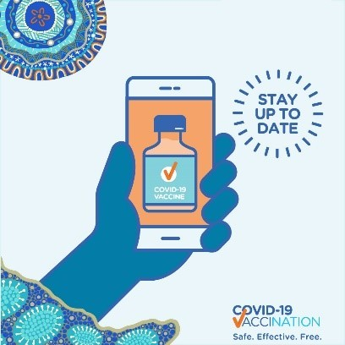 | #COVID19 #outbreaks are still happening across the country. #StaySafe by staying informed! Keep up to date by visiting your state or territory website, or health.gov.au.

Social media template
This social media template, created for Aboriginal and Torres Strait Islander communities, will allow you to upload your photo and then share it across your social media channels with your personal reasons why you are getting vaccinated against COVID-19.
Download the template from the website.
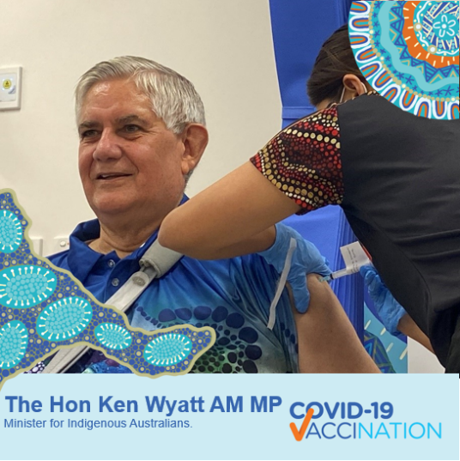
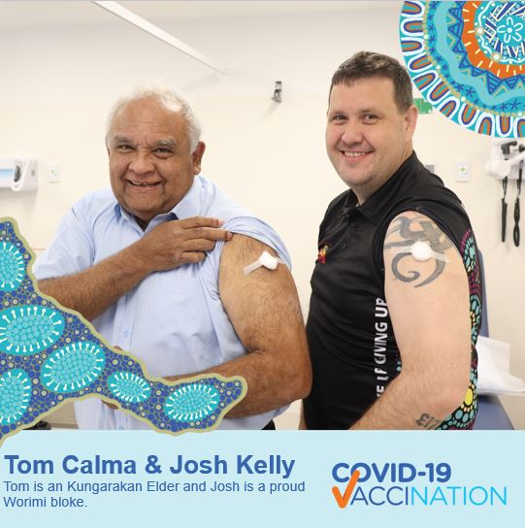

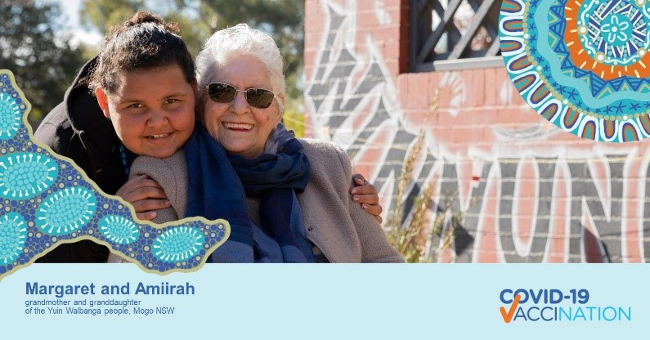

Fact sheets
Printable fact sheets that you can distribute to patients, that will provide more information about the vaccination process.
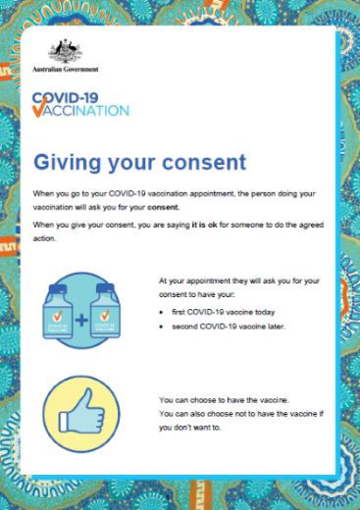 | Giving your consent  This easy-to-read fact sheet explains why you need to agree to get vaccinated and what are the different ways that you can give your consent before your COVID-19 vaccine.  Download fact sheet from the website.
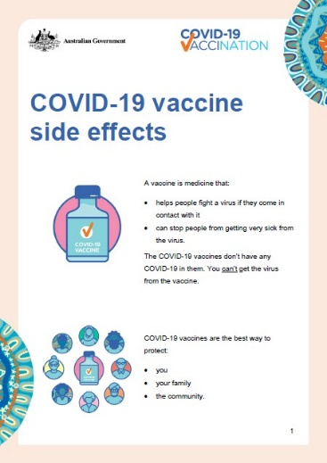 | COVID-19 vaccine side effects  This easy-to-read fact sheet outlines the side effects of COVID-19 vaccines and what to do if you feel them.  Download the poster from the website.
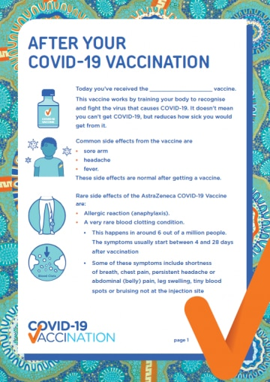 | After your COVID-19 vaccination  Printable fact sheets that may be distributed to patients, following their vaccine, with important information about what to expect after their vaccination. This fact sheet is available in an icon version, and a text version.  Download the poster from the website.

Posters
Downloadable posters with different information about the COVID-19 vaccination, designed for vaccine providers.
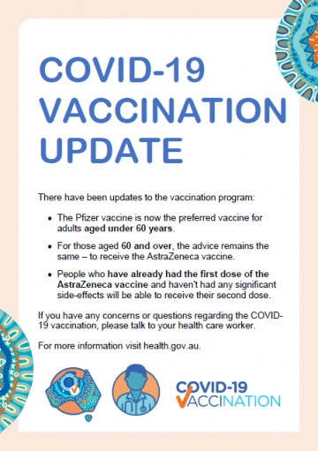 | A downloadable poster that can be used by Aboriginal and Torres Strait Islander vaccine providers in their clinics or on their websites to update patients with new recommendations from Australian Technical Advisory Group on Immunisation (issued on 17 June 2021).  Download poster from website.
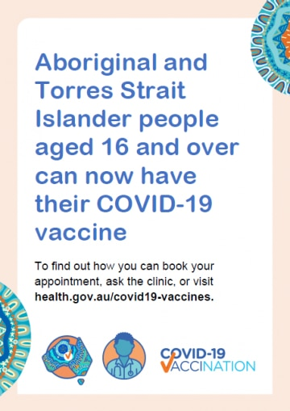 | This poster, designed for vaccine providers, outlines that Aboriginal and Torres Strait Islander people 16 years and over can now have their COVID-19 vaccine.  Download poster from website.
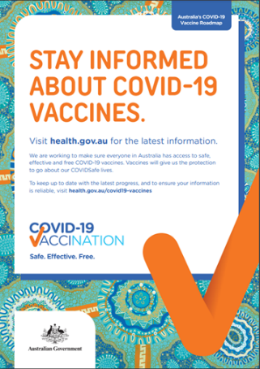 | This poster explains what you can do to stay informed about COVID-19 vaccines.  We are working to make sure everyone in Australia has access to safe, effective and free COVID-19 vaccines. Vaccines will give us the protection to go about our COVID Safe lives.  Download poster from website.

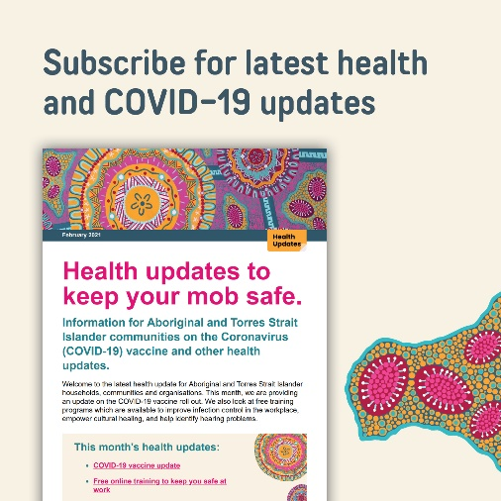
Newsletter
The department releases a fortnightly newsletter, distributed to more than 800 subscribers, featuring key COVID-19 vaccine updates, and other health updates for Aboriginal and Torres Strait Islander communities. All newsletters are published to the website, and all are welcome to subscribe.

Videos
Here are some videos that you can share across your social media channels and the community.
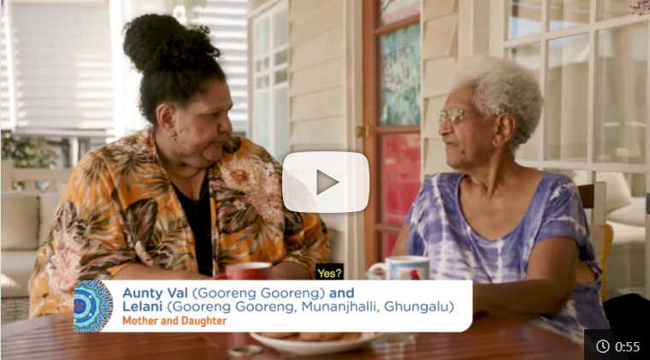 | This video shows Aunty Val and Lelani sharing a cup of tea, talking about the COVID-19 vaccine.
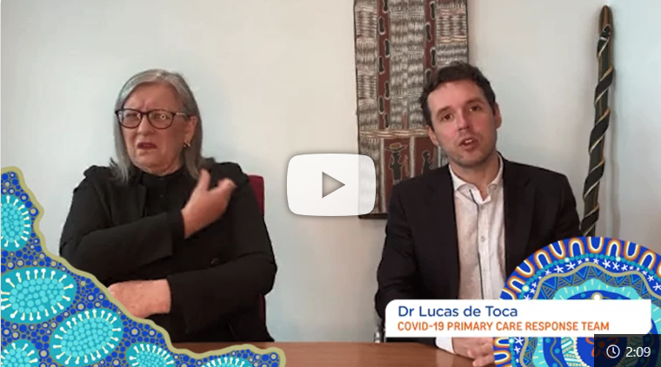 | Dr Lucas de Toca explains the importance of receiving the COVID-19 vaccine, even though some people may still catch the virus.
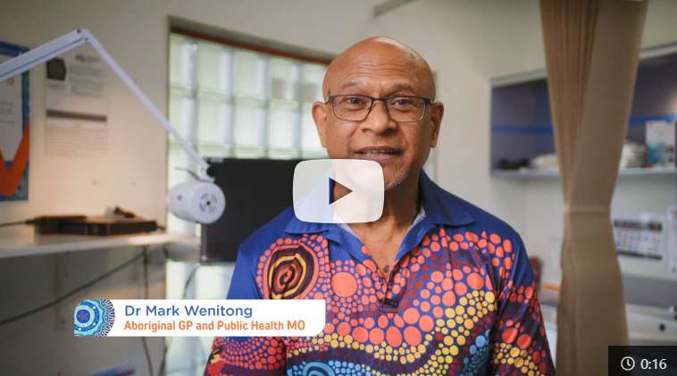 | Dr Mark Wenitong, GP in Indigenous Health for 25 years, reminds us to get information about COVID-19 vaccines from trusted sources.
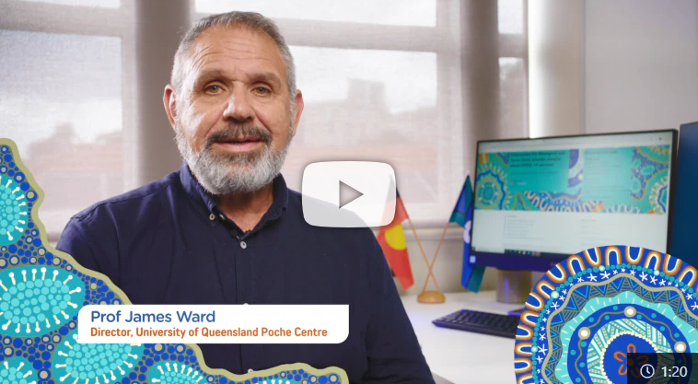 | Professor James Ward explains how COVID-19 vaccines work, and addresses some common misconceptions about the vaccines.

Community announcement radio scripts
Why is it important that most of us get vaccinated?
COVID-19 can be a very serious illness, especially for our Elders, and those in our community who have existing medical conditions.
Vaccines train your immune system to recognise and fight against specific viruses, like COVID-19. The COVID-19 vaccines are very effective at preventing serious sickness or death if you were to catch the virus.
When you get vaccinated, you are protecting yourself. When enough people are vaccinated, you are helping to protect the whole community.
We’ve seen with other vaccines that when enough people in the community are vaccinated, it slows down the spread of disease, and in some cases, it removes the threat of the disease altogether. For example, this includes very serious diseases such as measles, which is almost eradicated from Australia.
There is early evidence that shows COVID-19 vaccines also help reduce the spread of the virus.
The more people who are vaccinated against COVID-19, also makes outbreaks much less likely. This means that preventative measures, such as closing state borders and closing communities, may be needed less.
The COVID-19 vaccine is now available to all Aboriginal and Torres Strait Islander people aged 16 years and over. If you are now eligible, take the opportunity to get the vaccine, to help protect the vulnerable and those who are too young or too sick to get the vaccine themselves.
To book your appointment, have a yarn with your local health care worker, or visit health.gov.au. For information about ___ (insert state/territory), visit ____ (insert Government health website – see list below).

Two doses of COVID-19 vaccine needed
Some parts of Australia are still get pretty cold, and people are travelling north, following the hot Australian sun. While we love to see more people exploring these wonderful parts of our country, with the risk of COVID-19 still out there, it’s important to do what we can to keep safe.
The vaccines are most effective when you’ve received two doses within the recommended timeframe.
The first dose of your vaccine will begin to build up a protective response against COVID-19 in your system.
The second dose will boost your immune response to ensure a long-term protection against COVID-19. Without the second dose, your body will not be able to fight the virus as effectively.
The COVID-19 vaccine is now available to all Aboriginal and Torres Strait Islander people aged 16 years and over.
You might have some mild side effects, like for other vaccinations, such as a sore arm, headache or temperature. This is just your body building an immune response to the virus. If you have a side effect that worries you, speak with your healthcare worker.
When you have the chance to, take the opportunity to get the vaccine, to protect yourself, your family and your community. For information about ___ (insert state/territory), visit ____ (insert Government health website – see list below).
To book your appointment, have a yarn with your local healthcare worker, or visit health.gov.au.

Northern Territory: https://coronavirus.nt.gov.au/
Queensland: https://www.health.qld.gov.au/
South Australia: https://www.covid-19.sa.gov.au/
Western Australia: https://www.healthywa.wa.gov.au/coronavirus
Australian Capital Territory: https://www.covid19.act.gov.au/
New South Wales: https://www.health.nsw.gov.au/
Tasmania: https://coronavirus.tas.gov.au/

