Setting up EZLynx Version 5 to Quote Openly
Please DO NOT use Internet Explorer for this process because the Openly Agent Portal does not support it. We recommend using Google Chrome, Microsoft Edge, Mozilla Firefox, or Safari.
Do you have the older version of EZLynx? If so, go here.
Note: step 6 is crucial, so please pay close attention!
1. Open up the Settings page within the Openly agent portal at the top of the screen
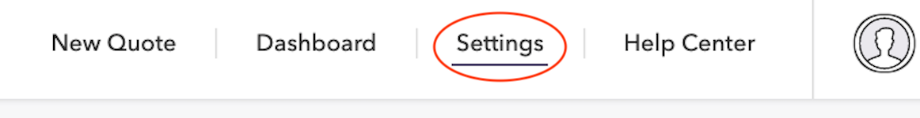
2. Scroll down to the Access Keys section
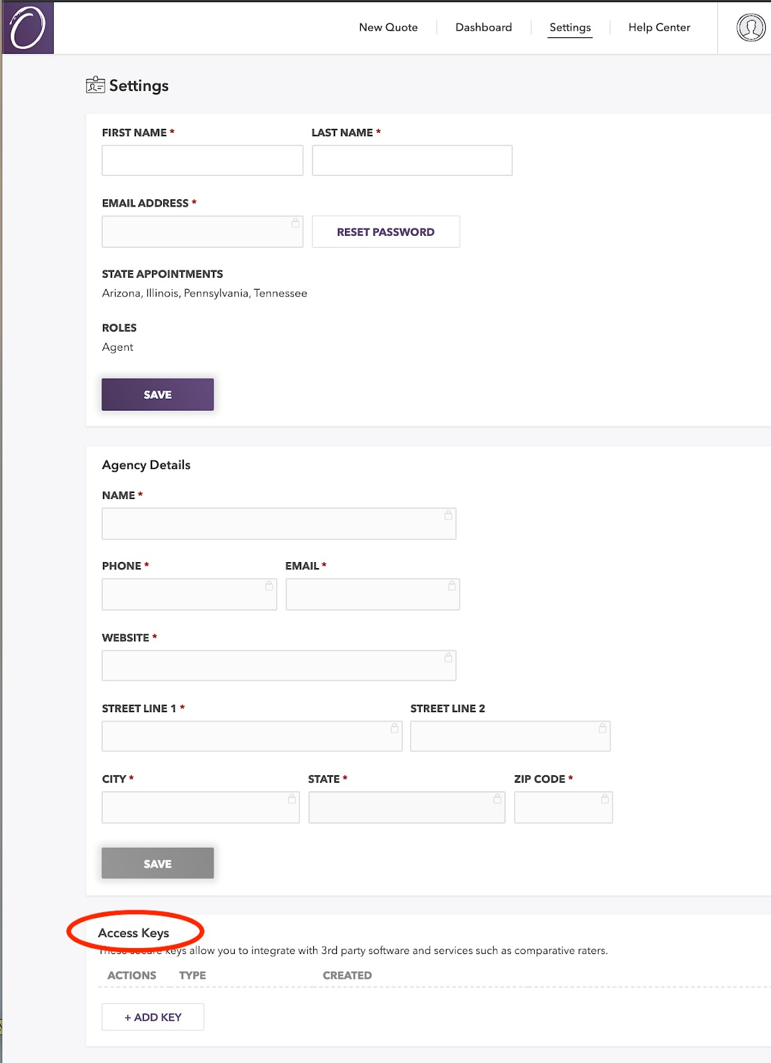
3. Click the +Add Key button
4. A box titled New Key Access should appear. Under Type, select "EZLynx"
5. Click Save
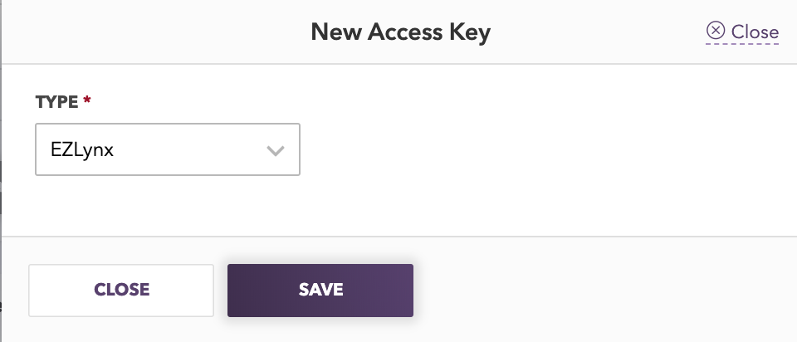
6. DO NOT CLICK CLOSE. You will eventually close this box, but not until you finish the setup process. Copy the key code in the yellow box. This key code will be used in Step 12.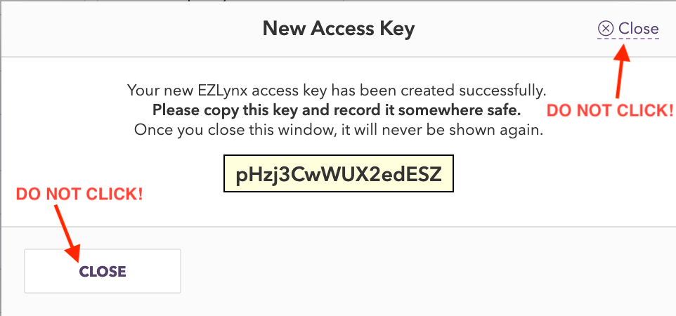
7. Open another window of your web browser and log in to EZLynx.
8. Rest your mouse over the gear icon to display the settings menu.
9. Click on "Carrier Quoting Setup" at the top of the settings menu. (If this picture looks unfamiliar, try this)
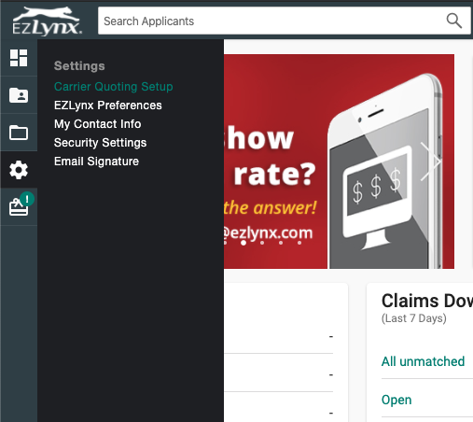
10. You will come to a page titled "Manage Carriers". Find Openly and click on it. 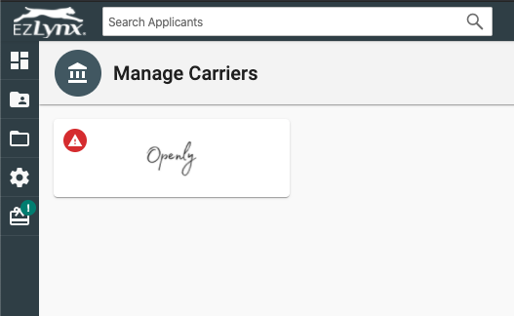
11. Clicking on Openly will bring you to the page below. Enter the email you use to log in to the Openly Agent portal, and paste or enter the Access Key code from step 6. Then click "Save and Test".
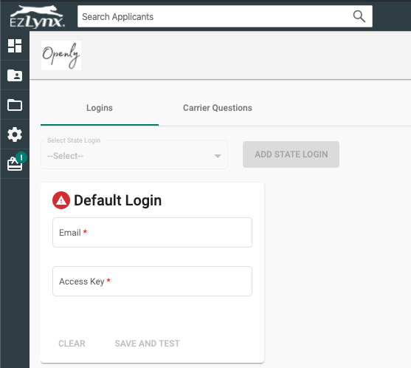
12. You will know the set up was successful when a message at the bottom of the page pops up with the words "Carrier login successful". You may now close the access key code window in the Openly portal.
You are now ready to begin quoting Openly in EZLynx!
Have a question? Please see our EZLynx FAQs or reach out to us via chat, email service@openly.com, or call us at 857-990-9080.

