How to Set up your EZLynx Account with Openly
Please DO NOT use Internet Explorer for this process because the Openly Agent Portal does not support it. We recommend using Google Chrome, Microsoft Edge, Mozilla Firefox, or Safari.
If you have the new version of EZLynx (version 5), go here
Note: steps 6 & 7 are crucial, so please pay close attention!
1. Open up the Settings page within the Openly agent portal at the top of the screen
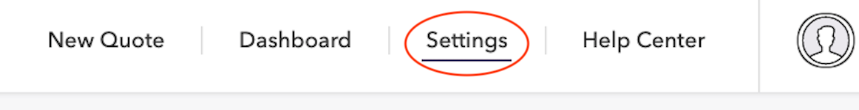
2. Scroll down to the Access Keys section
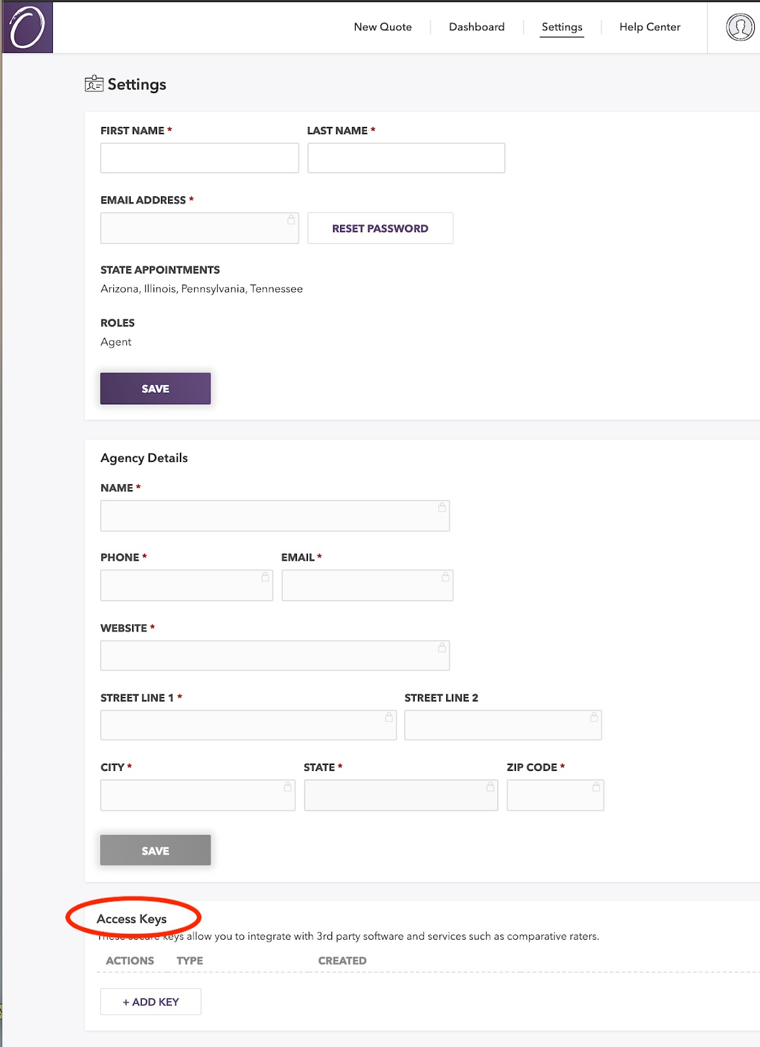
3. Click the +Add Key button
4. A box titled New Key Access should appear. Under Type, select "EZLynx"
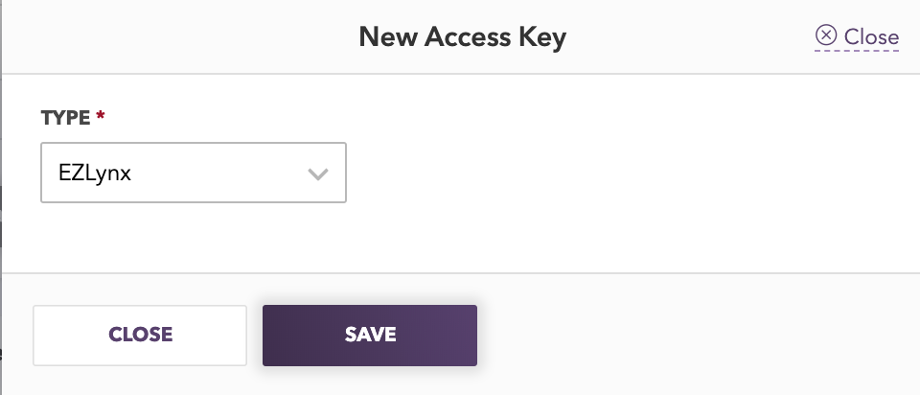
5. Click Save
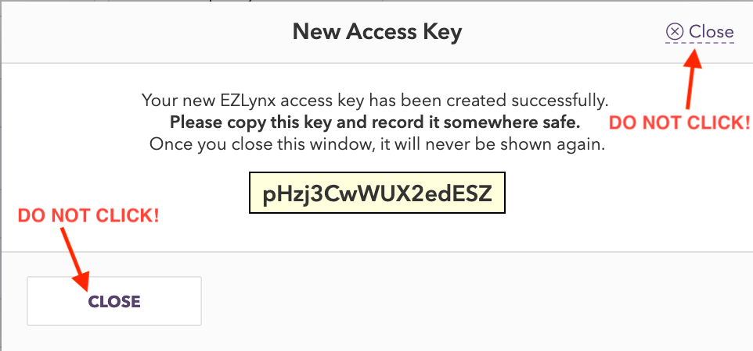
6. DO NOT CLICK CLOSE. You will eventually close this box, but not until Step 13.
7. Copy the key code in the yellow box because this key code will be used in Step 11.
8. In another window of your web browser, log in to your EZLynx account.
9. Navigate to the EZLynx Settings page by hovering over the gear icon on the left-hand side of the tool bar. In the settings menu that appears, click on the first menu option called Carrier Quoting Setup.
10. Under the heading Carrier Name, find Openly Inc and click Set Login. (Note: if this picture looks different than your EZLynx, you may have the new version)
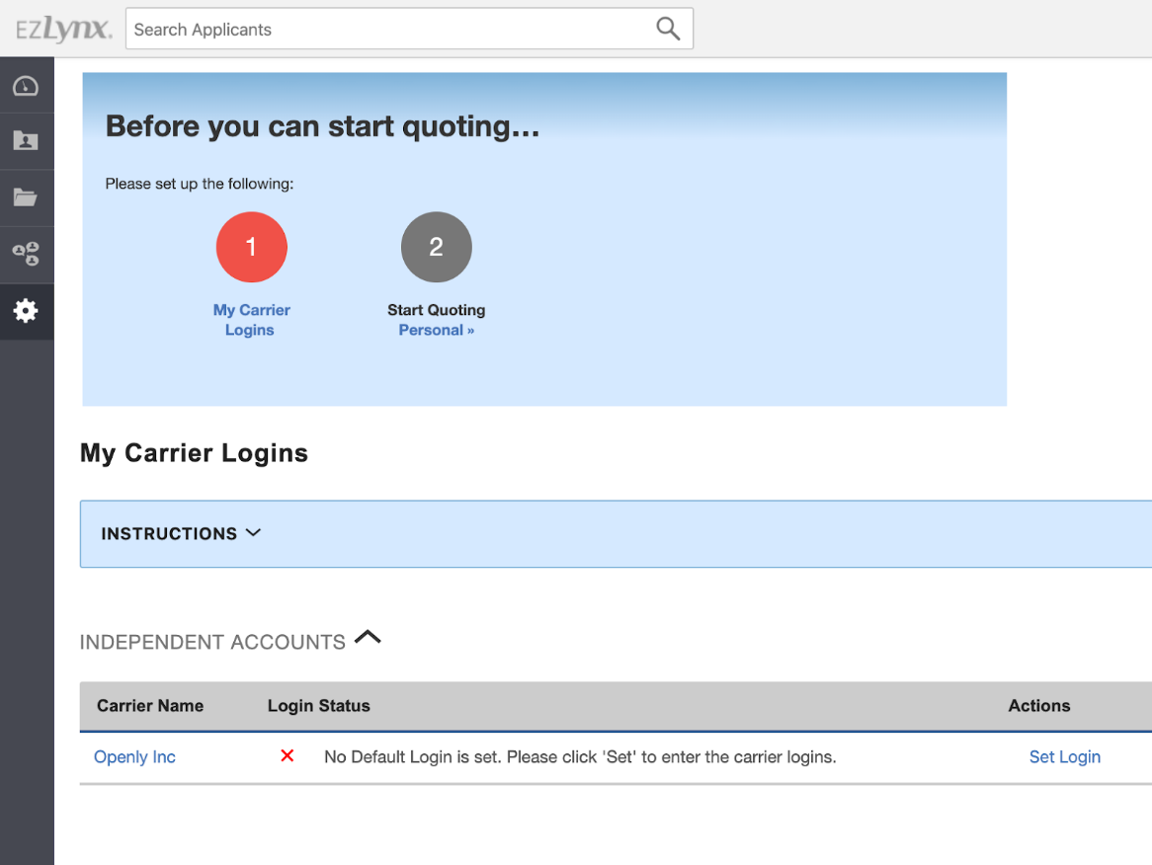
11. A box titled Set Carrier Login should appear. Enter the same email address that you use to log in to your Openly Portal. Paste the key code that you copied in Step 7 into the Access Key field in EZLynx.
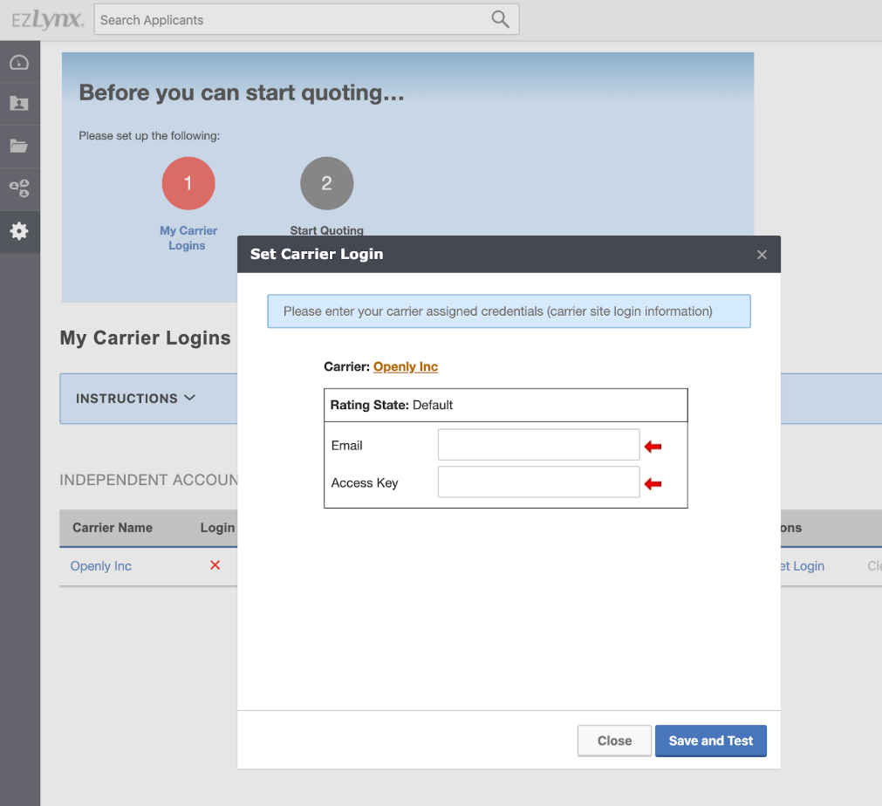
12. Press Save and Test. You should see “paw prints” moving across the screen as your information is being verified.
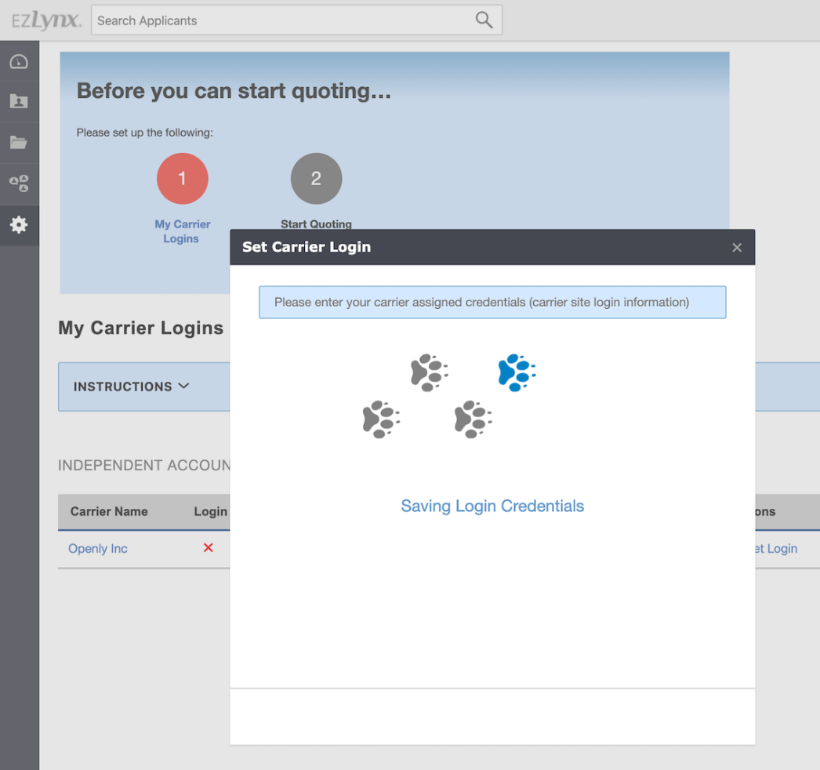
13. After verifying, EZLynx will now display a green check mark under your Login Status.
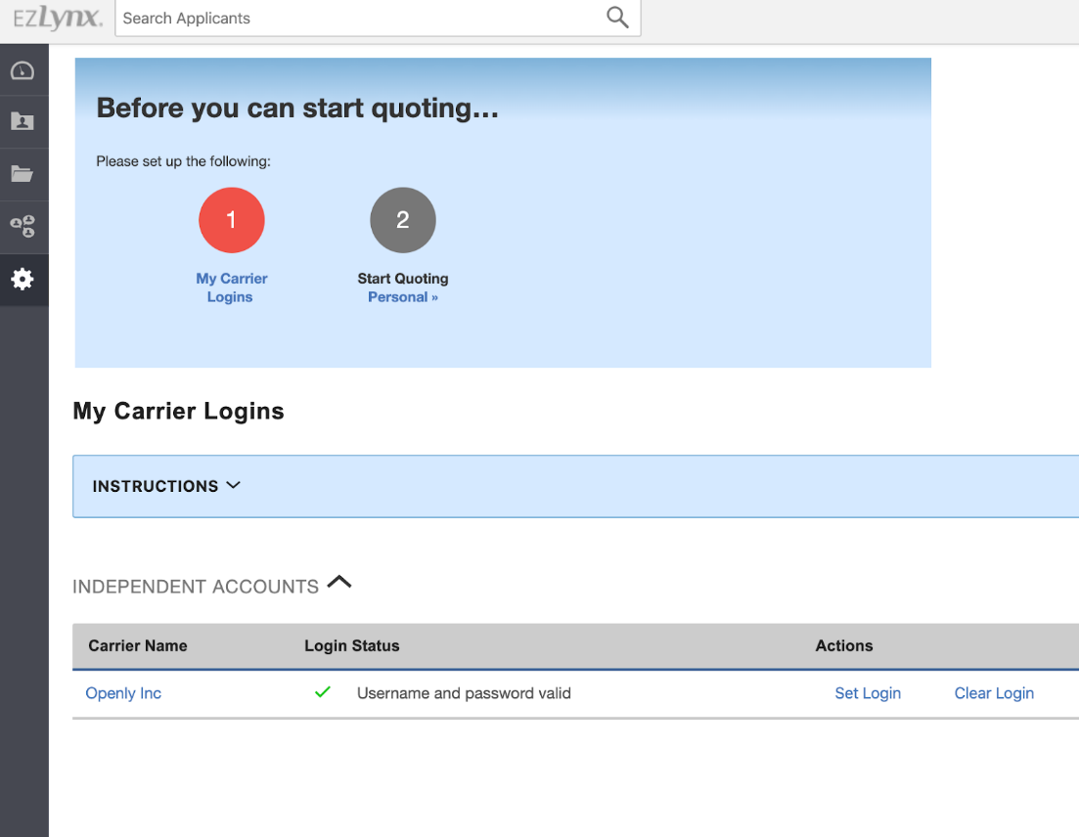
14. Return to the Openly portal and close the New Access Key Box
15. Now you are ready to start quoting :)
Have a question? Please see our EZLynx FAQs. You can also reach out via live chat, email us at service@openly.com, or give us a call at 857-990-9080.

