**Teacher Appreciation – Environmental Portrait**

Due: Tuesday, April 22.

100 points – photo

100 points – write up

**Directions:** Choose a teacher to honor with an environmental portrait. This portrait should capture the teacher in his/her environment and tell a story about what is most important to the teacher. In the past, students have gone to teacher’s homes, met them at a park where they play with their children, photographed them with their most prized possessions, in their gardens, etc. Take over 100 shots in a few locations in order to have a selection to choose from. **Automatic 20 point deduction if the picture is taken at school.**

You should NOT take the picture inside of school.

Your photo should be cropped to a 8 x 10 size. They will be printed, laminated, and hung in the front hallway Monday May 6nd. Save your photo under “Yearbook Drive 2013>Environmental Photo”. No later than **MONDAY APRIL 22ND**( I WILL BE OUT OF TOWN APRIL 24-28TH IN SAN FRANCISCO AT THE JEA/NSPA CONFERENCE AND NEED TO GET THE PICTURES PRINTED BEFORE I LEAVE).

You need to make arrangements with the teacher to take the photograph.

**Write Up:** Accompanying your photograph during Teacher Appreciation Week will be a one page feature story on the teacher. Your story should be in the third person, . Your write up MUST be in GOTHAM LIGHT, 16 point font. Your Headline should be in GOTHAM in ~ 55 point font (should span the entire header).

Rough draft of your feature story on your teacher due Friday, April 19th.

Please edit & spell check your write up. This is a small thank you to all those teachers who allowed us to interrupt their classes throughout the year. Try and choose a teacher that is supportive of our Journalism program!

☺☺☺☺☺☺☺☺☺☺☺☺☺☺☺☺☺☺☺☺☺☺☺☺☺☺☺☺☺☺☺☺☺☺☺

How to Take Environmental Portraits - the Tips:

**Spend time getting to know your subject**

Before you select a location and start shooting, spend some time getting to know your subject. Find out where they spend their time, what the rhythm of their life is like and observing their personality. Out of this you’ll not only find appropriate locations but will begin to get a feel for the style of shots that might be appropriate and you’ll begin the process of helping your subject relax into the photo shoot. If possible it might even be helpful to accompany your subject to some possible locations to see both how they look but also how your subject behaves and interacts there.

**Choosing a Location**

Sometimes a location chooses you (it’s easy) but on other occasions you need to be quite deliberate and purposeful in making your choice (and it can take a lot of searching). When choosing your environment you ideally want to get one that:

* says something about your subject - after all that’s what this style of photography is all about
* adds interest to the shot - as I’ve written in previous tutorials - every element in an image can add or detract from your shots. The environment that you place your subject in needs to provide context and be interest without overwhelming the shot
* doesn’t dominate the shot - sometimes the location can dominate the image so much that it distracts your viewer away from your main focal point (the subject). Try to avoid cluttered backgrounds (and foregrounds), colors that are too bright etc. Keep in mind that you might be able to decrease the distractions with clever use of cropping, depth of field and subject placement.

**Props? – Make sure they are appropriate and help tell the story.**

Props can make or break an environmental portrait. If they are subtle and naturally fit within the context of the environment they can be very appropriate and add to the image nicely but you’ll want to avoid anything that doesn’t quite fit or that potentially distracts the attention of viewers. The same goes for the clothes that your subject wears. Try to be true to the context without getting too outlandish.

**Posing**

What sets the environmental portrait apart from candid portraits is that you post your subject (it’s a fine line and you might end up doing a bit of both in any given shoot). Don’t be afraid to direct your subject to sit, stand or act in a certain way that fits with the environment that you’re shooting in. Some of the poses might seem slightly unnatural and dramatic but it’s often these more purposely posed shots that are more dramatic and give a sense of style to your shot.

The expression on the face of your subject is also very important in environmental photography and you should consider how it fits with the overall scene. For example if you’re shooting in a formal environment it may not be appropriate to have your subject with a big cheesy smile and you might like a more somber or serious look.

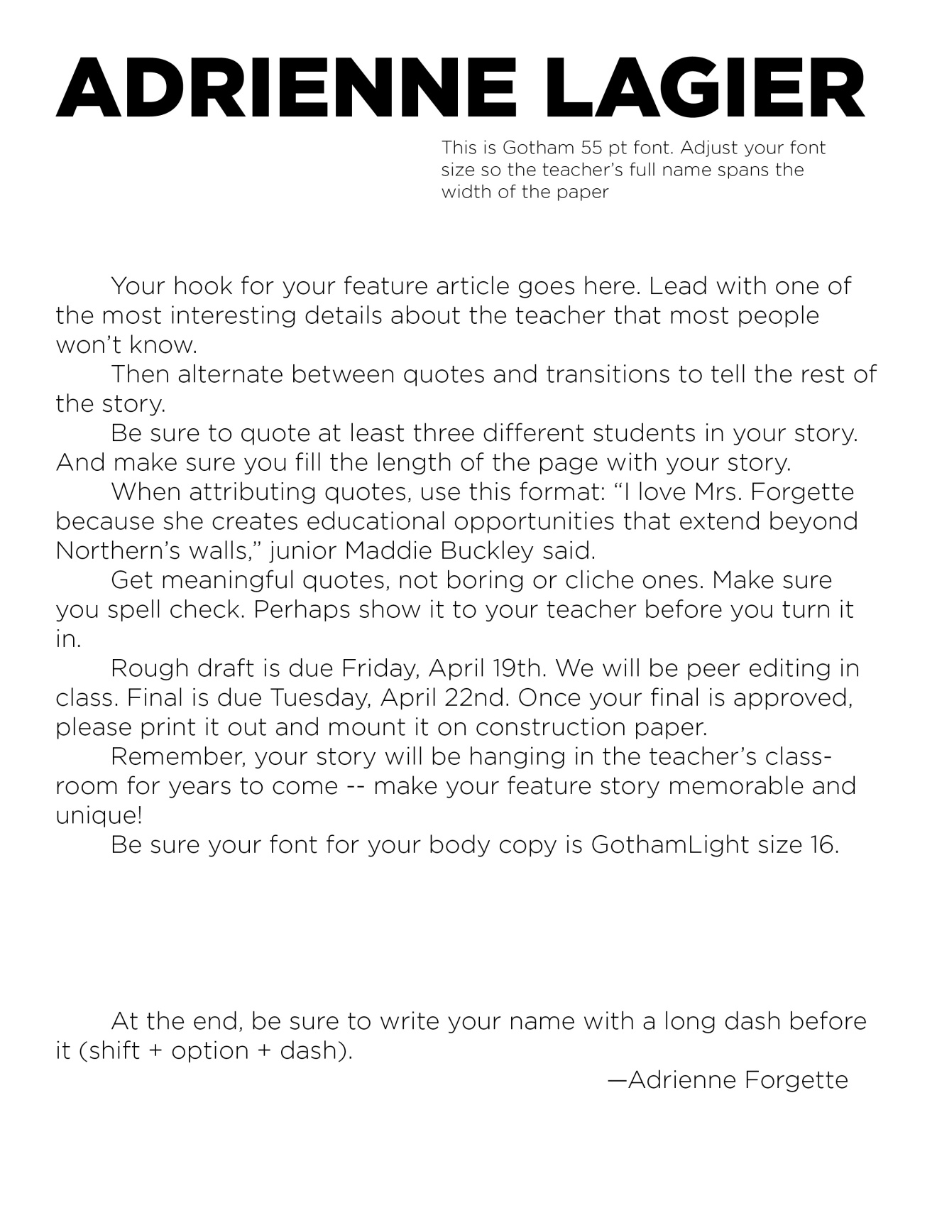

**Name:**

**Name of the Teacher’s story you peer edited:**

**Peer Edit Teacher Appreciation Feature Story**

**30 points**

**Directions:** When I was initially grading your rough draft (as long as you had a full page you got full credit), I found the following errors in multiple stories. It’s your job today as you peer edit to find these errors and point them out to your peers. If any of these errors are found in your final story, 5 points will be deducted for each one and you will have to revise it again until it’s perfect. Remember, your work will be on display and your teacher will treasure your essay forever! Perfect your work.

* Is the header in ALL CAPS?
* Is the header look like this font? ADRIENNE FORGETTE
* Does the hook include interesting information?
* Are all quotes attributed like this: “Quote,” Mrs. Forgette said. (Comma inside the quotation mark, subject verb – and the verb is said – not exclaimed, suggested, etc. Said should not be capitalized.)
* Does it have a MINIMUM of SIX PARAGRAPHS?
* Make sure a new paragraph is started after each quote.
* Are all paragraphs indented FIVE SPACES?
* Is the word YOU anywhere in the essay (other than a quote?) if so, they must take it out – YOU = SECOND PERSON; we want THIRD PERSON.
* Does it overly editorialize in the transitions? (Thank you coach for all of the hard and amazing work you do!) If so – take it out. The quotes are doing the praising, not the student journalist.
* Read all three quotes (are there three? If not, it’s a problem). Do they tell us something about the teacher we don’t already know? Or are they cliché and boring? Tell the writer to get new quotes if they are mediocre.

When you are finished marking up your partners’ papers, count the number of errors. Deduct five points for each one.

What grade would this paper receive if they don’t correct their errors?

__________