CREATING A NEW ACCOUNT
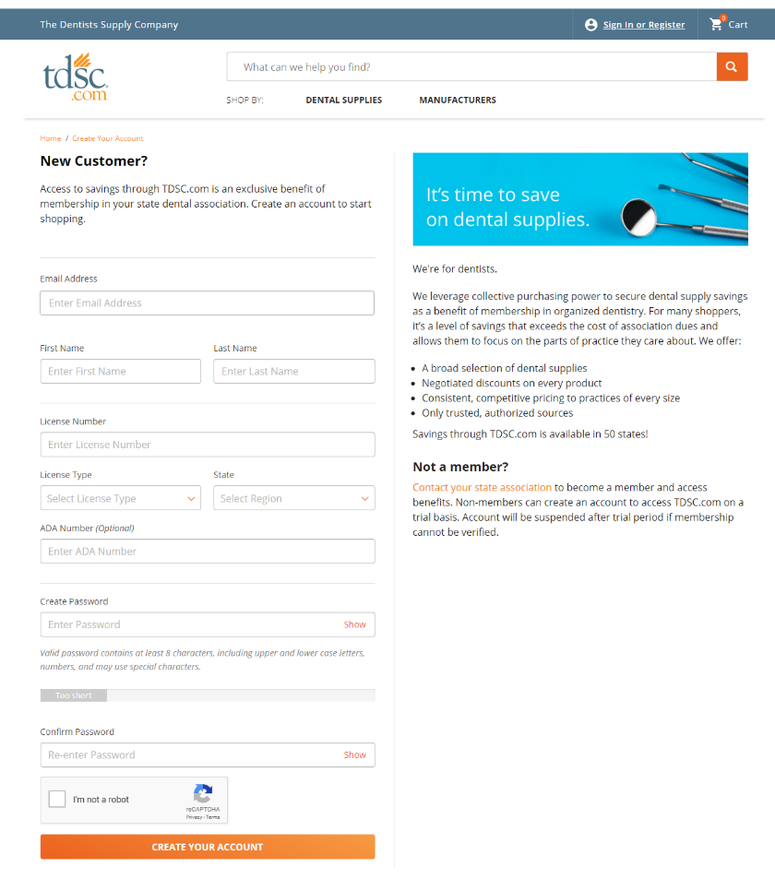
Visit https://www.tdsc.com/b2bregister

Provide the following information:
Email address
First and last name
Dental license number, type and state

Then create and confirm your password and click CREATE YOUR ACCOUNT

Tip! Passwords must contain at least 8 characters, including upper- and lower-case letters, numbers, and you may use special characters

Tip! If you get an error that an account already exists with your email or license number, try using the Password Reset instructions

PASSWORD RESET

Tip! After four failed sign in attempts you will get a warning and after five failed attempts you will be locked out and will have to call customer service to unlock

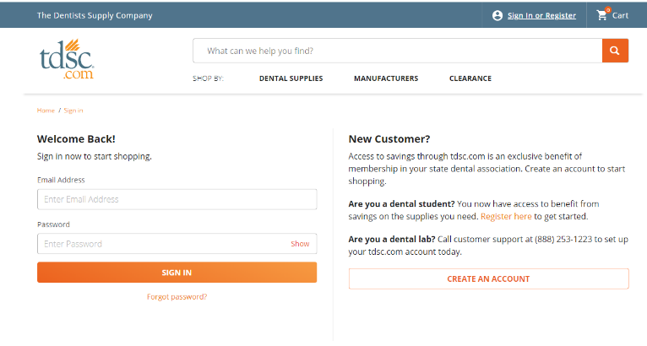
Visit https://www.tdsc.com/signin

Click Forgot Password?

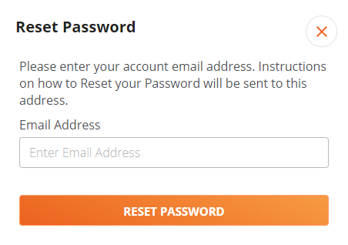
Enter the email address associated with your
TDSC.com account

Instructions on how to reset your password will
be sent to this address

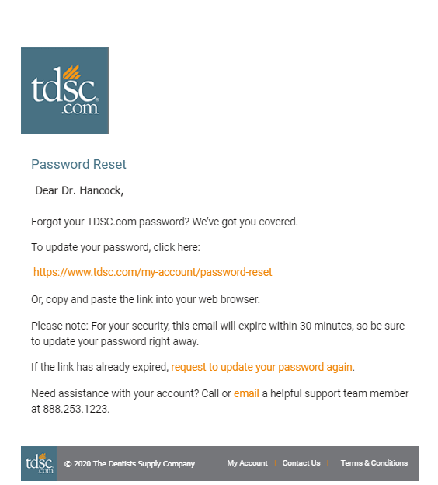

Click the link in the email to reset your
password

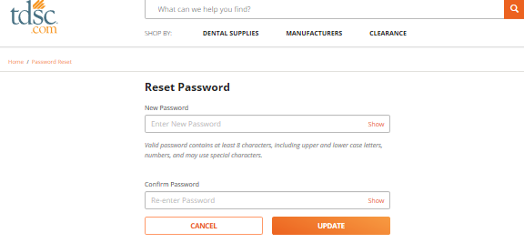
Create and confirm a new password

PLACING AN ORDER WITH LICENSE UPLOAD
Visit https://tdsc.com/p/242348-1

Select ADD TO CART
Note: the max quantity is 1 per dentist per account so anything placed in excess of that will be cancelled

When adding the item to your cart, if you do
not already have one on file, you will be
prompted to add you license.

Click ADD LICENSE

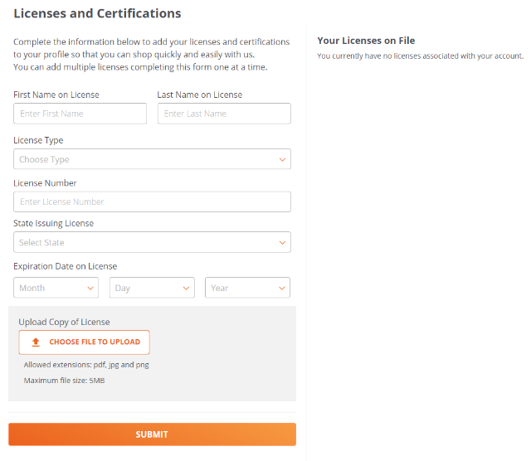
Complete the form and upload an image of
your state-issued dental and click SUMBIT

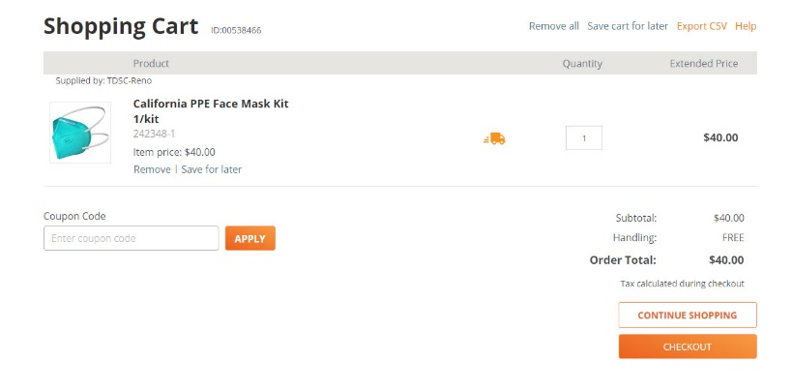
Click the cart at the top of the page to view your cart and complete checkout.

Select CHECKOUT

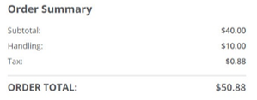
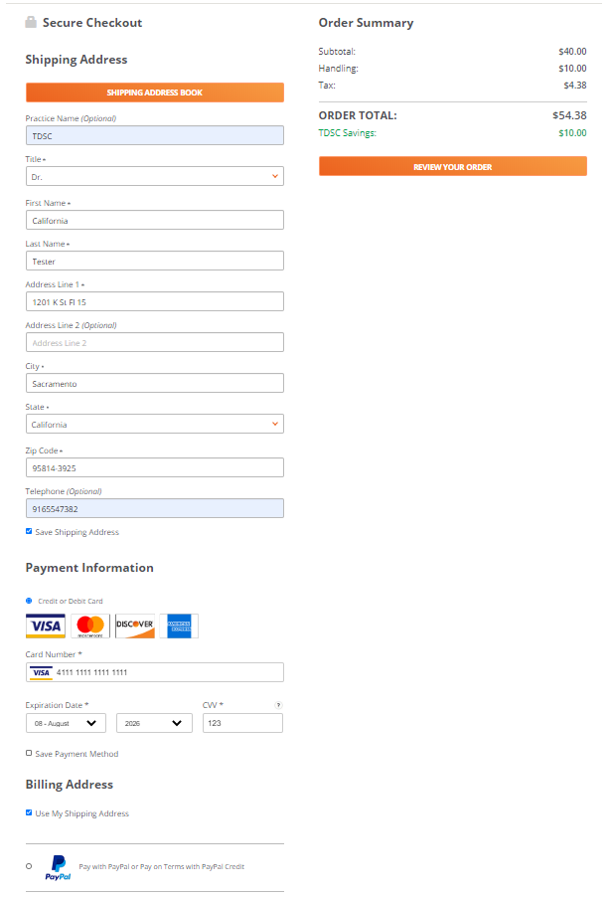

Enter your shipping address, payment information
and billing address

Select REVIEW YOUR ORDER to proceed to final review

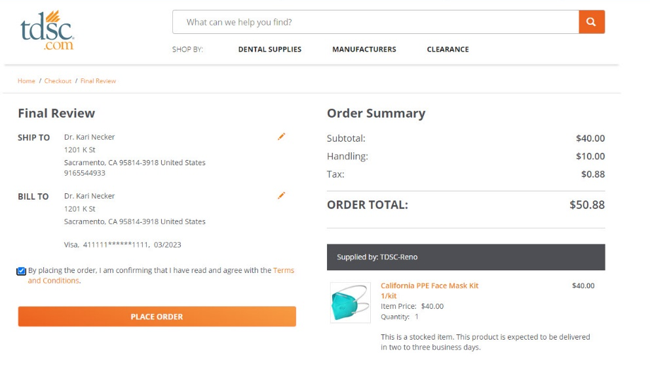
If all looks good, click PLACE ORDER

