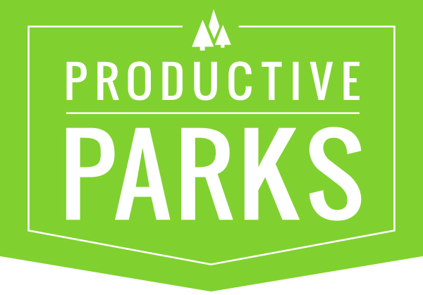

**TASK CATEGORIES AND TASK TYPES**

Define Task Types and Category Types here – What you do.

**Task Categories** /Task Types

* **Building Maintenance (task category)**
  + Window Washing (task type)
  + General Maintenance (task type)
  + HVAC Maintenance (task type)
  + HVAC Preventative (task type)
  + Alarm Maintenance (task type)
  + Annual Service (task type)
  + Appliance Installation (task type)
  + Appliance Repair (task type)
  + Repair (task type)
  + Replace (task type)
  + Electrical Installation (task type)
  + Electrical Maintenance (task type)
  + Elevator Maintenance (task type)
  + Inspection (task type)
* **Equipment Maintenance**
  + Inspection
  + Oil Change
  + Maintenance
  + Repair
  + Replace
* **Event Setup**
  + Special Event Clean-up
  + Special Event Take Down
  + Special Event Maintenance
  + Special Event Setup
  + Tent Set-up
  + Tent Take Down
* **Irrigation**
  + Irrigation Maintenance
  + Irrigation Shut Down
  + Irrigation Controller Repair
  + Irrigation Installation
  + Irrigation Maintenance
  + Inspection
  + Irrigation Repair
  + Irrigation Start Up
* **Athletic Fields**
  + Base Installation
  + Bench Installation
  + Bench Maintenance
  + Bench Removal
  + Field Layout
  + Field Preparation
  + Field Renovation
* **Landscape Maintenance**
  + Mowing
  + Mulching
  + Overseeding
  + Watering
  + Aeration
  + Edging
  + Repair
  + Replace
  + Removal
  + Maintenance
  + Inspections
  + Sign Maintenance
  + Bed Edging
  + Bed Preparation
* **Playground Maintenance**
  + Play Area Audit
  + Playground Installation
  + Playground Maintenance
  + Playground Safety Surface Maint.
  + Playground Swing Maintenance
* **Snow Duty**
  + Snow Plowing
  + Snow Removal
* **Trail Maintenance**
  + Path/Trail Maintenance
  + Pavement Maintenance
  + Prescribed Burning
  + Pest Control
  + Pesticide Application
* **Trash/Cleanup**
  + Litter Removal
  + Empty Trash
* **Tree Maintenance**
  + Tree Planting
  + Tree Removal
  + Tree Transplant
* **Turf Maintenance**
  + Mowing
  + Mulching
  + Overseeding
  + Watering
  + Aeration
  + Edging
  + Repair
  + Replace
  + Removal
  + Maintenance
  + Top Dressing
  + Inspections
* **Vehicle Maintenance**
  + Inspection
  + Oil Change
  + Maintenance
  + Repair
  + Replace