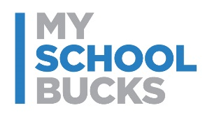
School or Program Logo

Pay for school meals online

[Date]

[First Name] [Last Name]
[Address Line]
[City], [State] [Zip]

To the parents of [Student Name],
Easily pay for school meals online this year! Create your free MySchoolBucks account to conveniently and securely add money to your student’s meal account online or with the mobile app.
With MySchoolBucks you’ll be able to view cafeteria purchases, check your student’s balance, receive low balance alerts and pay for school meals from anywhere!
Get Started Today:
- Go to myschoolbucks.com or download the mobile app
- Create your free account and add your students using their school name / student ID
- Add funds using your credit / debit card or electronic check
Note: For each transaction, you will be charged a program fee of [AMOUNT]
- Set up automatic payments and never forget to send in lunch money again
We appreciate you using this online option as a way to help reduce the amount of physical cash and check handling that would typically happen in the serving line.

If you need assistance with your account, you can find helpful how-to videos and answers to commonly asked questions by visiting myschoolbucks.com. Or, you can contact MySchoolBucks directly by logging into your account to start a chat conversation or give them a call at (855) 832-5226.
Thank you,
[Your school]

