Scanco SkyPrint

Label Printing, Configuration and Design
Table of Contents
Label Printing Process 2
Printer Icon 2
When you press the Printer icon 3
Label Quantity Prompt 4
Printer Prompt 5
Label Prompt 5
SkyPrint Configurator Utility 6
Print Q and Settings Tab 6
Services and Printers Tab 7
Users and Warehouses Tab 8
Users Labels 8
Warehouse Labels 8
Substitutions Tab 10
Keyboard Prompts 11
Label Designer 12
Designing Labels 15
Starting a New Label 16
How to Create this Label in less than 2 Min 19
GS1 Barcodes 20
Prerequisites 20
Register your GS1 20

Label Printing Process

Printer Icon
The printer icon is the button you will press to enable printing. Once printing is enable, print will remain enabled each time you enter the program until you touch the Printer icon to turn printing off.

The Printer icon can always be found in the menu. | The Printer icon is displayed on the top bar when space permits displaying the icon.
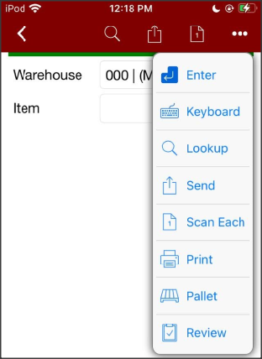 | 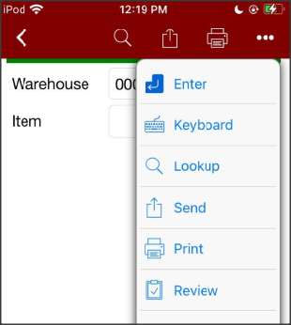

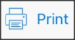  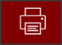 | These examples of the Printer icon show printing is either off or in Manual mode.
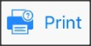  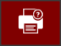 | These examples of the Printer icon show printing is either in Automatic mode or Prompt for number of labels to print mode.

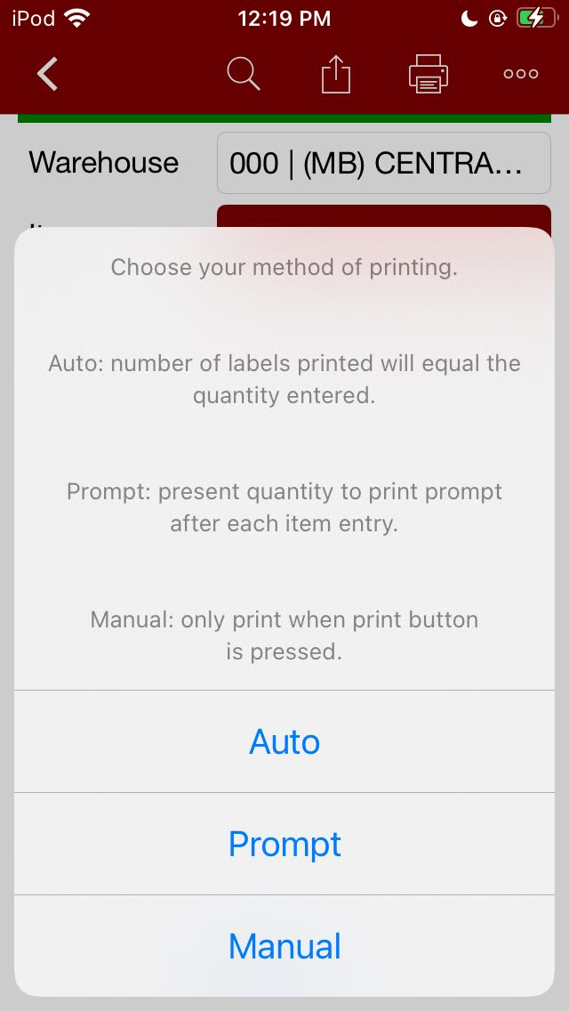
When you press the Printer icon you will be prompted for ‘Method of Printing’.

Auto
The quantity collected at the Quantity prompt will be used at the quantity of label to be printed. This method turns the Print button green.

Prompt
The user will key in the quantity of labels for each entry. This method turns the Print button green.

Manual
Once this option is chosen the user must press the print button after quantity entry whenever a label is required. This method turns the Print button gray.

Label Quantity Prompt
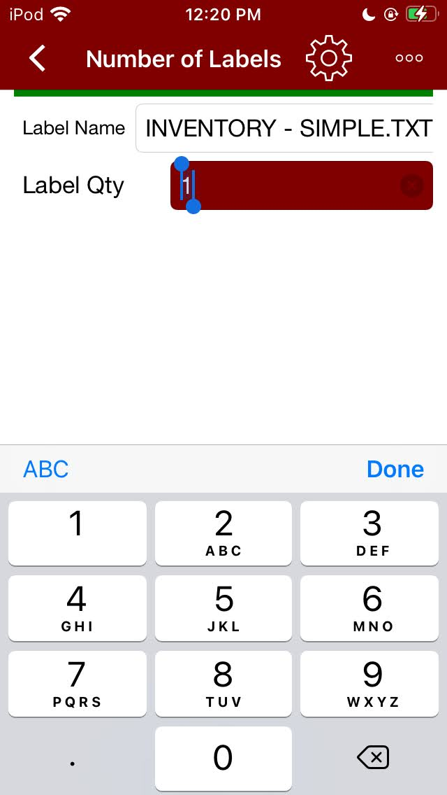
Printing can be finished by entering in the quantity of labels required and pressing ‘Done’
Gear icon
If you press the Gear icon you can [depending on your setup] change the printer and\or label design.

Printer Prompt  If you have pressed the Gear icon during printing and you have more than one printer available for printing, you need to chose the desired printer. | Label Prompt  If you have pressed the Gear icon during printing and you have more than one label design available for printing, you need to chose the desired label design.
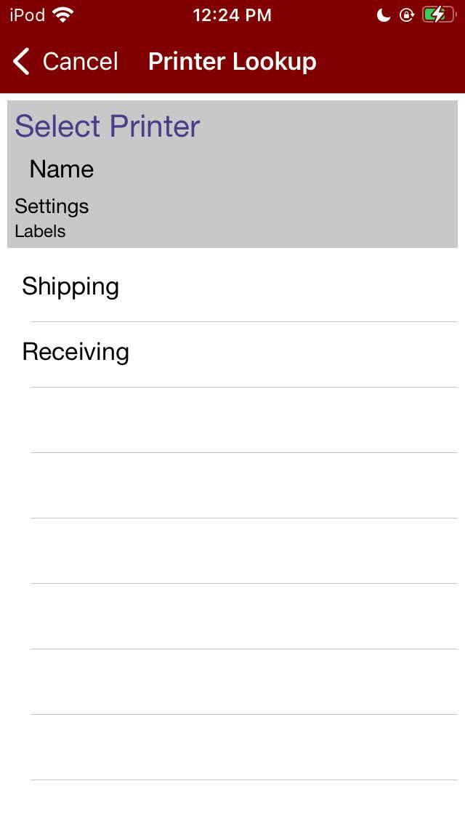 | 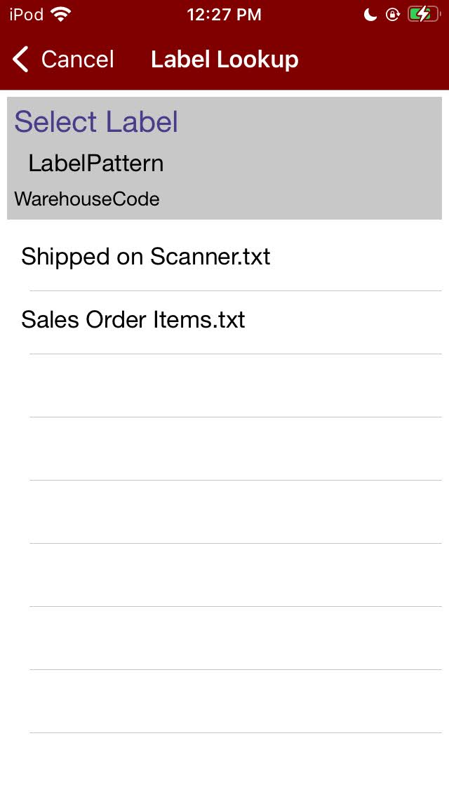

SkyPrint Configurator Utility

Print Q and Settings Tab
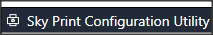
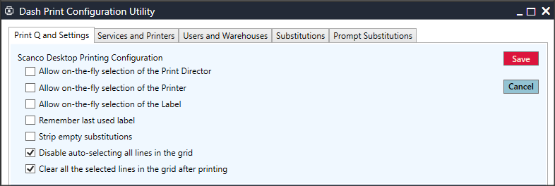
The first four checkboxes are for Scanco Skyprint
Strip Empty Substitutions (Checkbox):
This option removes the entire line of text from the design file whenever there is no data to be printed.
Example:
$LotSerialNo$ is a part of the design for a barcode.
If there is no LotSerialNo to display from the data, this option will remove $LotSerialNo$ and the label wont result in a bad barcode when it is read by the scanner.
Disable Auto-Selecting (Checkbox):
When disabled, all rows in the grid will be white and the user can selectively choose each row using their SHIFT or CTRL + mouse clicks.
When enabled, all rows will be blue and highlighted.
Clear All After Printing (Checkbox):
This option, when enabled, will deselect all rows after printing completes.

Services and Printers Tab
On this tab, you will be able to enter the ConnectIt director in order to print from the server to any printer on your network by using directors and printers.
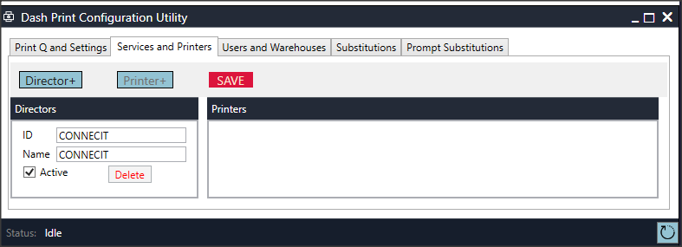
Press ‘Director +’ button to add a ConnectIt director to your services.
(This is how you will be retrieving data to print.)
Press ‘Printer +’ button to add a printer to your director.
(This can be one of many printers your director can reference from.)
Printer Delay Options
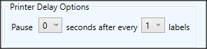
Printer delay allows for you to alter the time intermittence between each label.
X # of seconds after ever Y # of labels
This can help facilitate lengthy printing processes.

Users and Warehouses Tab

Users Labels
Users labels section is used to set up a printer on the network.
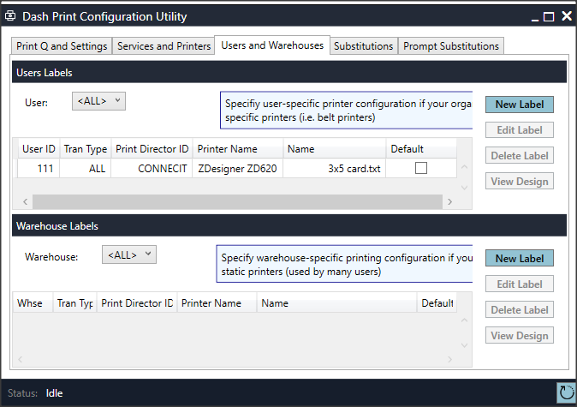

Warehouse Labels
Warehouse labels section is for Scano Skyprint printing from the hand-held scanners.

‘New Label’ Button
Pressing the ‘New Label’ button in either User or Warehouse Labels area, will bring up the window below.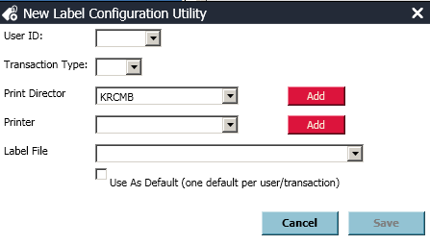
User Id: Determines which user(s) are able to use this label.
Transaction Type: Specifies what type of label.
- Purchase/Sales orders
- Inventory
- Pallet
- Manufacturing
- All
Print Director: Choose which ConnectIt customer becomes Director.
Printer: Receiving or Shipping.
Label File: Choose the label from a drop down list.
Use as Default: If checked, SkyPrint always uses this set up.
‘Add’ Button: Allows user to create new print director via their MAC address and Scanco customer code.

Substitutions Tab (Printing Data Not in the Grid)
Prerequisites
This is an advanced setup process!
Understanding of Sage Tables and SQL statements will benefit you greatly in this area. This program gets data from as many tables as needed if each table has at least one field that matches those in the grid.
Example:
PO_header has VenderNo, but does not have VendorName.
You need to print VendorName on the label, so you write an SQL statement into DashPrint Configurator to get the data. Here’s what that select statement would look like:
SQL Statement to gather data from AP_Vendor:
SELECT VendorName FROM AP_Vendor WHERE VendorNo = (SELECT DISTINCT VenderNo FROM PO_PurchaseOrderHeader WHERE PurchaseOrderNo = '$PurchaseOrderNo$')
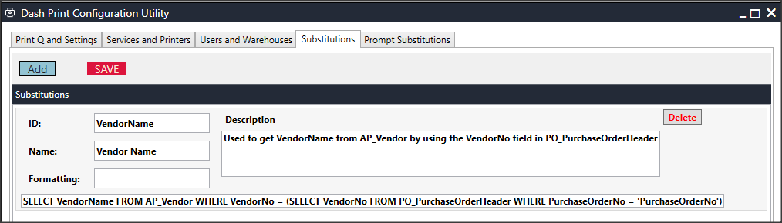
SQL Statement to print Julian Dates:
SELECT TOP 1 ((({FN YEAR({FN CURDATE()})}-2000) * 1000) + {FN DAYOFYEAR({FN CURDATE()})}) AS JULIANDATE FROM CI_ITEM

Keyboard Prompts Substitutions Tab
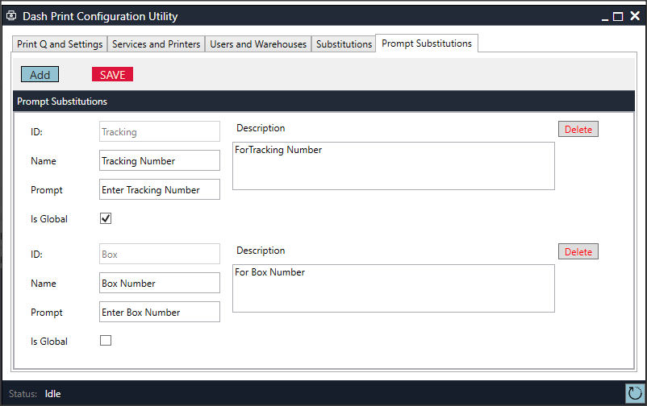

Global
Above, you’ll see that the ID field “Tracking” has the ‘Is Global’ checkbox enabled.
This means whatever is entered into the prompt field, located just below the name, will be printed on every label during the printing process.
The label design sub for this example would be: $Tracking$
Per Item
Above, you’ll also see the ID field “Box” has the ‘Is Global’ checkbox disabled.
This means whatever is entered into the prompt field will print for every label for only the item that it is displayed for.
The label design sub for this example would be: $Box$
Extended Description Sub
$ITEM_DESC_EXTENDED$

Label Designer
The Label Designer button is in the upper right corner.
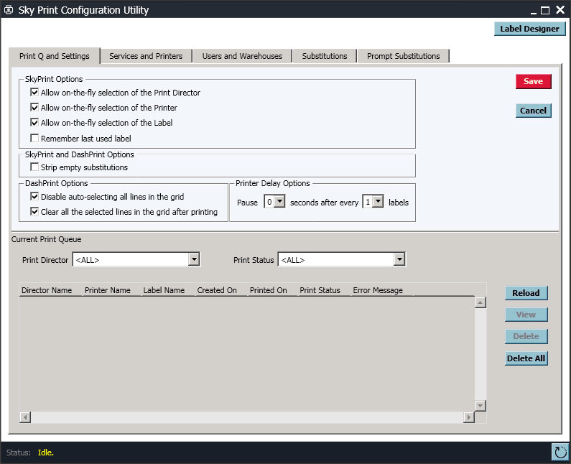

File Menu
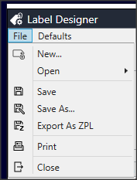
New
Creates a new label.
(It will first ask for label name.)
Open
Search for and open an existing label file.
Save/Save As…
Save over existing design.
Save As a new design.
Export as ZPL
Converts XML file format to ZPL (Zebra Print Language) as a text file.
Print
Used to print or test your design on a printer.

Defaults Menu
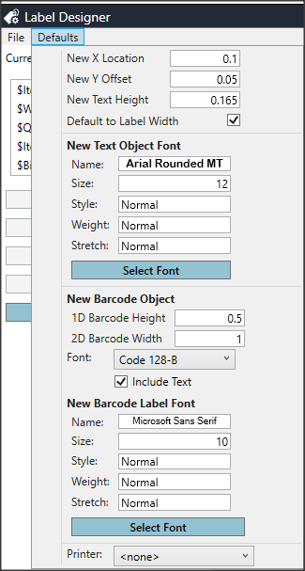
New X Location
Measurement from the left-edge.
New Y Offset
Measurement of spacing between elements as they are added.
New Text Height
Measurement of height for each element as they are added.
Default to Label Width
Should be enabled so data, such as, Item Description can print across the entire label.
New Text Object Font
Sets up defaults for all fonts.
New Barcode Object
Sets default height for 1D and 2D barcodes and chooses the default barcode type font.
New Barcode Label Font
Pressing ‘Select Font’ sets up all defaults for the human readables that can be printed below barcodes.
Printer
What you enter here will be the printer that is used by the system when you are finished with your design. This can be changed after you save.

Designing Labels
The current label is displayed at the top-left, just below ‘File’.
Design as text checkbox is used to see the print language ZPL (Zebra Print Language) and design your label using their standard convention.
Substitution Fields
The Substitution Fields on the left-hand side of the design menu hosts the label substitution codes.
These sub codes are used when designing a label to allow for the system to gather and display the desired information.
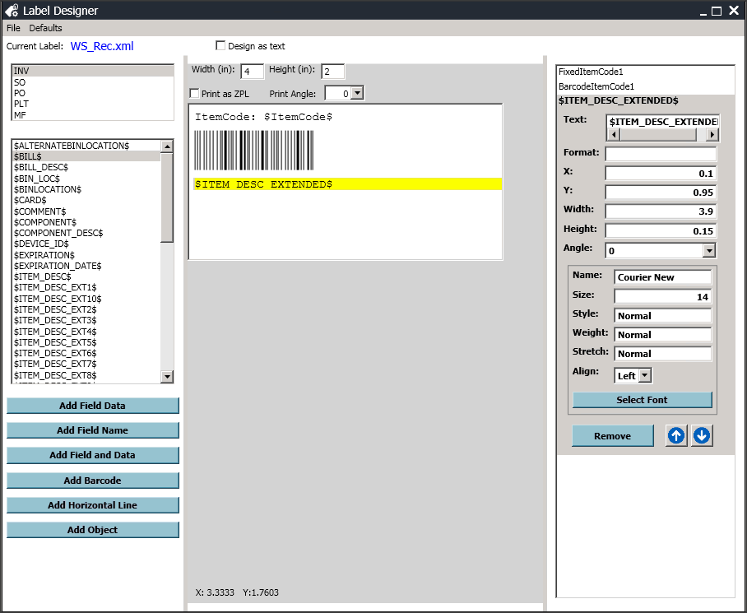

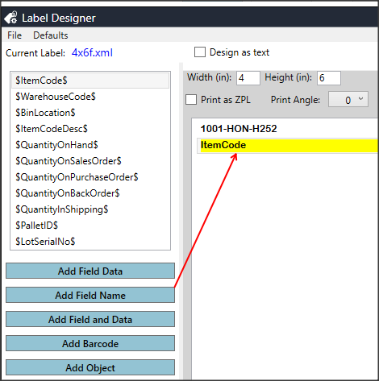
Starting a New Label
To add a field to your label, click on a desired field to display from the left-hand side menu area, and press the ‘Add Field Data’ button.
Click ‘Add Field Name’ to add the name of the field to the label.

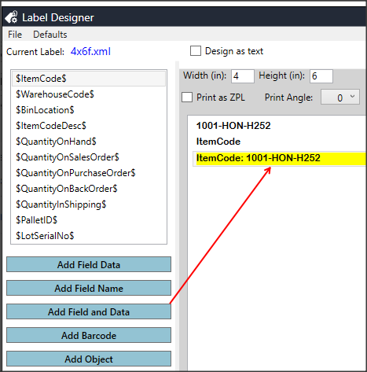
Click ‘Add Field and Data’ to add the field name, as before, but to also add the item code along with it.

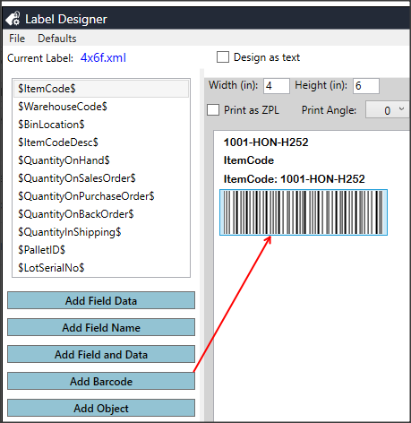
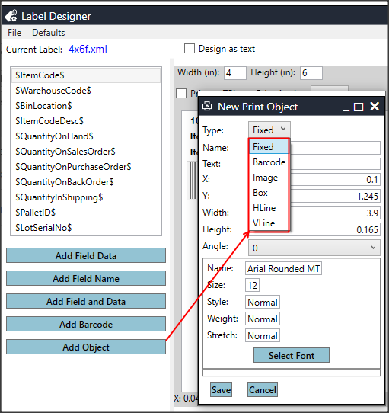
Adding a barcode to your label is as simple as clicking the ‘Add Barcode’ button.
Click ‘Add Object’ to create a static item that will print on every label.
Object Types:
Fixed
Includes text that is static to your label
Barcode
Creates a fixed barcode that you can edit the dimensions for.
Image
Allows you to search your local computer to add an image to your label. Ex: company logo
Box
Creates a box with the dimensions of Width and Height at the ‘X’ and ‘Y’ coordinates.
HLine
Creates a horizontal line on your label
VLine
Creates a vertical line on your label
Incrementally edit and adjust your objects via the following fields:
- Name (strictly for the designer to help you locate various elements)
- Text (Visible text to display)
- X coordinate
- Y coordinate
- Width
- Height
- Angle (360*)

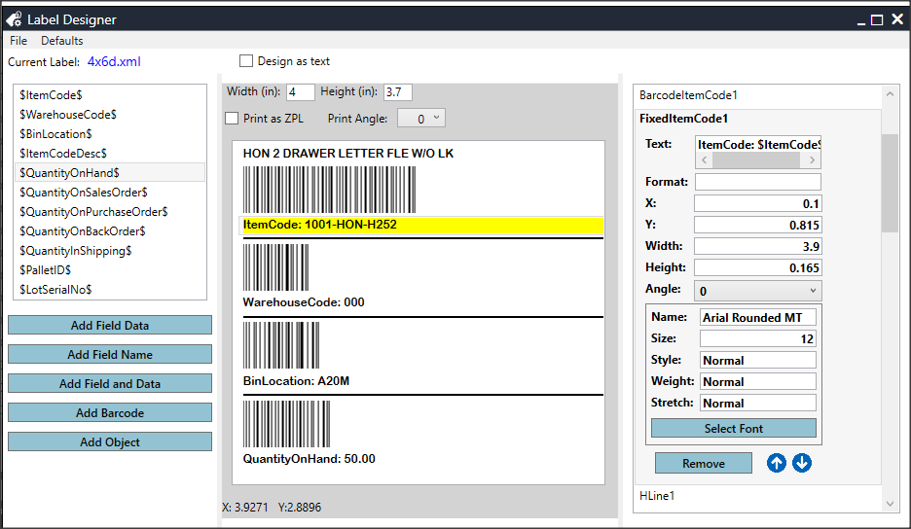
How to Create this Label in less than 2 Min
- Choosing the $ItemCodeDesc$ field and pressing the ‘Add Bound Column’.
- Choosing the $ItemCode$ field and pressing the ‘Add Barcode from Bound’ and then ‘Add Fixed Text and Bound’.
- Pressing the ‘Add Object’ and choosing ‘Hline’.
- Choosing the $WarehouseCode$ field and pressing the ‘Add Barcode from Bound’ and then ‘Add Fixed Text and Bound’.
- Pressing the ‘Add Object’ and choosing ‘Hline’.
- Choosing the $BinLocation$ field and pressing the ‘Add Barcode from Bound’ and then ‘Add Fixed Text and Bound’.
- Pressing the ‘Add Object’ and choosing ‘Hline’.
- Choosing the $QuantityOnHand$ field and pressing the ‘Add Barcode from Bound’ and then ‘Add Fixed Text and Bound’.

GS1 Barcodes

Prerequisites
Creating GS1 barcodes can be done in DashPrint Label Designer.
GS1 Standard requires item code data being 14-characters long.
Register your GS1 product here at US-Authentic Barcodes.

Design Process
Designing an XML file is the simplest process for designing a GS1 barcode in Dashprint’s Label Designer. Below are the prefixes that can be used during scanning.
- – “Item Code”
- – “Lot”
- – “Expiration Date”
- – “Serial”
- – “Quantity”
- – “Line Key”
- – “Alias Item Code”
- – “Weight in KG”
- – “Netweight in LB”

The programming requires a tilde (~) to be added before each GS1 prefix in order for the GS1 to be scanned properly. Remove the tildeto create a human readable barcode.

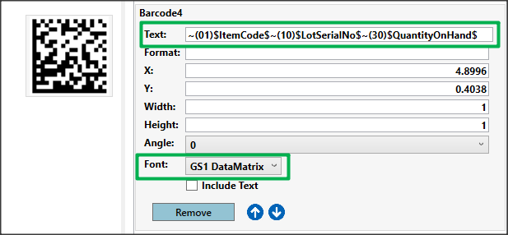
Example 2D Barcode:

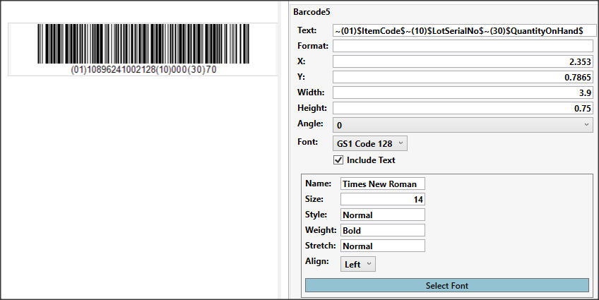
Example 1D Barcode:

Design as Text (Checkbox)
Used to see proper print language ZPL (Zebra Print Language)
Example: This process requires another program that generates said print language and should only be attempted by users that are familiar and have experience with ZPL.
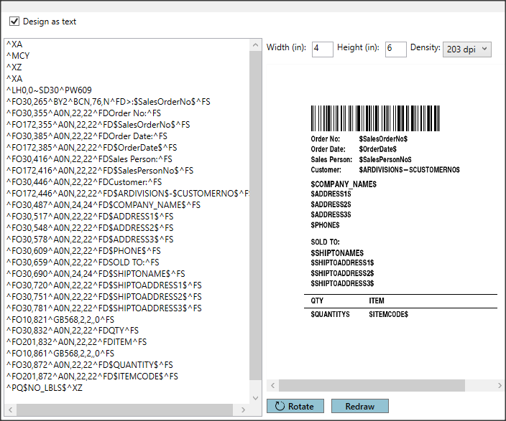
Zebra GS1 Examples
2D GS1 Barcodes MUST Have _1 BEFORE Each Prefix
^FO300,750^BXN,9,200,20,20,,_^FD_101$ItemCode$10$LotSerialNo$_130$QuantityOnHand$^FS
1D GS1 Barcodes MUST Have >8 BEFORE Each Prefix
^BY2^FO63,123^BCN,088,Y,Y,,D^FD>8(01)$ItemCode$>8(10)$LotSerialNo$>8(30)$QuantityOnHand$^FS
Human Readable
^AAN,27,12^FO55,245^FD(01)$ItemCode$(10)$LotSerialNo$(30)$QuantityOnHand$^FS

Formatting
Currency: Enter ‘C’ into the format prompt.
Example: If data = 1.23456, the program will print = $1.23
Dates:
- dd – day of the month (i.e 01 – 31)
- dddd – day spelled out (Wednesday)
- MM – month number (ie. 01 – 12)
- MMM – month name abbreviated (Mar)
- MMMM – month name spelled out (March)
- yy – year with two-digits (20)
- yyyy – year with four-digits(2020)
- hh – the hour of day (01 – 12)
- HH – the hour of day (00 – 23)
- mm – the minute of the hour (00 – 59)
- ss – second of the minite (00 – 59)
- tt – shows AM or PM
- d – MM/dd/yyyy

Format Samples:
Formatting | Output
dd/MM/yyyy | 21/03/2018
dd/MM/yyyy, hh:mm:ss | 21/03/2018, 11:36:14
dddd, MMMM dd, yyyy | Wednesday, March 05, 2018
MMM dd yyyy | Mar 21 2018
MM.dd.yy | 03.21.18
MM-dd-yy | 03-21-18
hh:mm:ss:tt | 11:36:14 AM
d | 3/21/2018

