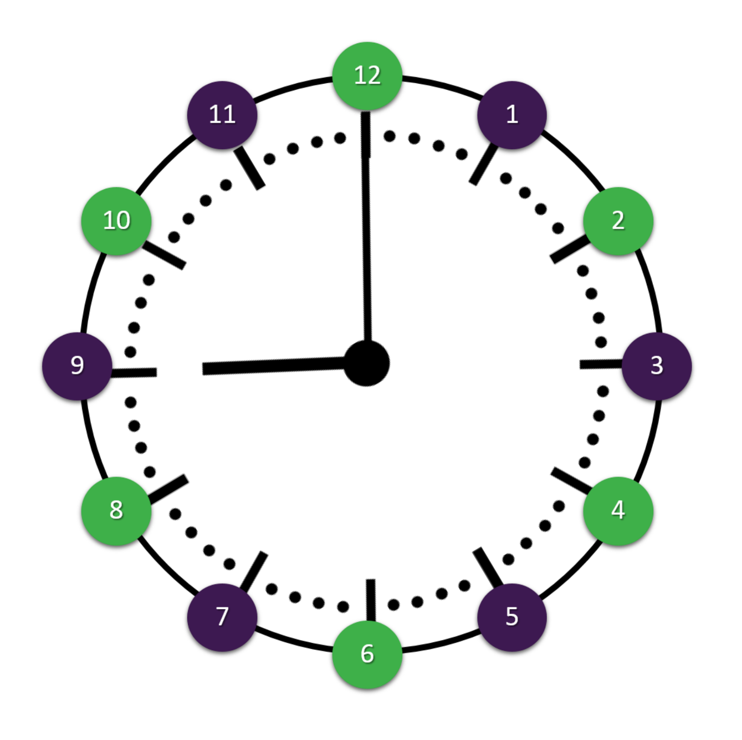

[www.BrianSmithGroup.com](http://www.BrianSmithGroup.com)

**11:00 Insert Title Here**

Insert details here.

**10:00 Insert Title Here**

Insert details here.

**9:00 Insert Title Here**

Insert details here.

**8:00 Insert Title Here**

Insert details here.

**7:00 Insert Title Here**

Insert details here.

**6:00 Insert Title Here**

Insert details here.

**5:00 Insert Title Here**

Insert details here.

**4:00 Insert Title Here**

Insert details here.

**2:00 Insert Title Here**

Insert details here.

**3:00 Insert Title Here**

Insert details here.

**1:00 Insert Title Here**

Insert details here.

**12:00 Insert Title Here**

Insert details here.