Cleaning guidelines – cleaning supervisors
All cleaning supervisors must follow the below COVIDSafe cleaning guidance to help prevent the introduction of coronavirus (COVID-19) in the workplace.

Storage
Cleaning products
Routine cleaning should be performed using a detergent. A disinfectant is only required to be used if there has been
a confirmed coronavirus (COVID-19) workplace member or for high touch surfaces in a high activity area.

Training
Ensure all cleaning staff have been trained to safely use the cleaning products and equipment, personal protect equipment and support any changes in cleaning schedules.

Monitoring
Completion checks should
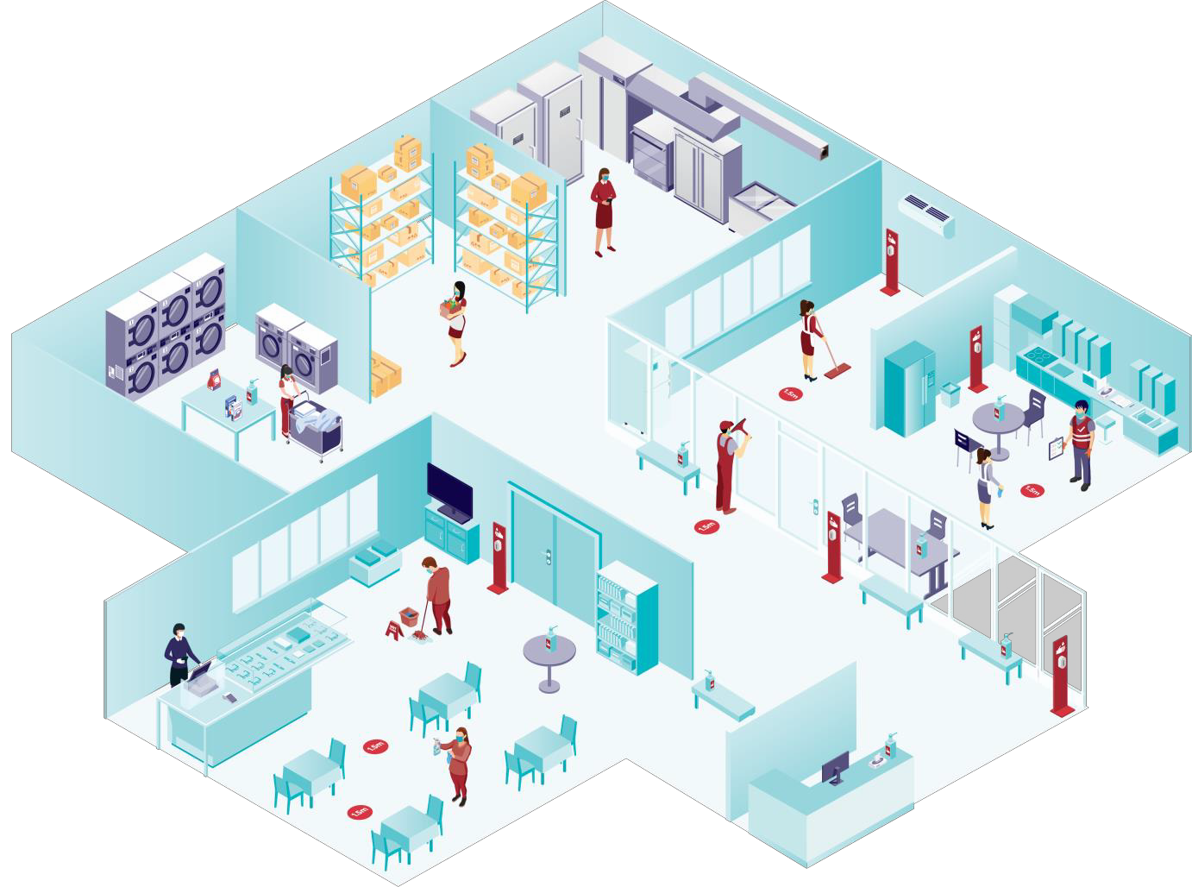be performed weekly to ensure daily/weekly/monthly duties have been completed in line with
the cleaning schedule and/or

Ensure clean environment is maintained in cleaners' room and laundry areas.
contractual agreement.

For the latest information on cleaning guidance, visit
0 coronavirus.vic.gov.au

OFFICIAL

Equipment
Provide the right equipment and products to enable best practice cleaning to be performed, which includes equipment maintenance.

High touch points
Hygiene tips for workers
- Stay home if you are sick.
- Avoid touching your eyes, nose or mouth.
- Take care when removing gloves. Ensure you wash your hands after removing them.
- Maintain physical distancing when travelling to and at work.
- Masks to be worn and changed after 4 hours of continuous use or when moist and/or visibly soiled.
Identify high touch surfaces and clean them first with a clean cloth (e.g. door handles and common-use tables).

