Cleaning guidelines – cleaning workforce
All cleaning workers must follow the below COVIDSafe cleaning guidance to help prevent the introduction of coronavirus (COVID-19) in the workplace.

PPE
Ensure you wear the right Personal Protective Equipment (PPE) for the task and understand how to put on, wear and take off your PPE safely.

Cleaning products
Do not mix the cleaning chemicals you use – they can counteract each others’ effects. Use correct product as instructed and carry out duties safely and effectively.

Training
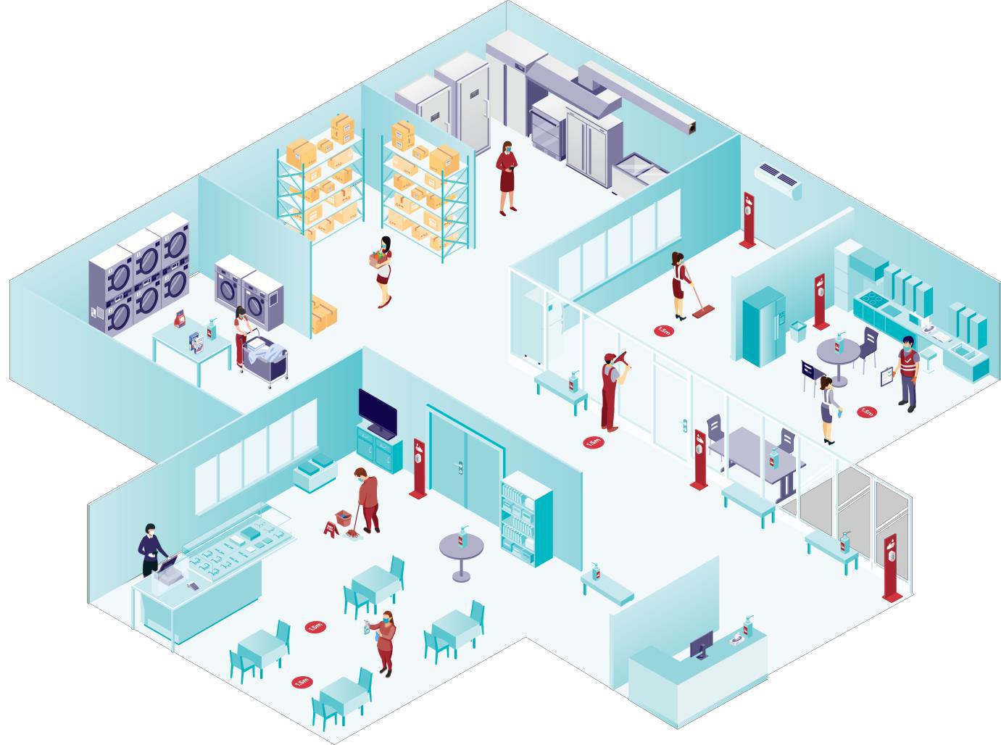Complete induction training in workplace health and safety and basic cleaning skills for site specific duties.
Complete required training prior to carrying out a COVID-Response clean.

Cleaning schedule
Complete record on cleaning activities daily.

Cleaning equipment
For the latest information on cleaning guidance, visit coronavirus.vic.gov.au
OFFICIAL
Ensure you launder reusable cloths, keep your equipment clean and keep your storage area tidy every day.

High touch surfaces
Hygiene tips for workers
- Stay home if you are sick.
- Avoid touching your eyes, nose or mouth.
- Take care when removing gloves. Ensure you wash your hands after removing them.
- Wash your clothes as soon as you get home.
- Wear a mask and change after 4 hours or before if it becomes moist and/or visibly soiled.
- Work in your designated workplace bubble.
Clean high touch surfaces using an appropriate detergent/disinfectant. Base frequency of cleaning on level of activity in the area.
Minimally touched surfaces should be cleaned with a detergent solution, or other suitable product.

