Cleaning guidelines – building owners and managers
All building owners and managers must ensure their workers follow the below COVIDSafe cleaning guidance to help prevent the introduction of coronavirus (COVID-19) in the workplace.

Documentation
Ensure there is documented cleaning specifications, schedule or scope of works in place that define required cleaning activities and standards.

Storage
Ensure your buildings’ cleaners room and laundry supplies rooms are clean and staff can come in and out easily.

Clean and safe environment
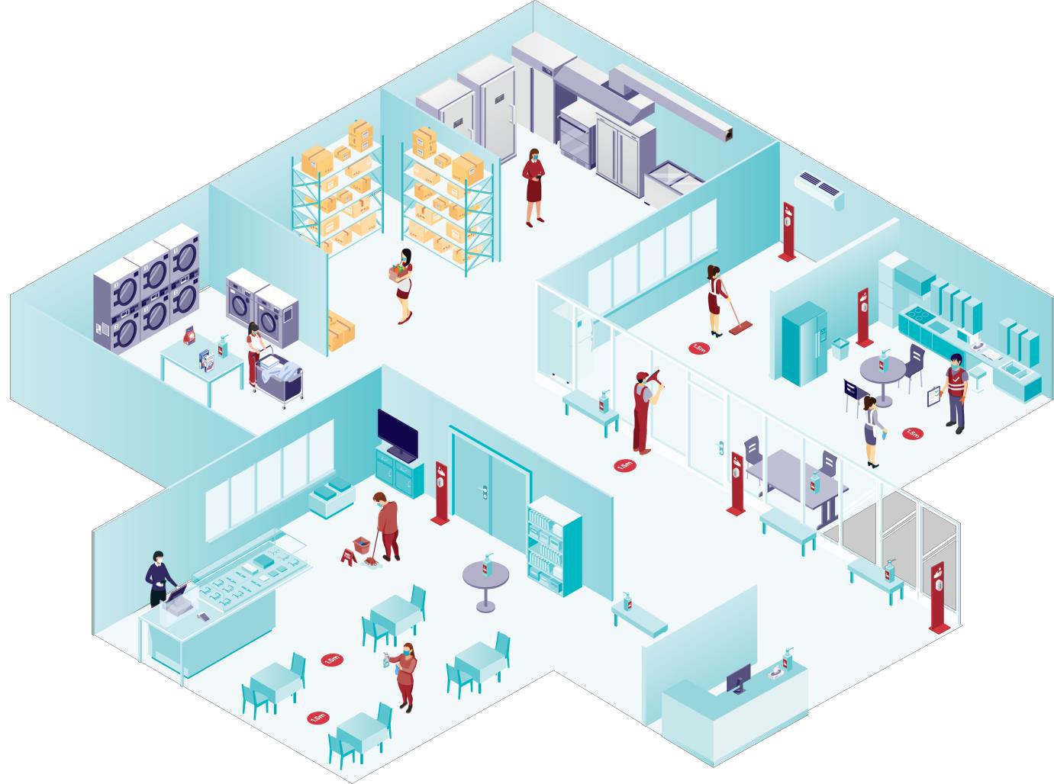It is the responsibility of the owner occupiers or business owners to ensure cleaning is performed to the expected standard. This can be achieved by either an in-house or contracted cleaning services.
Ensure equipment, cleaning products and personal protective equipment is provided to enable best practice cleaning to be performed.

Communication

For the latest information on cleaning guidance, coronavirus.vic.gov.au

Clear line of communication needs to be set up between all parties
i.e. building occupier/manager and its occupants (staff, tenants, visitors, customers) the cleaning service provider and the cleaning staff.

Risk-based cleaning
Target high use communal areas like kitchens and toilets that may require higher frequency cleaning with appropriate cleaning product.
Have ability to scale cleaning services in the event of a confirmed or suspected coronavirus (COVID-19) case.

Roles and responsibilities
Define the responsibility for each role that has a cleaning duty.
Agree who will be responsible for monitoring cleaning quality and that it meets
the expected standard.
Provide workplace cleaning training for staff who have site specific cleaning duties and to support any changes in cleaning schedules.

