AIRES’ ULTIMATE HOLIDAY COOKIE GUIDE

A COLLECTION OF OUR FAVORITES

Table of Contents
cookies & Cream cookies 2
Peanut Butter Cup Cookies 3
CAKE BATTER CHOCOLATE CHIP COOKIES 4
Kris Kringles – Butter Crescents 6
Double Chocolate Crinkle Cookies 7
Peanut Butter Cup Blondie 8
candy cane cookies 9

cookies & Cream cookies

- 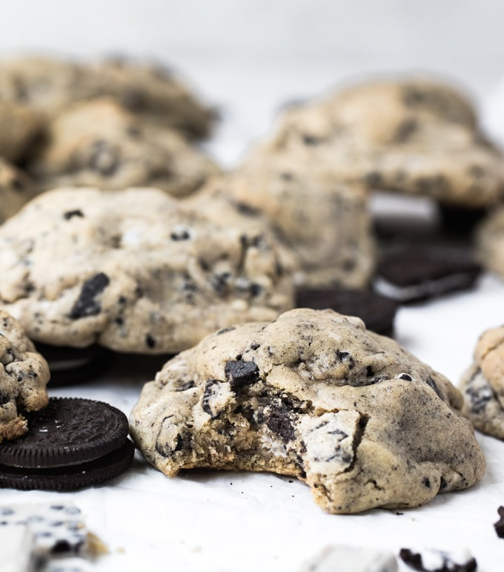  - INGREDIENTS  - 1 1/4 cup All-Purpose Flour  - 3/4 cup Cake Flour  - 1 tsp. cornstarch  - 1/2 tsp. baking soda  - 1/2 tsp. baking powder  - 1/2 tsp. salt  - 1 stick cold butter (8 Tbsp.), unsalted  - 1/2 cup brown sugar  - 1/4 cup granulated sugar  - 1 large egg  - 1 large egg yolk  - 1 tsp. vanilla extract  - 15 Oreo Chocolate Sandwich Cookies, chopped  - 9 oz. HERSHEY’S Cookies ‘n’ Crème Bars, broken into pieces 6, 1.55 oz. bars |  |  | Prep. Time: | Cook Time: | Servings:
 |  |  | 20 minutes | 10 minutes | 7 large cookies
  - DIRECTIONS
- Preheat oven to 375°F.
- Whisk together the dry ingredients in a large bowl: All-Purpose flour, cake flour, corn starch, baking soda, baking powder and salt. Set aside.
- Using a stand mixer fitted with the paddle attachment, cream the cold butter. Then add in the white sugar and brown sugar and let the butter and sugars cream together, up to 4 minutes.
- Then add in the eggs, egg yolks, and vanilla extract.
- Gradually add in the dry ingredients and then add in the chopped Oreo cookies and cookies and creme bars.
- Shape dough into 7 large cookies (~5 oz. each) and bake for 10-12 minutes @375°F.
- Let cookies cool on the cookie sheet for 15 minutes and then transfer to a wire cooling rack.

  - Tips
- Cream the chilled butter and sugar for up to 4 minutes. You want a nice creamy, fluffy texture!
- If your cookies are turning out flat, try adding a little extra flour.
- Be sure you preheat the oven to 375° first. Get the oven nice and hot while you prep the cookies.
- Slightly under baked is the way to go.

Recipe from: https://krollskorner.com/recipes/desserts/cookies-and-cream-cookies/

Peanut Butter Cup Cookies

INGREDIENTS  - 1 egg  - 1/2 cup creamy peanut butter  - 1/2 cup butter, softened  - 1 1/2 cups flour  - 1/2 cup packed brown sugar  - 1/2 cup granulated sugar  - 3/4 teaspoon baking soda  - 1/2 teaspoon baking powder  - Small bowl of granulated sugar  - Approx. 2 regular-sized bags of Reese’s miniature cups  Recipe is based off of this one:  https://www.goldmedalflour.com/recipes/classic-peanut-butter-blossom-cookies/1154abe5-2548-4cb0-8cfa-96c4b5db1374 |  |  | Prep. Time: | Cook Time: | Servings:
 |  |  | 30 minutes | 8-10 minutes | About 36 cookies
DIRECTIONS

- Heat oven to 375°F. In large bowl, beat 1/2 cup granulated sugar, the brown sugar, peanut butter, butter, and egg with electric mixer on medium speed, or mix with spoon, until well blended. Stir in flour, baking soda and baking powder until dough forms.
- Shape dough into 1-inch balls; roll in additional granulated sugar. On ungreased cookie sheets, place about 2 inches apart.
- Bake 8 to 10 minutes or until edges are light golden brown (While baking, unwrap the Reese’s cups). Immediately press 1 peanut butter cup in center of each cookie. Remove from cookie sheets to cooling rack.

NOTES
Can replace peanut butter cup candies with Hershey’s Kisses, ROLO candies, etc.

CAKE BATTER CHOCOLATE CHIP COOKIES

- INGREDIENTS  - 1 and 1/4 cup (156g) all-purpose flour (spoon & leveled)  - 1 and 1/4 cup (190g) yellow or vanilla boxed cake mix (not the whole box and you just need the DRY mix) *  - 1/2 teaspoon baking soda  - 1/2 teaspoon salt  - 3/4 cup (1.5 sticks or 170g) unsalted butter, softened to room temperature  - 1/2 cup (100g) granulated sugar  - 1/2 cup (100g) packed light brown sugar  - 1 egg, at room temperature  - 1 and 1/2 teaspoons pure vanilla extract  - 1 cup (180g) chocolate chips (I used 1/2 cup of white and 1/2 cup of semi-sweet chocolate chips)  - 1/2 cup (80g) sprinkles  - NOTES  - Make Ahead & Freezing Instructions: Cookies stay fresh covered at room temperature for up to 1 week. You can make the cookie dough and chill it in the refrigerator for up to 3-4 days. Allow to come to room temperature and continue with step 4. Baked cookies freeze well – up to three months. Unbaked cookie dough balls freeze well – up to three months. Bake frozen cookie dough balls for an extra minute, no need to thaw.  - Cake Mix: You can use funfetti cake mix and leave out the sprinkles called for in this recipe. I usually use vanilla cake mix. Remember, you only need 1 and 1/4 cups of dry mix. Not the whole box. Gluten free cake mix is not recommended. |  |  | Prep. Time: | Yield: | Cook Time:
 |  |  | 2 hours, 15 minutes | 24-30 cookies | 10 minutes
 |  |  | 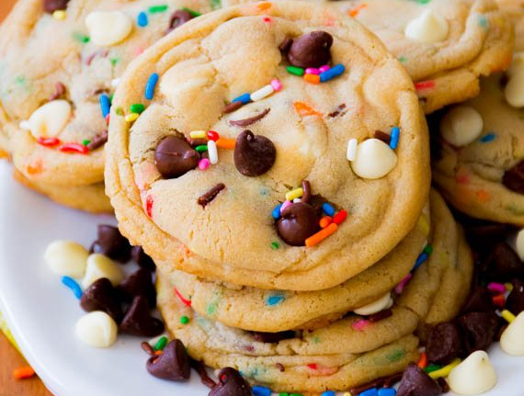
  - DIRECTIONS
1. In a large bowl, sift flour, cake mix, salt, and baking soda together. Set aside.

2. Using a hand mixer or a stand mixer fitted with paddle attachment, beat the softened butter and both sugars together on medium speed until creamy and smooth, about 1 minute. Add the egg and mix on high until combined, about 1 minute. Scrape down the sides and bottom of the bowl as needed. Add the vanilla and beat on high until combined. Add the flour mixture to the wet ingredients and mix on low-medium speed until just combined. Add the chocolate chips and sprinkles. Mix on low until the add-ins are evenly combined.

3. Cover tightly with plastic wrap and refrigerate dough for at least 2 hours, or up to 3-4 days. This step is imperative. The dough is fairly sticky, so chilling the dough is required in order to avoid the cookies from spreading too much. If you chill longer than 2 hours, make sure you roll the cookie dough into balls after the 2-hour mark. Place dough balls on a plate, cover tightly, and store in the refrigerator until ready to bake. You may also freeze the balls at this point for up to 3 months. (Then bake as directed adding 1 minute to the bake time without thawing.)

4. Once dough has been chilled, preheat oven to 350°F (177°C). Line two large cookie sheets with parchment paper or silicone baking mats (always recommended for cookies).

5. Scoop rounded balls of the cold dough onto an ungreased baking sheet, use about 1.5 Tablespoons of cookie dough per cookie. Shape your cookie dough balls to be “taller” than they are wide, as pictured above. Make sure to keep dough chilled when working in batches.

6. Bake the cookies for 10-12 minutes until edges are lightly browned. The centers will still appear very soft, but the cookies will continue to set as they cool. You can press a few more chips into the tops of the cookies at this point (the chips will stick because the cookies are still warm).

7. Allow the cookies to cool on the baking sheet for 5 minutes, then transfer to a wire rack to cool completely.

Find it online: https://sallysbakingaddiction.com/recipe-round-2-cake-batter-chocolate-chip-cookies/

Kris Kringles – Butter Crescents

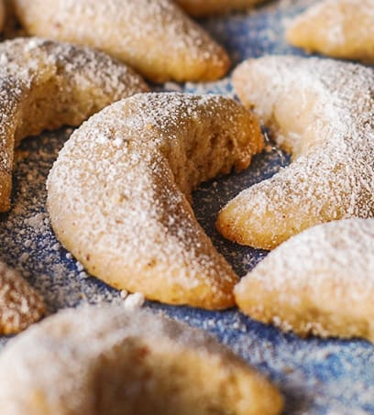  INGREDIENTS  - 2/3 cup sliced blanched almonds  - 1/3 cup sugar  - 1 cup (2 sticks) butter, softened  - 1 2/3 cups all-purpose flour  - ¼ teaspoon salt  Topping:  - ½ cup sugar  - ½ teaspoon cinnamon  Recipe from:  https://www.food.com/recipe/roses-crescents-holiday-shortbread-cookies-344772 |  |  | Prep. Time: | Cook Time: | Servings:
 |  |  | 30 minutes | 14-16 minutes | 40 cookies
DIRECTIONS

1. Sift the flour and salt together and set aside. Make topping mixture and set aside.

2. Chop the almonds in a food processor or with a hand chopper until finely chopped.

3. In a large bowl (I use a KitchenAid standing mixer), combine butter, margarine, sugar, and almonds. Beat at medium speed until light and fluffy. It may require stopping the mixer and scraping the sides.

4. Gradually add the flour mixture and beat until well mixed. You'll likely have to scrape the sides of the bowl occasionally to ensure that all the ingredients are combined. The result will be a fairly sticky dough.

5. Place the dough on wax paper and shape into a rectangle (4 x 6 x 1) and then wrap tightly in plastic wrap. Refrigerate for a minimum of two hours or overnight.

6. Preheat the oven to 325. Cut the dough into eight sections. Working with two sections at a time (keep the rest of the dough refrigerated), pinch off small balls of dough (bigger than a marble but smaller than a golf ball). On a floured surface, roll the dough into a rope about the size and length of your pinkie. Shape the ropes into crescent (half-moon) shapes.

7. Place on ungreased cookie sheets and bake for 10-13 minutes until set. The edges should be golden brown.

8. Cool on the cookie sheet for 10 minutes. Remove promptly and roll in topping mixture

Double Chocolate Crinkle Cookies

- 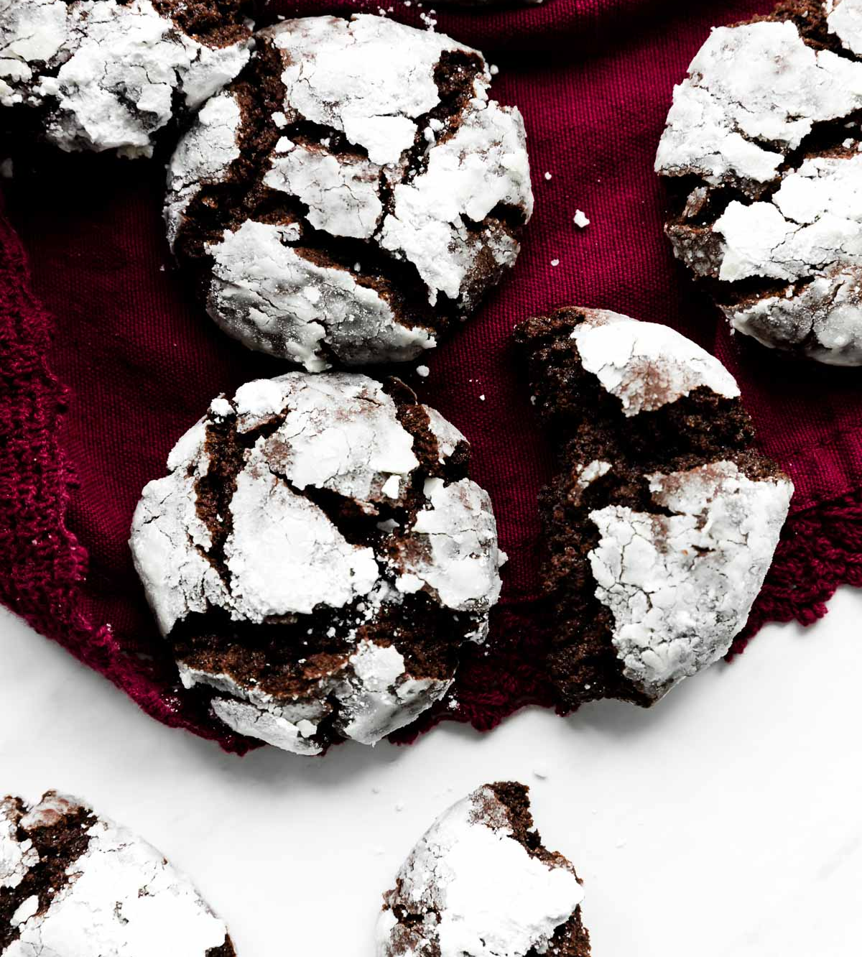  - INGREDIENTS  - 1 cup (125g) all-purpose flour (spoon & leveled)  - 1/2 cup + 2 Tablespoons (51g) unsweetened natural cocoa powder  - 1 teaspoon baking soda  - 1/8 teaspoon salt  - 1/2 cup (1 stick; 115g) unsalted butter, softened to room temperature  - 1/2 cup (100g) granulated sugar  - 1/2 cup (100g) packed light or dark brown sugar  - 1 large egg, at room temperature  - 1 teaspoon pure vanilla extract  - 1 cup (180g) mini or regular size semi-sweet chocolate chips  - Rolling  3 Tablespoons (35g) granulated sugar  1 cup (120g) confectioners’ sugar, for rolling |  |  | Prep. Time: | Cook Time: | Servings:
 |  |  | 2 hours, 30 minutes | 11 minutes | 20
  - DIRECTIONS
1. Whisk the flour, cocoa powder, baking soda, and salt together in a large bowl. Set aside.

2. In a large bowl using a hand-held mixer or stand mixer fitted with a paddle attachment, beat the butter, granulated sugar, and brown sugar together on medium high speed until fluffy and creamed, about 2 minutes. Beat in egg and vanilla on high speed. Scrape down the sides and bottom of the bowl as needed.

3. On low speed, slowly mix the dry ingredients into the wet ingredients until combined, then beat in the chocolate chips. The cookie dough will be thick and sticky. Cover dough tightly with aluminum foil or plastic wrap and chill for at least 2 hours and up to 3 days. Chilling is mandatory for this cookie dough. I always chill mine overnight.

4. Remove cookie dough from the refrigerator and allow to sit at room temperature for 15 minutes. You can preheat the oven during this time.
Preheat oven to 350°F (177°C). Line two large baking sheets with parchment paper or silicone baking mats. (Always recommended for cookies.) Set aside.

5. Scoop and roll balls of dough, about 1.5 Tablespoons of dough each, into balls. Roll each ball very lightly in granulated sugar, then generously in the confectioners’ sugar. Place 3 inches apart on the baking sheets.

6. Bake the cookies for 11-12 minutes. If the cookies aren’t really spreading by minute 9, remove them from the oven and lightly bang the baking sheet on the counter 2-3x. This helps initiate that spread. Return to the oven for a couple more minutes. The cookies will be thick regardless, though– they deflate a little as they cool!

Peanut Butter Cup Blondie

- 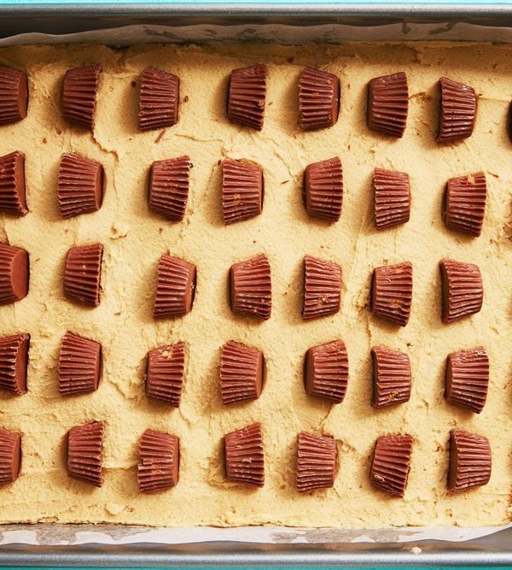  - INGREDIENTS  - Cooking spray  - 3/4 c. (1 1/2 sticks) butter, softened  - 1/2 c. peanut butter  - 1 c. granulated sugar  - 1/2 c. packed brown sugar  - 2 large eggs  - 2 tsp. pure vanilla extract  - 2 c. all-purpose flour  - 1 tsp. kosher salt  - 1 tsp. baking soda  - 30 Reese’s Miniatures, unwrapped  - 1 c. chocolate chips, melted (optional)  - 1/2 c. peanut butter, melted (optional) |  |  | Prep. Time: | Cook Time: | Servings:
 |  |  | 10 minutes | 30 minutes | 24
  - DIRECTIONS
Preheat oven to 350°. Grease a 9”-x-13” pan with cooking spray. In a large bowl, beat butter, peanut butter, and sugars with a hand mixer until fluffy. Add eggs and vanilla and beat until combined.

In a separate bowl, whisk together flour, salt, and baking soda. Add to wet ingredients and beat until just combined. Transfer blondie batter to prepared pan.

Press Reese’s candies into batter, creating even rows (as pictured). Bake for 25 to 30 minutes or until just set. Let cool to room temperature.

Optional: Drizzle melted chocolate and peanut butter over blondies before serving.

candy cane cookies

- 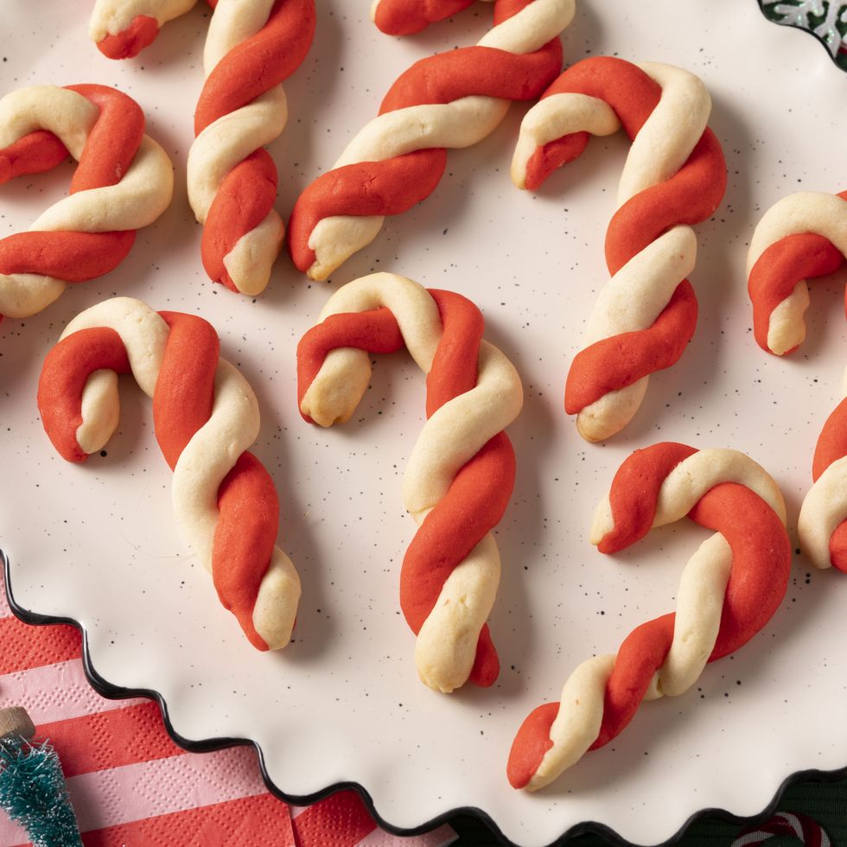  - INGREDIENTS  - 2 sticks salted butter, softened  - 1 c. powdered sugar  - 1 large egg, room temperature  - 1 tsp. vanilla extract  - 1 1/2 tsp. peppermint extract  - 3 c. all-purpose flour  - 1/2 - 1 tsp. red food coloring  - 3 candy canes, crushed, optional |  |  | Prep. Time: | Cook Time: | Servings:
 |  |  | 45 minutes | 1 hour | 24
  - DIRECTIONS
1. Place the softened butter and sugar in a large bowl (or the bowl of a stand mixer). With a hand mixer (or stand mixer with a paddle attachment) on medium speed, beat until light and fluffy, 2-3 minutes. Add the egg, vanilla and peppermint extract and mix well to combine. Add the flour 1 cup at a time, mixing on low to combine completely in between each addition. Scrape the bottom and sides of the bowl as needed.

2. Remove half of the dough from the bowl and form into a disc shape, about 1-inch thick. Wrap tightly with plastic wrap and refrigerate for 1 hour (or overnight).

3. Place the red food coloring in the bowl with the remaining dough. Mix on low to incorporate the coloring into the dough fully (add more food coloring until you reach your desired shade of red). Remove the red dough from the bowl, knead it a few times on a clean surface to incorporate all the coloring completely, and form into a disc shape, about 1-inch thick. Wrap tightly with plastic wrap and refrigerate for 1 hour.

4. Line 2 large baking sheets with parchment paper. Preheat the oven to 375°F.

5. Unwrap both pieces of dough and pinch off 1/2-tablespoonful pieces of each color. With the palm of your hand, roll each dough ball on a clean surface into a 5-inch-long rope. (It’s best to roll all the white dough in one spot on your counter, and all the red dough in another spot, so that the white pieces don’t pick up any red dough left on the surface.) Place the ropes side by side and twist, pinching the tops and bottoms to stick together. Carefully transfer to the
sheet trays and form into a candy cane shape. Continue to roll, twist, and form all the cookies. (If the dough starts to get too sticky, or difficult to roll without breaking, re-wrap it in plastic wrap and pop it back in the fridge for 15 minutes to firm up again).

6. Bake the cookies 12 minutes, or just until the white dough looks lightly golden. If decorating with crushed candy canes, sprinkle as soon as they come out of the oven. Let cool completely on the baking sheets. Store in an air-tight container in a single layer, between sheets of parchment paper, for up to 1 week at room temperature.

