Instruction
Set the due date for this assignment after students have read Chapter 8: “Website Analytics.” Have the students follow the instructions for the “Google Analytics Google Merchandise Store Assignment” available under “Student Resources” for this chapter in Edify. Below are the instructions for your reference.

STUDENT INSTRUCTIONS
You have been hired as a digital marketing analyst for the Google Merchandise Store.
Step 1
Please get familiar with your employer by exploring their site https://shop.googlemerchandisestore.com/.

Google Merchandise Store is an e-commerce site that sells Google-branded merchandise. The website has Google Analytics implemented, which pushes data into a demo account you can access. The data available through the Google Analytics account is typical of what you would see for an e-commerce site and includes the following kinds of information:
- Traffic source data: Information about where website users originate, including information about organic traffic, paid search traffic, display traffic, etc.
- Content data: Information about the behavior of users on the site, including the URLs of pages that users look at and how they interact with page co---ntent
- Transaction data: Information about the transactions that occur on the Google Merchandise Store website

Step 2
Gain access to the Google Analytics demo account for the Google Merchandise Store. Instructions for accessing this demo account are available from Google. Make sure when you access the demo account you use Master View 1 (see images below).

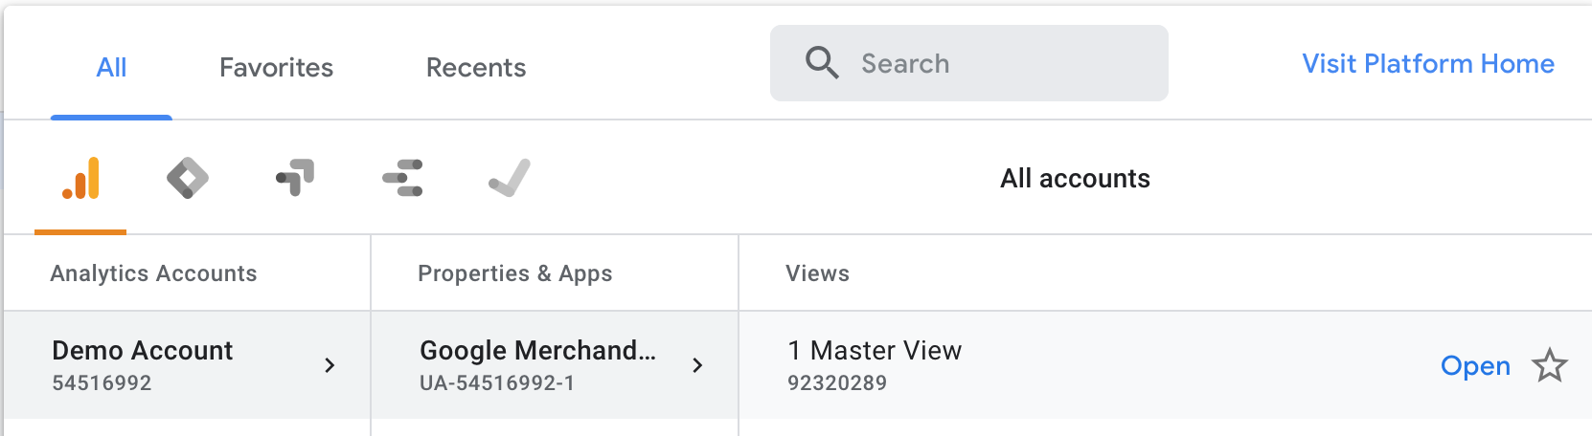

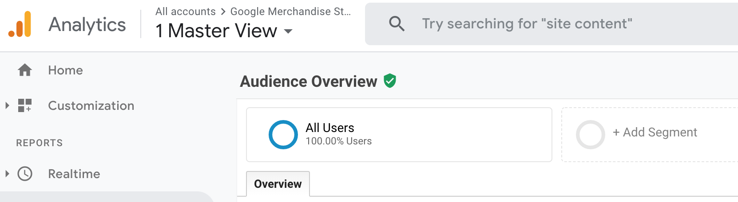

Step 3
Your manager is interested in the website performance for the Google Merchandise Store for the month of March 2020. Note: Make sure you adjust the Google Analytics demo account date filter in the upper right hand corner to start on March 1, 2020, and end on March 31, 2020.
Your manager has asked you to answer the following questions using data from the Google Analytics demo account. Provide an answer for each of the 10 questions below.

1. How many users did the Google Merchandise Store have in March 2020?

2. How many sessions did the Google Merchandise Store have in March 2020?

3. What was the page with the most pageviews in March 2020?

4. Of all the channel groups, which drove the most users in March 2020?

5. How many users did the channel group “Referral” drive in March 2020?

6. How many sessions did the channel group “Social” drive in March 2020?

7. What channel group drove the most revenue in March 2020? How much revenue did it drive?

8. How much total revenue was recorded from the website in March 2020?

9. What product drove the most revenue in March 2020?

10. Due to the coronavirus, schools and businesses began closing or going fully remote and economic activity decreased in March 2020. Do you see an impact from coronavirus on the Google Merchandise Store’s daily users throughout March? If yes, what impact do you observe?
---

