CHAPTER 10
Facebook Analytics Assignment
By Nathan David
Overview
LEARNING OBJECTIVES
- Practice navigating Facebook Analytics.
- Answer business questions using Facebook Analytics data.
- Interpret Facebook and Instagram analytics and provide performance insights.
Social media is a robust aspect of owned media. Social media marketing technology tools collect large swaths of data on consumer interests, behavior, and demographics. An analyst with social media analytics expertise can enhance a business’ results.

Social media platforms leverage the internet to create virtual networks and communities. Two of the largest social media platforms are Facebook and Instagram. Social media analytics provides invaluable insights about consumer wants, needs, interests, and behaviors on these platforms. An analyst needs to tap into this wealth of consumer information.

For this assignment, have students explore the analytics tool Facebook Analytics via a demo account. Through the demo account, an analyst can explore analytics for both Facebook and Instagram. A demo account presents sample data to give an idea of what can be expected with Facebook Analytics.
Instructions
You have been hired as a digital marketing analyst for the Facebook for Business team. They have a Facebook page and an Instagram account that promote their business services. Please get familiar with your employer by exploring their social media account (please note since these are demo accounts they have limited information publicly available at these URLs).
https://www.facebook.com/Demo-Page-704150636624256/ and https://www.instagram.com/fba_demo/

Facebook for Business gives businesses the latest news, advertising tips, best practices and case studies for using Facebook and Instagram to meet business goals. The Facebook for Business Facebook page and Instagram account have Facebook Analytics implemented, which pushes data
into a demo account you can access. The data available through the Facebook Analytics account is typical of what you would see from a Facebook page and Instagram account.

Step 1
The first thing you need to do is gain access to the Facebook Analytics demo account for the Facebook for Business team. Instructions for accessing this demo account are available from Facebook. This demo account has information on both the Facebook for Business’ Facebook page and Instagram account. The images below highlight the links that take you to the data for these respective accounts. Please note there are other data accounts available with app data (please ignore these other accounts as your focus is on analytics from Facebook and Instagram).

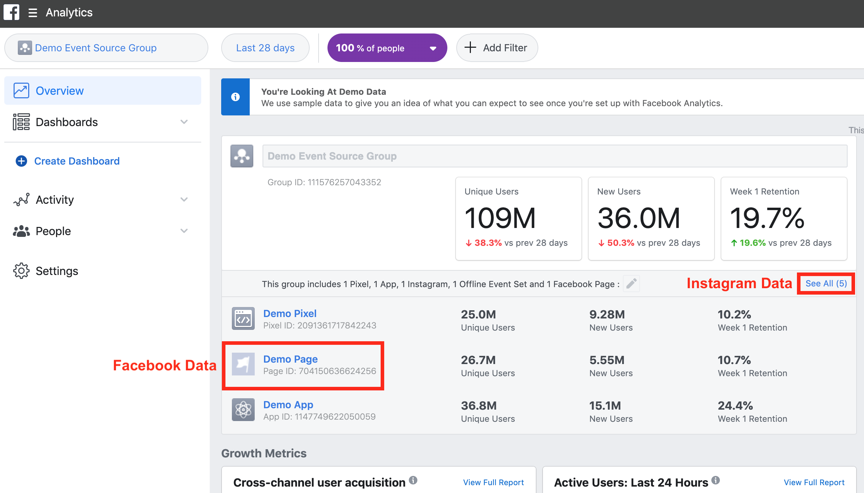

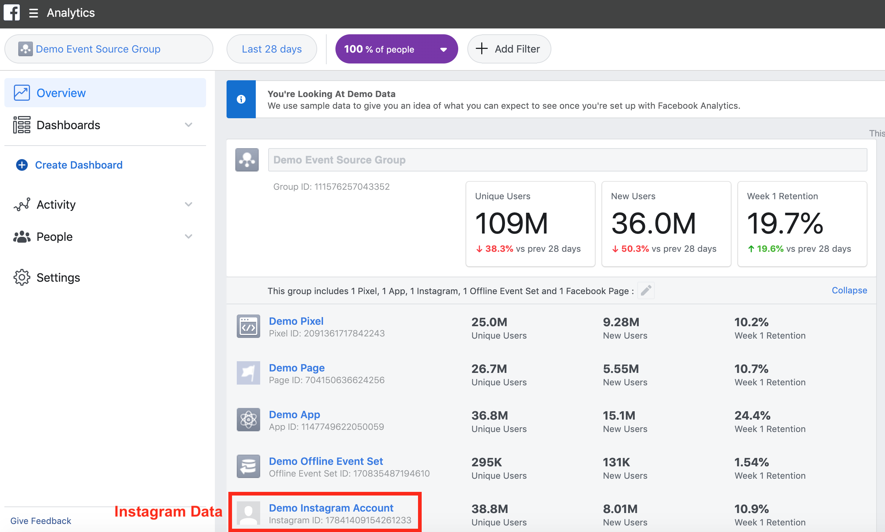

Step 2
Your manager is interested in the social media account performance for the month of June 2020. When you open the Facebook Analytics demo account make sure you adjust the date filter in the upper left hand corner to start on June 1, 2020, and end on June 30, 2020. (As you navigate throughout Facebook Analytics you need to continually reset your date range). Your manager has asked you to answer the following questions using data from the Facebook Analytics demo account.

- How many unique users (in millions) did the Facebook Page have in June 2020?

- How many impressions (in millions) did the Facebook Page posts have in June 2020?

- What hour of the week had the largest amount of Facebook Page unique users in June 2020?

- Which Facebook Page post had the most user reactions in June 2020 (your answer should be the complete text of the post)?

- How did weekly active users on the Facebook Page change during June 2020?

- How many unique users (in millions) did the Instagram Account have in June 2020?

- How many post likes (in thousands) did the Instagram Account have in June 2020?

- What country had the largest amount of Instagram Account unique users in June 2020?

- Which Instagram post had the most user reactions in June 2020 (your answer should be the complete text of the post)?

- How did monthly active users on the Instagram Account change during June 2020?

