CHAPTER 11
Google Analytics 4 Flood It! Assignment
By Nathan David
Overview
LEARNING OBJECTIVES
- Practice navigating Google Analytics 4.
- Answer business questions using Google Analytics 4 data.
- Interpret mobile app analytics and provide performance insights.

BACKGROUND
Mobile apps are an integral component of owned media. Mobile app marketing technology tools collect critical digital marketing data. Armed with mobile app analytics data, analysts drive better results for businesses.

Instructions
You have been hired as a digital marketing analyst for Flood It!. Please get familiar with your employer by exploring their mobile app, Android and iOS.

Flood It! is a real puzzle game in which you have to flood the whole game board with one color in fewer than the allowed steps. Flood It! has Google Analytics 4 implemented. The mobile
app data is flowing to the Google Analytics 4 demo project. The data available is typical of what you might see for a gaming app with in-app purchases.

Step 1
Gain access to a Google Analytics 4 demo account for Flood It!. Instructions for accessing this demo account are available from Google. Make sure when you access the demo account you navigate to the Property ‘GA4 - Flood-It!’ (see images below).

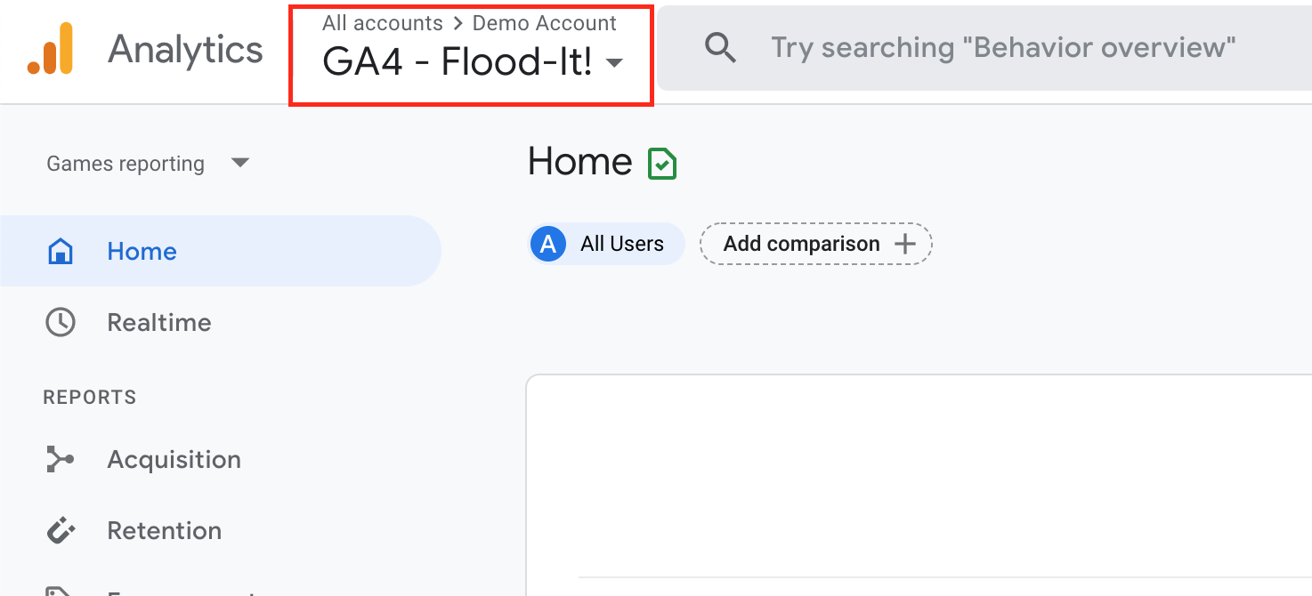

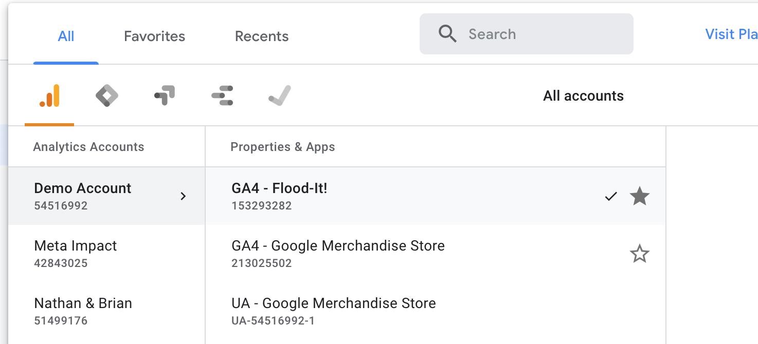

Step 2
Your manager is interested in the mobile app performance for Flood It! for the month of April 2021. When you open the Google Analytics 4 analytics dashboard, make sure you adjust the date filter in the upper right-hand corner to start on April 1, 2021, and end on April 31, 2021.

Your manager has asked you to answer the following questions using data from the Google Analytics 4 demo account.

1. How many new users (in thousands) did the Flood It! mobile app have in April 2021?

2. How many new users were acquired through CPC (cost per click) in April 2021?

3. How many returning users (in thousands) did the Flood It! mobile app have in April 2021?

4. How many post_score events occurred in April 2021?

5. In minutes and seconds, what was the average engagement time?

6. Which event name had the highest count in April 2021?

7. What was the total revenue in April 2021?

8. What was the average revenue per paying user in April 2021?

9. Flood It! uses first opens as a proxy for app installs. What was the first_open event count in April 2021?

10. Flood It! uses an audience called “Crashing Users” to track users that experienced an app crash. How many “Crashing Users” were there in April 2021?

