MossRehab Aphasia Center
Can We Talk? Communication Strategies for the Whole Community

Karen R. Cohen, MSPA CCC-SLP will discuss aphasia and review tips and techniques for making conversation inclusive.

Anyone and everyone welcome; please bring your questions, comments, and ideas... the more we can share, the better!

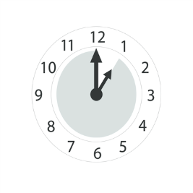
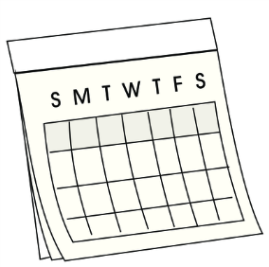
June 2021
16
When: Wednesday, June 16, 2021
1-2pm

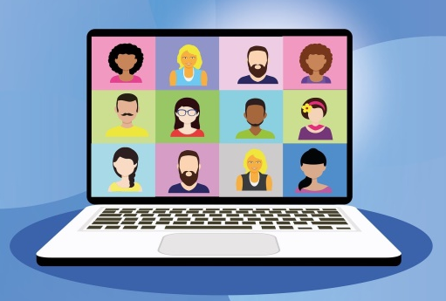
Where: ZOOM
Everyone will see and hear each other!

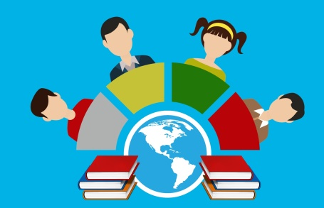
We will record the session.
We will post it publicly online.
Anyone will be able to watch you.

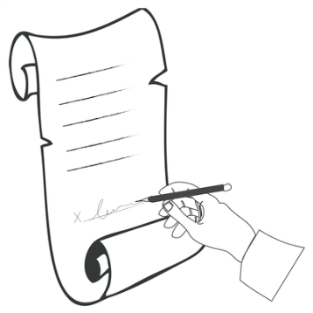

We will ask you to sign a consent form.

