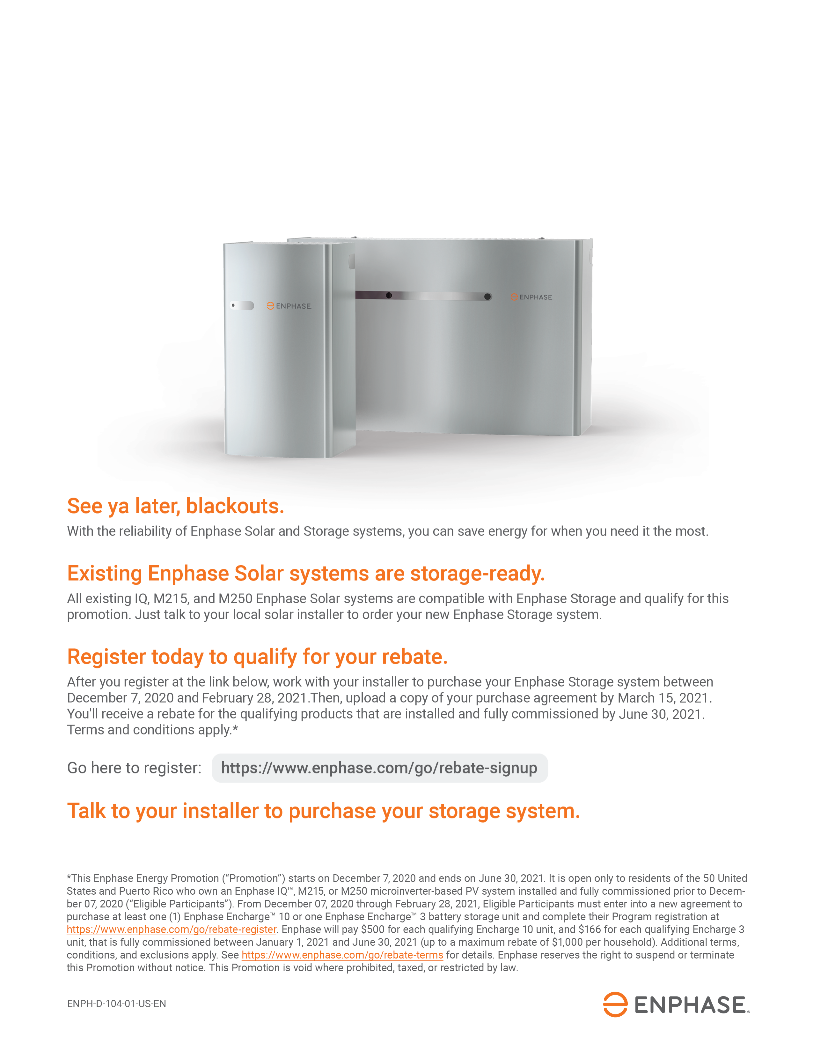

< Add your phone/email/website here

Call John Doe with ACME Solar at 800-555-1212

Add your logo here