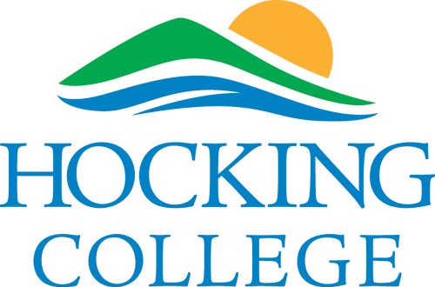
Prospective Dental Hygiene Student:
This form must be taken to a location that administers BCI and FBI Criminal History Record Checks. By providing this form to a police station or other entity you are permitting that entity to administer a BCI and FBI Criminal History Record Check. That entity will then provide Hocking College Dental Hygiene Program with the results.

Request for BCI and FBI Criminal History Record Check For the Dental Hygiene Program

Name:
____________________________________________________________
Date of Birth:
______________________________________________________
SSN:
_____________________________________________________________

Return Information To:

Hocking College
Attn: Misti Malf, Program Director
Hocking College – Perry Campus
5454 OH 37
New Lexington, OH 43764

