How to do the Continental Drift Dance

Step 1: Walk forward and do the Sid
Step 2: Walk back and do the Sid
Step 3: Step left and drift
Step 4: Step right and drift
Step 5: Crisscross and do the mammoth
Step 6: Crisscross and do the mammoth
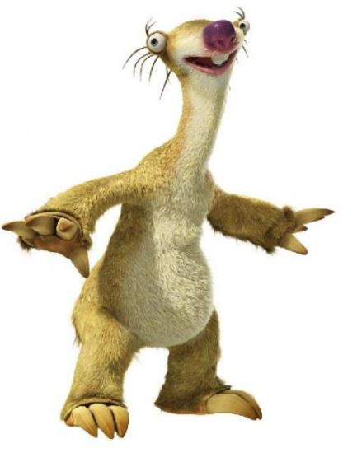
Step 7: Jump, jump
Step 8: Shake your rump
Step 9: Walk it out like granny

