**Why Am I Trading?**

For as long as I can remember I’ve always been interested in the stock market (I’m not kidding, I remember way back when I was 8 or 9 in 1984-85 thinking that I’d like to buy shares of Apple computer) Yet I’ve always held myself back from getting involved because I didn’t know how nor had the financial resources to get into it. I also listened to the doubters and naysayers that said the odds were against you or it was too difficult to do and you’d probably end up losing money.  But I’ve decided that I’m going to discover for myself whether or not I can be successful at this, and after seeing what Kunal and the other BOWS members and students have accomplished, I believe with hard work and dedication that I will be successful at this. In addition, I’m trading for the following reasons:

1)Foremost amongst the reasons I want to trade is the incredible independence and freedom that trading can provide. Independence, meaning that I am in control. I am my own boss, and my success is solely my responsibility (as too I only have myself to blame for my failures) I determine my daily schedule and routine. If I want to trade in my underwear all day, that’s my prerogative. As well, I see trading as providing freedom. Mainly to do some of the things I want. I’d love to have 2 homes on different sides of the U.S. As well I’d love the finacial freedom to travel when and where I’d please throughout the world. Staying in nice hotels along the way.

2) I believe that my particular intelligence may be well suited toward trading. I’m pretty good at picking up strategic minded games and patterns (good at chess, backgammon, poker etc.) I also enjoy taking calculated risks ie when I deem the odds to be in my favor I have the ability to pull the trigger.  As well, I have a strong desire to increase my understanding and ability of trend based trading.

**Objectives**

*within 1st to 3rd month*: Paper trade in a profitable and effective manner, looking to hit my targets. (As with live trading I will have targets in mind that I would like to accomplish but they will not be absolutely imperative to attain these targets as I don’t want my trading to be affected by my p/l ratio)

1st target: just be profitable for the first week(s) 2nd target: $500-600+/per week 3rd target: $800-$1000+/per week

*within 2nd to 6th month:* Begin trading live. (I may want to trade w/ the hedge fund, I need to get more info. on it) I’ll allocate 3-10k for the BOWS prop fund.  I may have an additional 15-50k in another brokerage account.  (I currently have a schwab account, but may switch to Merrill Edge or just use DAS trader) 1st target: $500-600+/per week 2nd target: $800-$1000+/per week

*within 6th month to 5 years:*  Continue to increase my trading ability and eventually be as profitable as Kunal and ultimately I’d like to have at least 1 month where I was more profitable than Kunal :)

**Trading Style:**

I’ve come to the conclusion that I want to be as proficient as possible in day trading.  I think this is the most difficult of the 3 styles but also the most rewarding. I like the idea of being able to get in the market during the day and then getting out without having the worry of overnight gap downs. I also like being able to see my results of my trading day in and day out.  Having said that I think I will try some swing trades as well, but will take smaller positions overnight.

**Setups**

Learning what setups I’m good at and which one’s need work will be a big part of my simulated trading experience. But I will initially focus on the following types:

*-PR/Earnings gappers:* Maribeth has stated that if she were to do the course over again, she would focus alot more on this setup as it’s a very common goto setup played in the chatroom.

*-flattop breakouts, base breakouts, flag breakouts:* These all have their own unique characteristics but I’m grouping them together as they have common characteristics.  Looking for break of key resistance levels, and a more explosive breakout after consolidation or coiling.

-*Pullbacks:* These setups are the lowest risk type of trade for the following reasons. They have a clearly defined reward to risk ratio. Target is the recent high of the stock price and your stop is placed just below the area of support. So both the target and stop loss are well defined.

**Risk Management**

*Rule #1:* The max loss I will take for the day will be $350 w/in my 1st target range.  If I reach that max then I will have to stop for the day.  Once I’m hitting my 2nd target range the max loss will be bumped up to $550 per day.  This rule will apply from the 4th week of my paper trading onwards into my live trading.

*Rule #2:* If I have 3 losing days in a row, I will have to temporarily suspend my trading and either consult with Kunal, Maribeth or another trading mentor on what I’m doing wrong and figuring out ways correct the problem.  As well, this rule will apply from the 4th week of my paper trading onwards into my live trading.

In winning positions I will use the following guideline.  Once I’ve hit my initial target, during Bull markets, I will scale out ⅓ of the position and ½ the position during choppy or bear markets and set my stop at the buy price in all markets. I will continue to scale out of the position based on the trend of the stock and the current market cycle.

**Trading Rules**

1) After entering a stock if the price doesn’t validate the setup then I will take the small loss and exit, avoiding a potential bigger loss.

2) Always align on multiple timeframes, looking for hidden support and resistance before taking a position.

3) Do not hold a stock overnight thru earnings or if bought on margin.

4) Look for high probability trades with a potential reward to risk ratio of 2:1 or better.

5) Trade low float stocks. Under 100mil, under 20mil ideal.

6) Be aware of the liquidity of the stock. Look for stocks with decent volume.

7) Always use stop losses and honor max loss limits.

8) Be aware of emotional state when trading and do very best to minimize emotional trading.

9) Do not trade out of boredom, or wanting action. This is a business not a gambling fix.

10) I like MB’s rule to avoid shorting stocks with strong upward momentum before 1pm

11) Review my trades for the day and week, journaling what went right and what went wrong, and how to avoid the same mistakes in the future.

**Morning Routine**

6:45-8:30 - wake up, workout, shower, get dressed, eat

8:30-9:30 - check internet connection (plan on getting a mifi connection as well) prepare

      platforms & screen setups, review any holdings from night before

                              and adjust stop losses and exit targets, run through watchlists and setup

                              alerts, check for pre-market gappers 3% or more, check market for news,

                              use the following resources for all of this info:

* http://www.speedtest.net
* Finviz scans
* Thestockmarketwatch.com (pre market movers)
* yahoo inplay
* Benzinga (pre market outlook, Earnings stocks)
* Twitter
* Bulls Chatroom

**Scanning Routine**

I will use TC2000 for scanning and either current Schwab brokerage for charting, or may switch to Think or Swim for charting. I will also use the BOWS blog to generate ideas. As well as the following:

* check market breadth and indices for overview of market
* Weekly scan of momo stocks
* Daily scan of 4% gainers and losers
* review watchlists

**Reviewing and Journaling**

1) Post trades on Tradervue providing the following info:

* setup and reason for trade
* entry price
* target
* placement of stop loss
* Risk/Reward Ratio

2) Review my statistics, at first on weekly basis, then on a monthly basis to track my progress and see what areas need work and to understand where and when to avoid certains trades (ie certains days worse than others, certain setups not profitable) Keep notes of this on Evernote and create a spreadsheet with metrics of winning and losing trades.

3) In addition, I will blog about my trading experiences.  Sharing the challenges I’ve experienced as well as my emotions, thoughts joys and sorrows caused by trading.  I may need a push from Kunal and others to do this on a regular basis as I have a tendency to procrastinate on things like this.

**Education**

Foremost is reviewing my current notes and bootcamp classes till the ideas are seared into my brain.  I will continue to participate in the Google Community. It’s a great resource to see what other traders are doing to improve myself as well as contributing my own input to help other traders succeed. I will also continue to sit in on bootcamp classes, which will allow me to gain more insight into certain trading ideas, setups etc.  I will read other traders blogs and trading forums in order to adopt successful trading strategies.  I’m also considering employing the services of Greenbar Trading ie Chris Zelensky.  He seemed incredibly astute and may be a great additional mentor.

**Trading Checklist**

*Nightly routine & Pre-Market*

1) Market over-view:

* what phase is the market in?
* check key ETF’s to see which sectors are growing and declining
* check market breadth
* check slope of MA’s on S&P 500 and if price is above or below MA’s to determine direction of the market

2) Potential stocks to trade:

* momentum stock?
* float
* liquidity (ie good volume)
* is it in accumulation or distribution
* trending upwards or downwards

3) What is the setup:

* identify potential setup type
* price pattern
* volume
* moving averages
* stochastics
* bollinger bands

4) Filter for best stock

* clean pattern on setup
* potential target at least 2:1
* strong relative volume
* strong consolidation or good momentum in stock

5) Organize & prioritize watch list

*Market Hours*

1) Identify potential stocks to trade

* Identify Intraday setup
* Align on multiple timeframes
* look for hidden resistance and support levels
* check intraday volume
* identify target (at least 2:1)
* identify stop (less than my max loss for the day?)
* size appropriate position
* double check order
* limit price order
* # of shares purchasing
* stop placement
* type of order (buy/sell)
* check stock periodical while owned and adjust target and stop placements

2) Run hourly scans (finviz) to find potential stocks to play

*After Market Hours*

1) Review trades for the day

* Upload to tradervue and access trades
* input data into spreadsheet
* take notes on successful and unsuccessful trades
* blog about the days trades and my trading in general

# Why am I trading?

I believe that trading is the ultimate expression of entrepreneurship: to process to creating opportunities through the management of your risks and the generation of the rewards. So in essence, trading for me is a business and I am trading to make money.

Like any sport or learning a new profession, to succeed in trading you must first understand the fundamental rules and principles that govern your environment (markets). You then must learn and master the craft (through education and practice). Third, to be truly successful in the trading business you must master yourself - your emotions, fears, insecurities and trigger points. Isn’t that a scalable to life mastery? I love that there is no end state - Trading is a never ending process. Ultimately, i am trading to become a successful entrepreneur - creator of wealth..

So I am trading for essentially 2 reasons: First, the generation of income. I am currently employed and love my full time job. However, i am depending on my salary as the main source of income to pay the mortgage and bring food on the table everyday. If one day, i would lose my job, i would have to look for another position and i am not sure i have the passion to continue working in the same field of expertises (IT and Finance) which brings me to my second reason: develop a new skillset and master a new craft. Ultimately, what if i could fulfill a lifelong dream of becoming self sufficient financially and not worry about money? Trading can help me achieve this dream.

# Objectives

**Months 1-3:**

My first objective is to become profitable as a trader. I am confident that i will achieve this first milestone very shortly - Profitable means being in the black after trading transaction costs and to be achieved by increasing my win % and maintaining my stops at all times to avoid large losses.. My winning trade % before taking the Bootcamp was between 37%-45%. reason for my low win % is due to two things: 1) lack of focus - trading on emotions and largely based on other people’s recommendations. So taking many set ups without necessarily knowing why and then cutting them short in an attempt to control my environment. My largest issue has been to cut my trades too short believe it or not and not allow the trade to develop thru time. 2) trading rules. i didn’t not respect my set ups, methodology or rules (because i didn’t have any). To reverse the current trend, i will focus on no more than 2 trades per trading day and i will diligently honor my stops when hit. I plan on dealing with this thru the trading simulator to avoid large losses and maintain my trading capital intact.

**Months 4-6:**

My account size for trading is roughly $15K. My second objective will be to generate a minimum $720 (or ~5% of total account size) growth per month for 3 consecutive months before increasing my risk size. For each individual trade, i would risk half a point or $75. I will trade an average of 3-5 positions / week. If i see low risk trade opportunities, i will take them. If i manage to exceed expectations on two consecutive months by a better win % and more profits - i may increase my risk size by then. To achieve my objective i will dedicate most of my trading activities on opening gap plays as they are frequent and appear easier for me to trade at this point. on intraday charts, i will exclusively trade flat top and flag breakout patterns.

So conservatively, if i trade 12 positions during the month - with a 60% win rate and assuming a profit of 2R ($150) this means that i would generate 12*60%*$75= $1,080 for 12*40%*-$75= $360 which would net = $720. I will obviously try to ride my profits to 2R and will have scratch trades. Key here will be to cut losers quickly and let the 2R play out..

| Trades | Win % | Win $ | Los $ | Profits |
| --- | --- | --- | --- | --- |
| 12 | 60% | $1,080 | $360 | $720 |
| 12 | 65% | $1,170 | $315 | $855 |
| 15 | 60% | $1,350 | $450 | $900 |
| 15 | 65% | $1,463 | $315 | $1,148 |

**Months 7-9:**

If everything goes according to plan i should be now trading with a high percentage win %. Next step is to increase win rate to 70%+ and increase position size to 1% of total account size. Number of trades should remain the same. By month 9, success would be defined by having grown trading account to close to between $19K-$20K. Profit table should look like this:

| Trades | Win % | Win $ | Los $ | Profits |
| --- | --- | --- | --- | --- |
| 12 | 70% | $2,520 | $540 | $1,980 |
| 12 | 75% | $2,700 | $450 | $2,250 |
| 15 | 70% | $3,150 | $675 | $2,475 |
| 15 | 75% | $3,375 | $563 | $2,813 |

During this period i would like to allow myself to master 1-2 new trade set ups. This will likely involve short trade set up possibilities. A good place to start might be the Red to Green patterns on day following big push ups in price and trading the opening range of momentum stocks on my arsenal list. However the most obvious natural transition for me would be to trade opening gap plays to stay within my area of expertise. Looking for Bear flag patterns on intraday gappers (Gap downs) and flat bottom breakdowns on consolidating intraday charts will likely be the best way to expand on my trading arsenal. On gap downs, the squeez’em after major flush downs may present very good opportunities as well. I have observed reversals to the upside that moved almost half the size of the flush.

**Months 10-12**

By now i should be able to generate close to $3,000 / month from my trading activities. My confidence levels should be very high with regards to my capabilities. My stretch target should be to increase my success % to BoWs levels of higher than 80%. My position size would now be at around $200 / trade. My 2:1 reward to risk pattern should be clear and well executed. Sky is the limit for what happens next. I also increase my trade volume to ~20-25 trades / month.

**Year 2**

Trading should be done almost mechanically and effortlessly. By now, i am trading like water (Bruce Lee said to be like water) :-); not worried about losing money on trades and applying my rules that have evolved through my trades from year 1. My objective should be the generation of $3,500-$5,000 month from trading activities. I will have to consider diversifying my activities into a 3rd stream of income generation - this could be to take profits and start buying some real estate properties or other business ventures and possibilities that can be managed more passively. Key here is to develop a new income stream and reduce stress tied to generating income from trading activities. I believe that not depending on trading income is an edge in trading decisions as you might be willing to take on a bit more risk to generate even more income.

**Long term (Year 3+)**

In my third year, i expect to grow by income stream by 50% from year 2. So $60K should be a good target. Investment diversification continues. I take this opportunity to reflect on the necessity of maintaining a full time job versus trading full time. Maybe it is time to start thinking about early retirement :-0 I might take some time off from my day job to travel more around the globe. Because trading activities have become second nature, i decide that i will never stop trading but definitely retire from the 9 to 5 gig. I buy a summer home somewhere in the caribbean. I trade with a view on the ocean. What a life.

# Trading Style

I will dedicate my trading to a mix of both swing and day (short term) trades. My vision is to take position trades in extreme conditions (such as bollinger bands extremes on key ETFs such as SPY, QQQ and XLF) or longer developing patterns in my retirement accounts, while focusing on shorter term plays on my cash account. My strategy is going to be more conservative on my retirement account, while i focus on opening gaps and intraday plays on my cash account. 90% of my efforts and energies will be invested in finding intraday plays. The remaining 10% to be applied in extreme market conditions (overbought and oversold on the daily charts)

# **Setups on Retirement account**

In period of trading extremes, i would like to capitalize on periods of buying and selling pressures from the markets. I strongly believe that these show buying opportunities with limited downside risk. I just need to let the position evolve over a longer time period. This is the reason why i would only use this strategy for my retirement account and focus on ETFs - QQQ, XLF and SPY. Based on past history, the execution of this strategy would only take place 1x or 2x a year.

My set up rules would be simple:

1. Look at key ETFs above 1M shares of trading volume
2. Isolate Bollinger bands extremes
3. Buy opportunity takes place once the entire daily candle is outside the lower band
4. Buy the next day if price breaks high of set up day - stop set at low of previous day low
5. I would look for an intraday consolidation pattern as an entry point
6. For ETFs that include double or triple leveraged stocks, i would prefer over main vehicle. So for example - on QQQ if we go long, i would buy the QLD
7. I would sell if the price reaches the opposite extreme - full candle outside of upper band limit

This is an example using QQQ

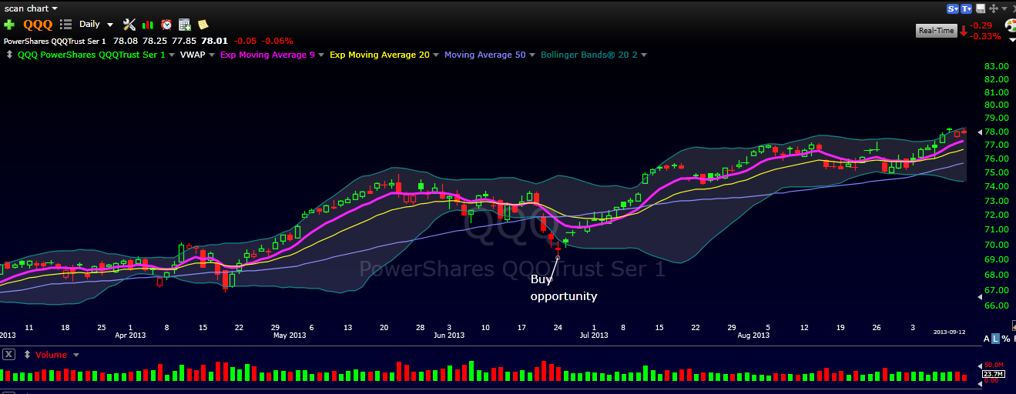

# **Setups on cash account**

During my first 6 months of live trading, my trading will primarily evolve around 2 key set ups: Flag breakout formations and Flat top breakouts on both daily charts and opening gap intraday charts.

**Flag Breakout**

These are short term consolidation patterns following a major move. My focus on these will be:

1. Momentum: significant volume on the initial move upwards (creation of pole) - this could happen through a big positive bar up or through opening gap move
2. Orderly pullback during the consolidation phase with less volume (flag) - the volume on the pullback should be much lower and not the same - similar volume could indicate indecision towards future price move
3. The depth of the pullback or consolidation. classic set ups will not pullback the entire size of the initial thrust up. Ideally, if price consolidates no more than 50% the better it will be for the future trend upward
4. The coiling effect of lower or flat highs and lower lows on stock price with receding volume

An example of what i would be looking for on a daily chart (before breaking out):

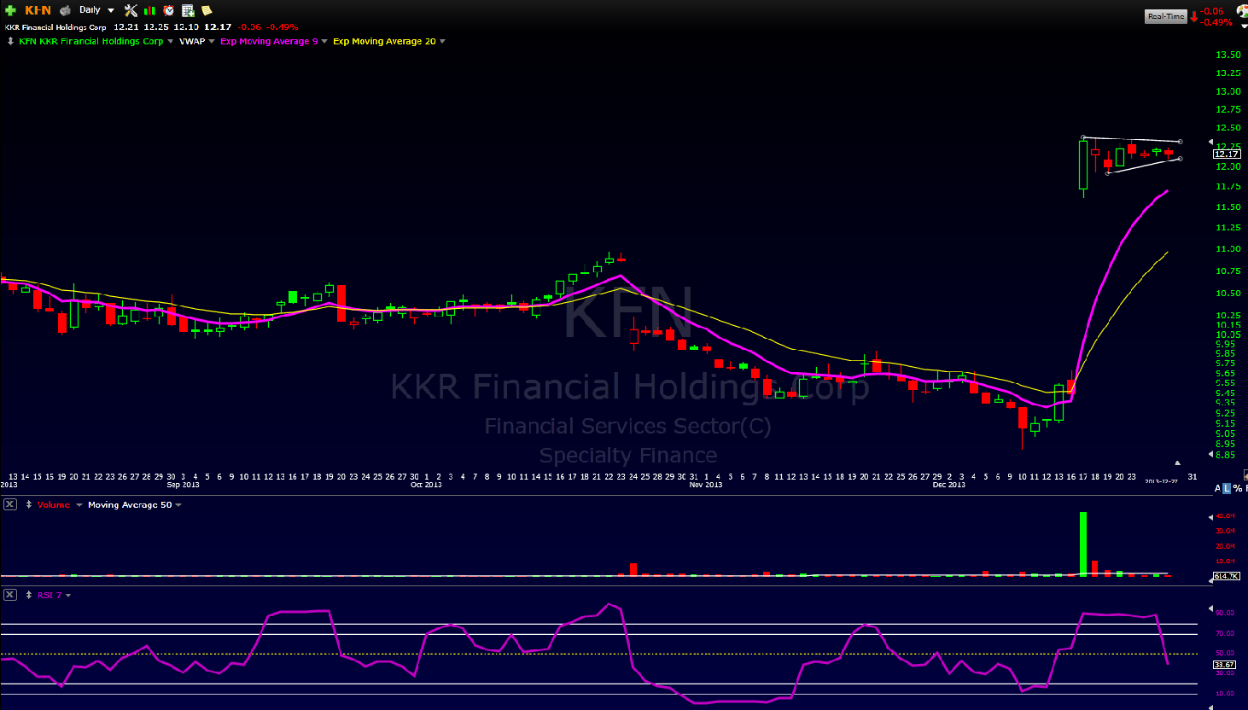

Trading rules for buying a flag breakout:

1. I would set a price alert on my platform a couple of pennies close to the previous day high
2. Once alert hits, i would switch to the intraday timeframes (10 and 5 minutes) and look for a low risk entry point.
3. I would buy the break of the descending upper trend line. In this case i would buy a penny above the high of that last bar with a stop at the LOD of the bar of the previous day.
4. I would also ideally like to see the 9EMA hug the price bar that makes the initial breakout move
5. I would hold until there’s a good reason to sell - likely the break of the 9EMA or a gap down after several days of movement. Through this process i will experiment my reasons to sell : break of trendline versus using other clues such as moving averages

For this example specifically i would buy @$12.31 with a wide stop at $12.07 - giving me $0.24 of risk for a longer term hold period of a couple of days:

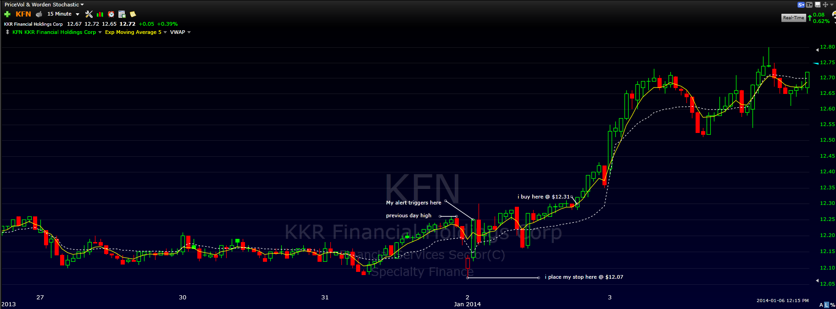

The result could potentially be spectacular:

I would be still holding this position as still in clear uptrend and rising with now more than $0.77 of gain or 3R

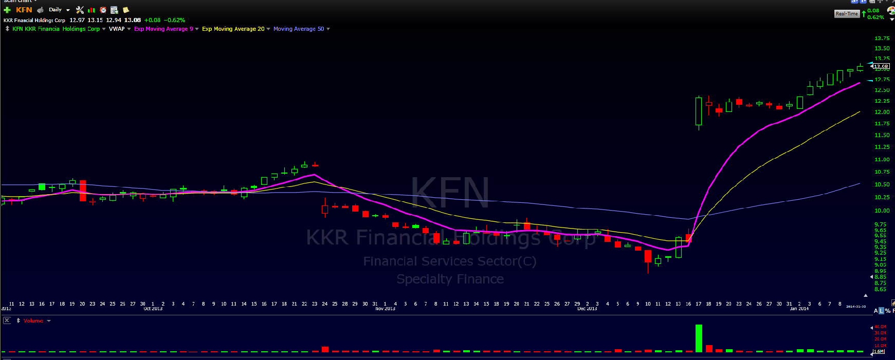

On intraday plays, my rules would be:

1. Select opening gap stock with high relative volume
2. Wait for orderly pullback to VWAP or 9EMA
3. Buy the break of the upper trend line high
4. Because i am holding for a couple of days i would put my stop at low of day
5. I would sell the position at the break of the uptrend. I would likely move my stop to buy point a couple of days later and maybe let the move play itself out until the last hour of the day (more on these sell rules later)

On this example, i would buy @$5.46 with a stop @$5.40 for 6 cents or risk:

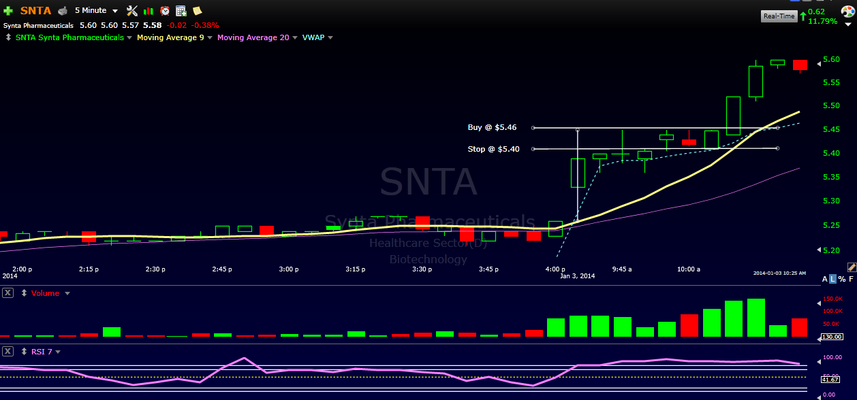

**Flat top breakout**

Aka the triple tap breakout. I have come to appreciate the third test of previous highs. At the third tap - 2 potential scenarios are likely to take place: its either going to explode on the upside or totally negate making a new high and swing violently lower. For these moves, my most important concern is going to be the placement of my stop.

My set up recognition rules would be as follows:

1. Pattern of accumulation supported by growing volume
2. Clearly defined resistance area - being hit before pulling back
3. higher lows - ascending triangle pattern
4. When it breaks out - typically on an opening gap it does with momentum with higher than normal relative volume

On this example on the price chart you can clearly draw the line at the resistance area and you see a pattern of higher lows before the breakout bar.

The buy rules on the flat top pattern would be to switch to an intraday view and find a smaller pattern to enter into the trade such as flag, pullback or consolidation and buy where the probability of breakout to new highs is higher than the risk of pulling back.

This is the set up example of flat top breakout on the daily chart - notice the tests of highs on the 1-2-3 areas - then followed by the breakout bar (last on the chart) with high relative volume

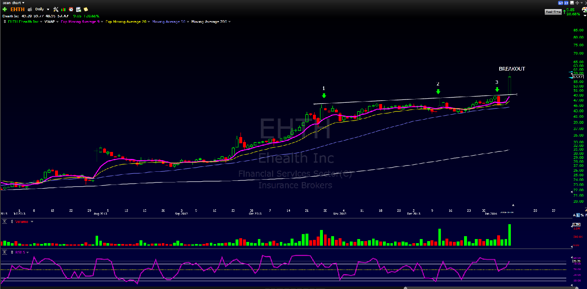

I would then look for an entry point on the intraday set up. On this chart - i am finding a flag pattern and would buy on the breakout of the pattern with low risk. In this example, my risk is ~20 cents for a $3.00 run ! This is what it’s all about

# 

# Risk Management

Cardinal rule #1 for me will be: Not losing money. I understand that losing trades are unavoidable and part of the business, but i will do everything possible to minimize these potential losses or keep them to a minimal $$$ hit. This will be done by focusing on two behaviors during my ramp up period: 1) Managing proper position sizing based on % of my overall account $$$. 2) Focus on high probability trades where key support levels are near - likely based on lower timeframes. Once i have become more comfortable with these two rules i will add the third one riding my profits (2R).

**My Position sizing**

As stated in my objectives, my risk will be limited during my development phase to roughly half a point (0.5%) of my account size ($15K). So therefore, from months 1-6 i am willing to lose ~$75 per trade. Only after i have traded consistently for 3 consecutive months, i will raise my risk to 1% or $150 per trade. In addition to this, i will trade no more than 2 different positions at the same time during the same time frame - again with an objective of minimizing risk pattern. For example, If i am daytrading, i will focus on no more than 2 separate stocks at the same time for entries and exits. I might buy and sell multiple times during the same period. Therefore my maximum loss / per day will be limited to $150. I will likely stop trading and go back to simulator if i get 3 consecutive losing days with maximum loss ($450). Share size will be calculated based on my maximum loss potential of $75 / Trade such as follows:

| Buy @ | Stop @ | Delta | Risk | #Shares |
| --- | --- | --- | --- | --- |
| $16.49 | $16.39 | $0.10 | $75 | 750 |

**High probability trades**

Engaging only in high probability set ups will be key to my success %. For my set ups, i will look at 3-4 timeframes, but essentially engage and set my stops based on 10 and 5 minutes timeframes. My triggers will be set near key support levels during pullbacks or consolidations. Ideally i would position my buys on very short candles that mark indecision or pauses in the shorter trend. Targets would be a minimum of 2 or 3R (where R= $ of risk) Here’s an example:

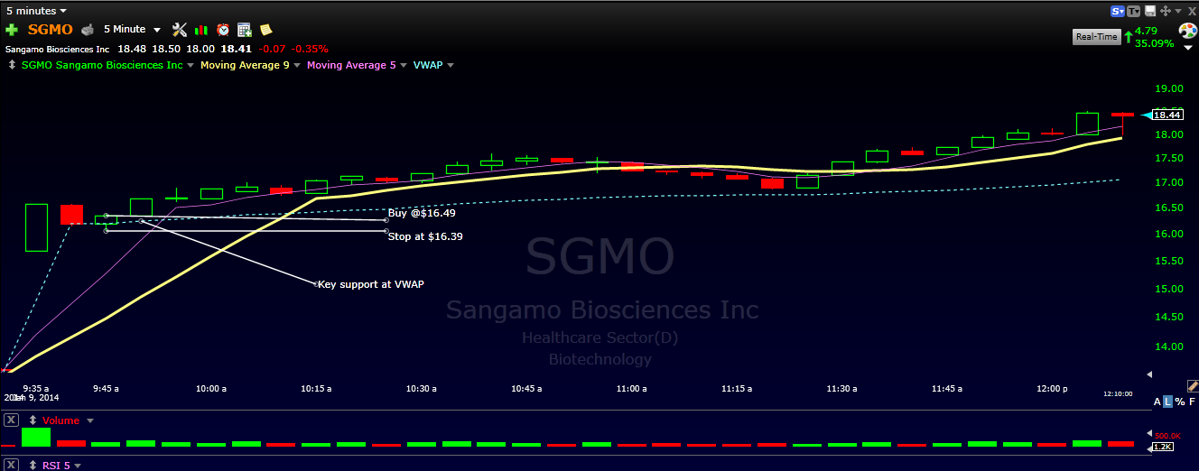

SGMO gapped up - formed a flag pattern and retraced in an orderly fashion to the VWAP - my key support level. My stop would be set at the low of the third candle and my buy at the break of the high of that candle. Total risk $0.10. This stock ran for at least $1.00 (10R) before pulling back.

To maximise my probability of success, i will always favor stocks that are far away from potential resistance areas on higher timeframes (daily and weekly) where supply might exist and likely create reversals in trends or major pullbacks. Like for example stocks that are making all time highs. I will always honor my stops… Always and non negotiable… The example below is an illustration of a stock without any clear resistance area on the daily timeframe:

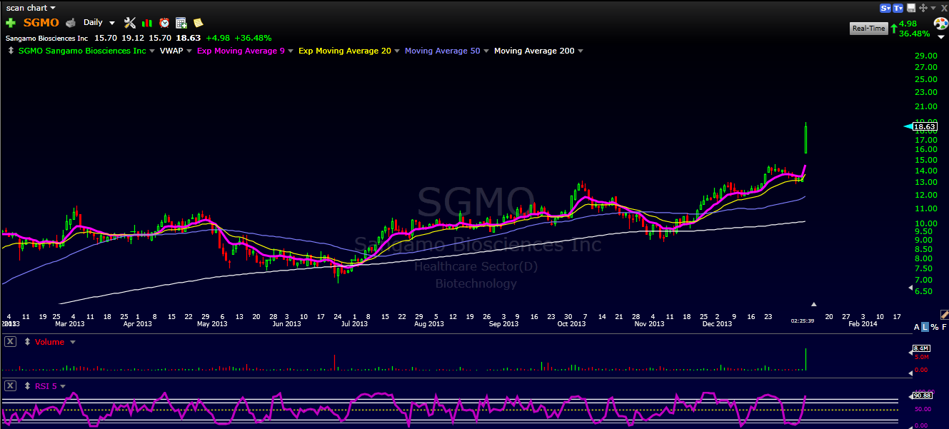

## Let profitable trades run

## Through my development phase in plan on testing two approaches in scaling my trades with an objective or letting profits run. I have to admit that this will be one of the hardest aspects of my trading to master. The first approach would be to buy a full size position with a defined stop in place - I would let my entire position ride until i have a reason to sell. In most cases it will likely be the violation of the moving average (9EMA) or violation of key trendline. The advantage of this approach would be that if successful, i would harvest most of the move in the direction. The flip side would be that if the stock reverses quickly and without much notice i would get out of a trade with a scratch or a loss.

## 

## The second approach would be to go in with a full position and then scale out 50% once i have generated 1R of upside and put the stop on buy point for the remaining position and let ride until possibility the next day if the stock is behaving really good until the end of the trading session. If during the afternoon session i hold a winning position that continues to make new highs, i will consider keeping some of my shares overnight (likely a third of my position) with the hopes of capitalizing on a continuation gap. More to come on this as i test both scaling approaches..

## Account Management

My planned account size is $15k on day 0. I have more capital that can be allocated to the trading account by $20K increments once i have a proven track record. Everything will be based on cash transactions / i will not trade on margin as i don’t need it and don’t want to deal with this additional pressure on margin requirements. My initial goal will be to grow my $15K to $20K+ so that i don’t need to allocate more seed capital to my account.

Trading Rules

1. Always have a set up - flag pattern or pullback to support - not set up / no trade
2. Wait at least 15 minutes from opening session before making a trade - to avoid many whipsaws on the opening range trade
3. Check your VWAP - always buy above it (for longs)
4. Check your market conditions before engaging with a trade - how is SPY, QQQ and XLF behaving? up, down, sideways?
5. Where is the next resistance level before entering the trade ? blue skies above or key levels close?
6. Does this stock have momentum? Big volume bars
7. Cut your losers / Ride your winners
8. Honor your stop level - Do you want to live to see another trading day?
9. Focus - always be in the moment

List to be refined with more trading experience….

# Trading Routine

# Everything starts on Sundays. Key here is to remain focused on what is important and material to successful a trading environment. I will usually start my process by reading through a couple of key blogs and websites: The Kirk Report, SMB university, BoWs blog, Peter Brandt, New Trader u and Sharp Traders.com. The goal is to get a sense of market breadth and overall sentiment. I will also carefully read through my past week trades from my log entries. This will establish the baseline for my scanning routine.

# Scanning Routine

Once my reading done, i will initiate my scans. My meat and potatoes scans are based on two tools i will leverage: Finviz.com scans and TC2000 scans. I currently have subscriptions to both services (FinViz elite and TC2000 platinum).

**Finviz scans**

1. Top gainers scan - that i will filter on volume and stock price. I will look at everything above $4 and with relative volume >500k shares
2. ETF baseline scan: which consists of all ETFs >1M in daily relative volume
3. Up in %: all stocks above $5 with relative volume over 1 and change from open >3% and current volume >750k shares
4. MoMo scan: All stocks with relative volume over 2; current volume >750k shares

**TC2000 scans**

1. MoMo scan: All Us stocks; price >$4; >300k volume daily, % since open >3; volume moving up daily
2. Pullback scan: Us stocks with price >$4; volume moving down daily, Float <100M shares; daily volume >500k shares
3. RSI cross scan: Us stocks with price >$4; RSI 7 crossing above 30% on daily, Volume >500k shares, Float <100M shares

The objective of these scans consist in finding high and tight flags on daily charts or potential breakout plays after pullbacks. I usually tag 20 charts that i will add to my follow up list. I will then re scan through these to identify 5 potential plays for the next day or less. Ideally 3-4. I then set up breakout alerts on TC2000 a couple pennies before critical breakout price. In addition to this i will look at my core list of stocks which mainly consists of stocks that i have successfully traded in past trading sessions and some BoWs favorites that come through the chat room trades or watch list from website. I will also set up alarms on my trading platform on 3-4 key potential plays for the next day. Finally i have started to post my short list on our Google+ BoWs community. I will continue to post as part of my learning experience and sharing with others.

**Pre market open scans and intraday routine**

I wake up at 6:30 and get ready for work on my full time job. Shower, drink water, prepare breakfast and coffee.

I arrive early in the office (7:30) to prepare for my work day and set up for trading

When i open up the computer in the morning, i will usually first look at the FinViz main page that will give me a general idea of the daily bias (by looking at the overnight trading sessions in SPY, QQQ, XLF futures). I will also take a look at key stock trends for GOOG, AAPL, FB and TWTR, C & BAC

Once 9:00AM hits - i will see a map of what’s hot and gapping up in pre market (FinViz). I will take note of the top 3 - top gainers in pre market - I will usually follow these very carefully in early trading session. I will prioritize stocks that have no overhead resistance over other potential plays.

9:35 - 9:40: I will run two scans in TC2000:

1. Opening gap scan: Us stocks with >$3 price; 3% change since open; gap up on daily;
2. MoMo scan: Us stocks with %change since open >4%

By then, i have picked no more than 3 potential plays for the day.

Between 11:00 and 12:00am : i will take another look at my short list to see potential pullbacks to 9EMA or VWAP and will prioritize flat top breakout potential plays.

Afternoon trading: take another look at my main list to see for intraday consolidation set ups with low risk entries. If i don’t have anything in play, i may enter a trade if i get confirmation on multiple timeframes of set up; if i have exited earlier in the day and the charts are setting up - i will consider re entering if i see a low risk set up.

During the last trading hour, for my existing positions, i will consider holding some until the next day with the hopes of continuation. To minimize risks - i will check for any pending news or earnings releases dates to gage my risk. Ideally, if stock price closes near highs of day i would keep a third of my full position still in play until the next day opening range.

Once trading and work day is over i go home and prepare to go for a long walk or exercise

Prepare dinner and enjoy with my wife

I get back behind my computer at around 7:30pm. Start scanning for the next day. read up on the blogosphere. Prepare the new stock set ups.

# Reviewing and Journaling

This will be a key element of my ongoing improvement process. I currently track all my activities in my trading journal - with critical entries. These are housed in a Google doc template and is constructed as follows:

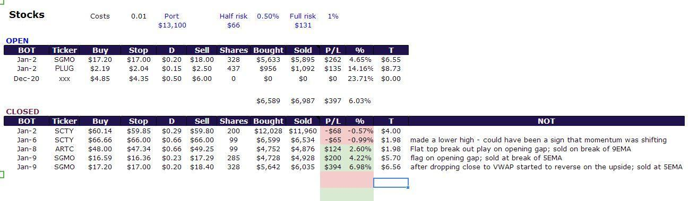

I document my set ups that made me buy the stocks in the first place in my NOT section and reasons for selling. I also add post mortem notes once my trades are closed. From these i will try to detect behaviors i am trying to avoid or correct.

I would like to augment this by leveraging the Tradervue account potential to develop data that can be actioned. Once i get into the trading simulator, i will connect it with a Tradervue journal. Every single trade will be entered and documented through this account. I will recap my trades daily and analyse trends on a weekly basis. The big upside to the Tradervue account is that i will be able to share with the BoWs community and hopefully shorten my learning curve.

# Education

Throughout my journey i plan on continuing to educate myself with trading set ups and gain new knowledge to constantly improve my methodology. To do this i will pursue a couple of key activities:

1. Continue my subscription to the BoWs chat room: to learn from Kunal, MB and Szaman
2. Re take the Bootcamp on Jan 21st
3. Continue to read up - but focus on a couple of good books such as : The Playbook written by Mike Bellafiore and anything related to trader’s psychology and mindset for success
4. Be an active participant in the Bulls on Wall st. Bootcamp Google+ community. This have been solid gold in my learning curve. By sharing my thoughts and trades, i get to benefit from other trader’s perspective and feedback.
5. Continue to be curious and test new ideas and challenge paradigms. Keep an open mind and enjoy the learning process. For example, right now i am comparing using RSI over Stochastics as an oscillator to best see divergences in momentum.
6. Feedback look and self assessment. I came across a very interesting feedback mechanism in the Google+ community by fellow trader Oliver Oberdorf. i plan on using a similar plan and ask myself the following questions:
   1. Have i traded according to my plan?
   2. Was i profitable through the month?
   3. Have i detected anything that need to be changed in my trading behavior?
   4. Have i repeated past mistakes? what will i do to avoid them in the future?
   5. etc.
7. Leverage another tool i just took a subscription to: TradingSim. Found it pretty cool to replay the stock movement as it appeared in realtime. I am using this to improve my entries and exits: was my timing good or premature? If i had waited before pulling the trigger would I have seen a better entry - did i have enough time to pull the trigger etc…
8. Finally, always bring things back to its simplest form: higher highs and lower lows - at the end of the day - isn’t it just about capturing a few moments in time where stock trend in a specific direction. All we need to do is trend in the right direction to make profits !

Why am I trading?

The main and most immediate reason I've decided to trade for a living is to replace the current income generated from my restaurant making it passive and non essential. I want to change careers and trading can provide the necessary income and lifestyle that my family needs and desires. There are many other supporting and beneficial reasons but career change is my main driving force.

Business Philosophy

I will build a Trading Business through very directed and methodical steps. My primary focus will be Daytrading stocks at this point. All risk put on will be manageable and never compromise the stability of any accounts. I will always act in complete accordance with the signals generated by my trading system or strategy and with the risk management rules that accompany my system...I WILL PLAY BY THE RULES!

Objectives

My most immediate objective is to simplify my trading process and to achieve consistent positive results. I will isolate and master a hand full of setups that I can focus on trading repeatedly for the upcoming year.

Beginning January I will trade on simulator to isolate what setups I am most consistently profitable with. My goal is to establish good trading habits and to be 4 out of 5 days green so I can start trading live by February 1st.

Keep in mind...CONSISTENCY IS ALWAYS MY MOST IMPORTANT OBJECTIVE OR GOAL.

Below are my financial objectives for the upcoming year.

February thru March $150.00 - $200.00 per day

April thru May $250.00 - $300.00 per day

June thru August $350.00 - $400.00 per day

Sept thru Dec $500.00 plus per day

Trading Style

My only focus at this point should and will be day trading stocks. I believe while I am focused on mastering consistent profits on day trading I should not allow myself to be distracted with other styles or instruments. After I have achieved 4 months of consistent results I will begin swing trading again. At that point I estimate 70% day trades 30% swing trades but that might be influenced by market conditions.

Setups

Initially I will focus on mastering the following setups because I feel most comfortable with them and they will offer many opportunities each and every day. I am starting with 3 but within a week to 10 days after I begin trading I will focus on my strongest two and master them before adding more. At this point more is not better…but being better at less is more!

I tend to have less stress and more success when I wait for about 20 to 30 minutes after the market opens to watch things develop before entering a position. I will verify timeframe alignment along with my checklist with all setups and trades taken at this point. I will not trade against the trend.

**Intraday Base or Flag Breakouts**

I find that this is an easy pattern to recognize and can be found both in morning and afternoon trading. It is easier to spot because the stock will have formed a tight range consolidation at or near the day's breakout price. My rule will be if I enter the stock prior to breakout I will do so with reduced size and add when the breakout is confirmed. Stops will be placed just under the consolidation unless the MA's suggest different. If moving average it within the consolidation then placing a stop just below it will create a tighter stop.

Things to look for in this pattern are:

-Consolidation on low volume with a tight price range.

-Rising 9 & 20 EMA's supporting below and helping to push prices up.

-Volume starts to increase and the stock tends to drift up in the consolidation before the stock breaks out.

-When the stock does break out it should do so with strong volume.

Beware of hidden resistance just above the breakout area on a higher timeframe as this could cause a breakout failure.

**PR / Earnings Breakouts**

When Maribeth was asked if she was just beginning what setup would she focus on. She confidently stated "Gapers". Prior to Boot Camp I steered away from and feared stocks that were gapping. Buying on a gap just went against my nature which is "I just want it a little cheaper" I see things differently now.

What I like is they are easy to find and when you do they can offer several entry points using intraday setups throughout the day. When they do work they are very powerful and can run fast and far. I also like the fact that once you are involved in the stock many times it will offer another clean setup the following day such as a red to green trade so tomorrow's watch list is already in the works today.

-Scan premarket for stocks gapping 3% or more

-Volume is key as is the case with any sustainable breakout

-Check for resistance on the daily chart or to see if it clears all overhead. If so the stock can run even harder.

-Look for another breakout in the afternoon for stocks that gap up on big momentum.

I prefer to monitor the 1 minute and 3 minute charts for the first 20 to 30 minutes as I find it a bit easier to see a possible flag develop for entry.

**Pullbacks**

I am choosing to trade pullbacks because they are easier to manage...are lower risk trades and have clearly defined reward to risk ratios. To increase my odds for success I will only buy pullbacks in stocks that are in an uptrend. Conversely, I will short the opposite.

Stops will be placed at either just below price support or the moving average.

Pullbacks work because new buyers jump in feeling they missed an earlier move and shorts will cover as the stock reverses.

Rules or things to watch in a pullback:

-It should be orderly with no large gaps down.

-Volume should be less on the pullback than the run up and best if decreasing as it nears support.

-Oversold Stochastic will increase the chances for a bounce off support.

Risk Management

Initially when I begin live trading for the first 60 days I will keep my losses tight. Only when I am profitable and have built a solid foundation of consistency will I then increase risk. When I begin swing trading the maximum loss per trade will start at less than 1% of account value.

**Day Trading To Start:**

Max Loss per Trade $ 125.00

Max Loss per Day $375.00

Scaling out:

Most times I will scale out of my trades in thirds unless I have a specific reason to exit otherwise. I will try to always keep a small Runner/Lotto position unless there is an absolute confirmed "Reason to Sell". I will do so to keep skin in the game and for the experience of living out each trade for the larger move. I will of course adjust my stops as the stock moves in my direction.

**My Reasons to Sell:**

-Stock hit my target

-Stock goes parabolic

-Stock reverses trend...lower high...lower low

-Stock hits resistance

-Stock violates an MA that has been holding

-Stock violates support

-When the set up is no longer valid

Trading Rules

-Do not take other peoples trades…Trade your own ideas.

- Don’t take the trade…If you can’t name the setup or the setup is not clear.

-Honor your stops…Always!

-Don’t try to pick tops and bottoms…Perfection not required.

-No after hours trading…Desperation is not a winning attitude.

-Reduce chat noise…It is a distraction interfering with your internal voice.

-When you get a clear signal - TAKE IT!…The cost of being wrong with a tight stop is always less than the psychological cost of regret.

-Be tough on money management in a trade…Let your winners run!

-Predefine you risk…Before you enter the trade.

-Determine your exit before you enter…Be the man with the plan.

-Do Not Ride Your Losers…Ride you winners and remember…it is ok to be wrong!

Enjoy the Process!

Morning Routine

-My phones, emails and texts will be turned off until 12 noon each day. For the morning trading session I will shelter myself from all distractions and potential negative situations.

-I will always arrive at my desk no later than 8:30 am.

-I will review my previous day’s journal and trade activity.

-I will check and sort stocks flagged from the previous session and study any unusual pre market activity.

-I will breeze through twitter alerts and sort out the best 2 or 3 that meet with my trading plan.

-I will sort and organize up my Go To List looking for possible setups.

-For now I will use Finviz to scan for stocks gapping pre market. I will pick the best 3-4 checking criteria such as volume, float, resistance, etc.

-I will check the community for watch lists and see what looks of interest to me. I will then clear those against my checklist before adding to my watch list.

My Stocks to Watch List will consist of 5 to 10 stocks each day. 3 to 4 will be on my "Hot Watch Focus List" while the remaining will be on my "Keep An Eye List" to see what develops. Watching more than this at the open is distracting for me. If I have more that might be of interest they will be put on my "Later In The Day List" so I am not distracted or feeling like I will miss something.

Scanning

In the beginning I will use Finviz...Twitter and the BOWS Community to scan. I will be careful not to over saturate. Too much info is crippling. Once I have developed a comfortable routine and am consistently profitable I might monitor T3 Live as it is a subscription I have already paid for. I will only do so if I feel it is good for valuable idea generation and not just another distraction.

I am in the process of changing my charting platform over to TC 2000 when up and running I will set some basic scans on that program.

Commitment

I am committed full time to the extent possible in developing my trading skills. For 6 months beginning January 2014 I will delegate everything possible at Amelia’s Bistro and avoid being drawn in on most of the day to day distractions. Barring emergencies, Monday through Friday up until 12 noon will be completely uninterrupted and dedicated to trading. At this time my primary area of focus is to become consistently profitable.

Business Plan Contingencies

1). Amelia’s demands more time than I planned for due to unforeseen circumstances.

A.) I will temporarily reduce trading to mornings only until the issue is corrected and then resume full time trading.

B.) I will focus immediately to isolate and correct the issue.

C.) I will readjust my goal dates if necessary to accommodate the interruption to my trading business.

2). My personal / family life begins to show signs of stress and imbalance.

A). I will immediately address the issues head on and take the necessary steps to correct “My Imbalance”. I will focus on spending more off hours time with family and make certain to be involved and assisting where I can.

3). No Signs of trading consistency or improvement after 60 Days (03/15/2014)

A.) I will isolate and trade only one strategy for 30 days with minimum share size only increasing after positive results are achieved.

Follow Through & Follow Up

**Daily**

1). I will keep a Daily Journal tracking my trades with details and a description of the day in general.

**Weekly**

2). I will log and Journal my weekly progress financially, psychologically and the overall trading experience.

**Monthly**

3). I will log and journal my monthly financial, psychological and overall trading progress.

4). I will read and review my previous day's journal each morning. Furthermore I will review the previous week's journal prior to the start of a new week. This will help to isolate both positive and negative patterns assisting me to adjust my execution and the opportunities I decide to enter.

5). I will perform Quarterly reviews and report to my immediate family and mentor.

Summary

This business plan is a detailed guide mapping out the initial steps to achieve success in my trading business. The details listed create the framework for my business. They are the guide to assist in running the operation successfully.

Initially the primary area of focus is to achieve consistent profitability through day trading. When this is accomplished I will take the necessary steps to grow my income so that I may change careers and earn a very prosperous living through trading.

Additionally my longer term objectives are to:

-Build Alexander and Emilie's Accounts

-Increase and grow both of our IRA accounts

-Increase and grow my mother’s accounts

-Increase the inventory of my trading account.

I will also use trading as a means to develop my psychological outlook and personal discipline through reading, seminars and self-discovery. My desire and intention is to work toward having balance in all areas of my life.

For the first six months beginning 01/01/2014 I will strive to exercise discipline…good work habits and build from the ground up. I will use small share size in the beginning and take every legitimate trade setup in order to build execution skills. I will also focus on keeping a small position to allow my trades to play out…further improving my skills and my profit.It is critical that I take this time to develop a system and understand what works and what does not. Documenting and keeping track is essential.

Plans for the Business

A). Description of the Business

1). The initial focus is to master day trading stocks only. After a solid foundation with consistent results and profits I will expand to include swing trades and options. The business will ultimately go on the once again manage my children’s and mother’s accounts.

2). Consistency is what establishes whether or not the business is on track. If you are not producing overall consistent results then you must isolate the things that are standing in your way and correct them.

3). A guide for each phase or step in growth would be...

---Initial Phase - Exploration...Education...Testing....Documentation

---Stage 2 - Slow but steady and consistent growth. Finding "MY THING"

---Stage 3 - Accelerated growth...managing more risk without the highs

and lows

B. The Competition - Strategies and Tactics

My only competition is the negative or darker side of myself. I will strive to overcome and succeed in becoming a "TOP TRADER". I will work on building my confidence and self-esteem thereby "Overtaking My Competition"

I am committed to working with my Trading / Psychological coach on a bi weekly basis throughout 2014. Once I have generated $15,000 in net profits I will schedule the 3 day personal session with the objective of taking my psychology and trading to the next level. Target date is May / June 2014

C. Status of the Markets

We are currently in a Bull Market. We have continued to move to all time highs. Caution should be exercised while the market is in the vicinity of the 50 day moving average. Keep open minded to observe whether we are in a normal pullback or the beginning of a larger correction. Adjust your long / short ratio accordingly.

D. Company Background

I have been trading on and off for 3 years. There have been many outside business interruptions throughout the period. As of 01/06/14 I will be committed full time. My experience has been minor losses to breakeven trading at best. I was frozen for a good period of time having problems with execution...too tight stops and no real focus or direction. I have yet to isolate what it is that I do best. I can spot the winners on a regular basis but have not been disciplined enough to formulate a plan and follow through consistently.

E. Other Resources

1). People

Accountant - Brian Lynn

Lawyer - Robert Ritter

Computer Consultant - Falcon Trading

2). Tools - Office Equipment

The business has all the necessary equipment at this time. In January I will purchase the Geek Desk

3). Software…Charting & Brokers

Brokerage Accounts - IB Brokers, Lightspeed Trading, TOS

Charting Platforms – E-Signal (phasing out…was primary charting)

TC2000 (phasing in…primary charting/scanning)

TOS Current secondary charting program

Tradervue – Will begin using to log and post daily trades

Financial Information

1). Balance Sheets - Not necessary at this time

2). Personal Financial Statement - Not necessary at this time

3). Projected cash Flow for First year – At a later date

4). Monthly Expenses – to be added at a later date

Building My System

A). System Development

For the remainder of 2013 I will begin part time simulator trading as time permits considering the holidays and prior commitments. I will look at and use this as a sort of warm up.

Beginning January 06, 2014 I will begin full time simulator trading. My specific intent is to isolate 2 setups and master them first. I will start with small share size making certain to execute the legitimate opportunities or setups that trigger. If I hesitate or balk for no valid reason I will execute a minor share size keeping in mind that taking a higher number of legitimate setups will ensure a more accurate probability outcome.

I will review, document and log all trades. I will post my trades daily in the community welcoming both positive and negative feedback. I will use this to build a better product.

When I have achieved consistent positive results over a reasonable period of time I will then begin to test, master and incorporate other setups and strategies slowly.

Assets and Liabilities

**Assets...**

1). I have no pressure from living or business expenses as my restaurant

provides all my necessary income at this time.

2). I completely enjoy chart analysis and research

3). I have complete support for my wife and entire family.

4). I am relentless and tenacious...I do not quit...never have.

5). I have the necessary funds already available to grow my business.

6). I have started and seen 3 other businesses through to success.

7). I am very organized, passionate and patient.

8). I am committed to improving my psychology

9). Throughout my life whenever I have established and understood a

system I was then completely consistent and disciplined in following it.

**Liabilities...**

1). I tend to overcomplicate things.

2). I am lacking confidence in this area.

3). I must build my self-esteem.

4). I look at way too much…over saturate and have been unable to isolate and focus

on what setups or strategy I am most suited.

5). I must focus on living life in balance...I tend to neglect some areas of

my life while I focus intensely on the other.

6). I tend to isolate which limits outside interaction and input.

7). I tend to lose sight of big picture and get caught up moment to moment blips.

8). Amelia’s could become a distraction if things unravel because a lack of attention.

Trading Criteria

Rules and Tactics

1). Philosophy - Slow and steady consistent steps to build confidence, stability and

systematic growth.

2). System - Work immediately on isolating what is comfortable for me and building on

that...best chance for success

3). Markets to Trade – Stocks (to be revised in the future)

4). Time Frame – Day Trading (to be revised in the future)

5). Type of Trading – BOWS Go To intraday and daily setups

6). Money to Trade – IB Day Trading account only for first 120 days

7). Reward to Risk - 3 to 1 more conservative. Maximum loss… less than ½ % of

account balance on any given trade

Developing Signals

Setups for Focus

1). Intra Day Base and Flag Breakouts (bull and bear)

2). PR / Earnings Breakouts

3). Pullback Buys

4). Red to Green / Green to Red

I will begin 01/06/2014 test trading these setups to establish which 2 are my best fit. I will document and narrow the field. After testing I will only trade those setups where I have achieved consistent success.

Entering a Trade

Rules and Tactics for Entering a Trade

To enter a trade it must meet the list of requirements on my trading checklist.

1). Name the Setup…NO NAME…NO TRADE!

2) Trade Expectation – Scalp or daytrade?

3). Time Frame Alignment – Align multiple

4). Where is my Stop?

5). What is My First Target Price?

6) What Size Position?

7). What is the Reward to Risk Ratio? 3:1 but no less than 2:1

8). Crisp, Clean & Tight Chart? - No entry at this time on sloppy setups.

9). At this point I will focus on taking higher probability trades and will only enter with

full alignment or layers of support. (price/ma support, volume confirmation etc)

No Gamble or Hope it Bounces Trades!

Setting the Stop Loss

Rules for Stop Loss

1). Stop always determined prior to execution.

2). Stop placed immediately upon execution.

3). Never leave your desk without a hard stop in place.

4). Max loss per day trade $125.00 at this time

5). Max loss per day $375.00 at this time

6). Max loss per swing trade at beginning…less than 1% of acct value

7). Max loss on any trade never to exceed 5% of the stock basis value.

6). Exit the losers and move on...no reason to stay. REMEMBER GLD!

7). LET THE TRADE PLAY OUT. GIVE IT SOME ROOM TO WORK!

Profit Exits

Rules and Tactics for Exits

1). Never go red on a winning trade. Always lock in some profit.

2). Immediately after initial move place stop at cost to protect against a loss.

3). Scale out in thirds or halves depending on market conditions.

4). Have a strategy to re-enter trade if exit war premature.

5). Focus on letting your winners run. Keep a small runner or lotto position as an

exercise to experience how the trade would have developed with more time.

6). Control you emotions and manage you trades wisely.

Prior to exiting a trade ask yourself… **“Is There a Reason to Sell?**

**My Reasons to Sell:**

-Stock hit my target

-Stock goes parabolic

-Stock reverses trend...lower high...lower low

-Stock hits resistance

-Stock violates an MA that has been holding

-Stock violates support

-When the setup is no longer valid

Monitoring the System

Rules and Tactics for Monitoring the System

1). Never Pull an Ostrich...head in the sand when a trade or strategy is not working.

FACE the ISSUE...MAKE a DECISION...MOVE ON!!!

2). Evaluate the signals within the time frame you are trading in. Don't over analyze a

swing trade against an execution time frame. Plan the trade then Trade the Plan!

3). Evaluate each trade and adapt as circumstances change BUT...do not micro

manage your trades. Plan them out then give them time and room to work.

4). Review daily, weekly and monthly trades, log and journal.

5). All trades will be documented and logged for review. They must contain:

Setup Name, Stop, Target, Reward to Risk Ratio and Caution Signs.

Adding info from the list below will be beneficial for future review and reference.

-Moving Average support and resistance.

-Stochastic – Overbought/Oversold

-Volume thrust?

-Intraday flag break?

-Lower Float?

-Tight Consolidation?

-Clean, Crisp chart?

-Time Frame Alignment?

Evaluating the System or Setup

Rules and Tactics for Evaluating the System or Setup

**Exercise...**

1). Select one Setup or Strategy that you believe in. Determine if it

fits well with who you are.

2). Perform 30 small share test trades following specific entry and exit rules.

3). Strive to execute 100% of all recognized setups as close to trigger as possible.

4). If you balk then execute with minimal shares…even 50 shares will work

so you have skin in the game and get a truer reflection of the probabilities

over the largest amount of trades.

5). Document and log each trade

System and Setup Testing

Rules and Tactics for Testing a New Setup or System

1). Make certain to stay with small share size while performing test trades. This will

keep you from being shaken out or overreacting. You will benefit by getting more

accurate results if more trades play out over the planned or necessary time.

2) REMEMBER...System testing is not to make money. It is specifically done to

test a strategy. Reap the maximum benefit...stay disciplined and follow

through to the end. Do not jump the gun. PATIENCE!!!

3). Rules must be observed completely even though share size is small

otherwise you will not get an accurate picture.

4). Exit trades by scaling out in 1/3rds or 1/2's to maximize each trade

regardless of initial share size.

5). Stay focused when you are testing...keep distractions to a minimum.

Money Management

Rules and Tactics for Money Management.

1). Trade only in the direction of the trend.

2). Stay with a set position size or adjusted position size until you achieve

consistent results. Avoid increasing size until you have momentum in your

favor and feel secure with your present level.

3). Learn to add to a position on the next buy setup when you show a

profit. Use small size if necessary to gain the experience.

4). DO NOT KEEP STOPS TOO CLOSE...Allow the room for your good

trades to work out. Maximize you winning trades.

5). Plan all aspects of the trade to reduce the guess work, emotional charge

and risk.

6). ADMIT...when a trade is not working and GET OUT!

It is OK TO BE WRONG!

7). RIDE YOUR WINNERS…Not the Losers. Dump them and move on to

the next winning trade.

8). NO GAMBLING...NO FAST BUCK TRADES...Trade based on setups only.

Education and Self Development

I am committed to defining and mastering a trading strategy that works for me, my personality and my life style. In addition I am also dedicated to self-development and improving my general psychology. Listed below are some of the plans I have for the upcoming months and year to help further that development.

-Review all Boot Camp videos and re-organize my notes for easy reference and review.

-Continue on with all remaining Boot Camp sessions including all live trade reviews and items required to complete the program in its entirety. NO SHORTCUTS!

-December & January…Very heavy focus on watching past trade reviews paying specific attention to the setups I will initially be trading.

-Study and Review BOWS list of Setup Examples focusing primarily for now on the setups I will initially be trading.

-Attend all live sessions of the upcoming Boot Camp beginning in late January. Repetition can only improve my knowledge and results.

-I will follow timely with my daily updates to my trading coach.

-I have made a commitment to myself for bi-weekly phone sessions with my trading-psychology coach for 2014. I will follow through not only to improve my trading but my general psychology which in turn will also improve my trading.

-I will continue to incorporate positive and inspirational cd’s in my daily routine.

- I will strive to connect with other like-minded individuals in the BOWS community to share information and knowledge in both directions.

-I will not let my pride or ego get in the way. I will ask questions and seek direction from those who are further along the path than myself. I will reach out to Kunal, Maribeth and other successful people in the community.