October 2021 Social Media Posting Instructions

We want you to be successful at marketing your orthodontic services to your patients. Please follow the posting recommendations below to maximize your social media opportunities, but also feel free to modify the text to match your own patient audience tone and style as needed. We are also available for questions where needed, and best wishes for your continued success in all your practice endeavors, PDS Team

Use social media to advertise your orthodontic services to your patients to create awareness, drive sales, convert followers into customers, and find your next potential patient.

Select a day of the week to post each of the following posts consistently over the next 4 weeks. Depending on your audience, we suggest the following times for each social media platform to get the best traffic results.

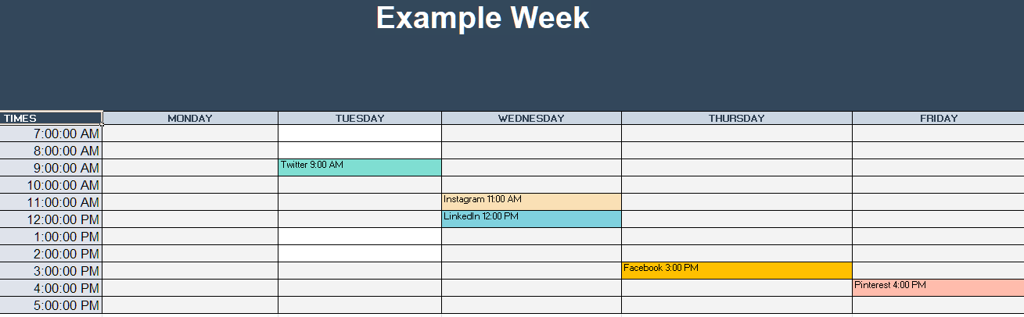

Twitter – Tuesday and Wednesday at 9:00 AM.
Instagram – Wednesday at 7:00 AM, 11:00 AM or 3:00 PM and Friday at 11:00 AM.
Facebook – Thursday at 1:00 PM or 3:00 PM and Friday at 1:00 PM or 3:00 PM.
LinkedIn - Wednesday at 10:00 AM or 12:00 PM and Thursday at 9:00 AM.
Pinterest - Friday at 4:00 PM.

Note – please insert the name of your General Practice where it says “Xyzdentistry”

1) Week 1 Social Media Post
Facebook/Instagram/Twitter
Write text – Your shining bright new smile will go a long way! Ask Xyzdentistry about exploring the world of Orthodontics today! #orthodontics #smile

2) Week 2 Social Media Post
Facebook/Instagram/Twitter
Write text –Xyzdentistry will help you smile with confidence! #confidence #smile

3) Week 3 Social Media Post
Facebook/Instagram/Twitter
Write text – Xyzdentistry will help keep the whole family smiling this year. #happyfamily #orthodontics

4) Week 4 Social Media Post
Facebook/Instagram/Twitter
Write text – Let Xyzdentistry help you work out a great smile today! #greatsmiles #ortho

Progressive Dental Supply will notify you in the Collaborate section of your www.smilestream.com account when monthly updates are available for download.

