July 2021 Social Media Posting Instructions

We want you to be successful at marketing your orthodontic services to your patients. Please follow the posting recommendations below to maximize your social media opportunities, but also feel free to modify the text to match your own patient audience tone and style as needed. We are also available for questions where needed, and best wishes for your continued success in all your practice endeavors, PDS Team

Use social media to advertise your orthodontic services to your patients to create awareness, drive sales, convert followers into customers, and find your next potential patient.

Select a day of the week to post each of the following posts consistently over the next 4 weeks. Depending on your audience, we suggest the following times for each social media platform to get the best traffic results.

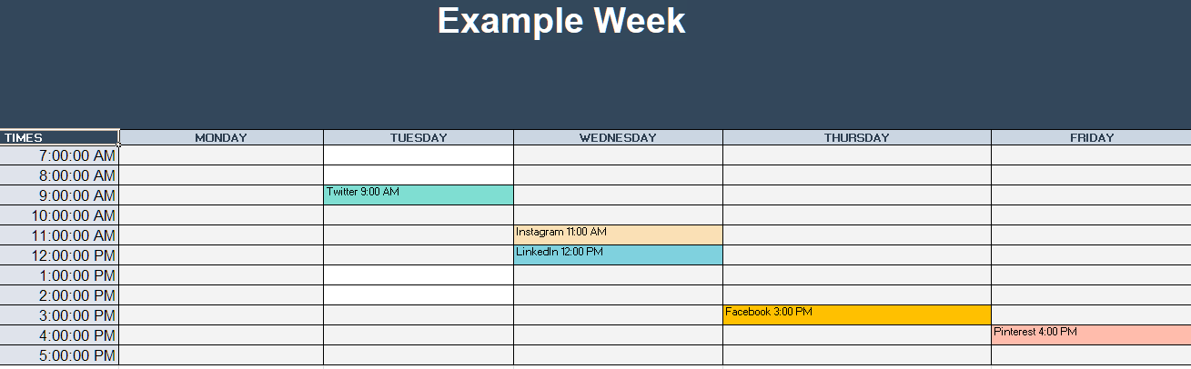

Twitter – Tuesday and Wednesday at 9:00 AM.
Instagram – Wednesday at 7:00 AM, 11:00 AM or 3:00 PM and Friday at 11:00 AM.
Facebook – Thursday at 1:00 PM or 3:00 PM and Friday at 1:00 PM or 3:00 PM.
LinkedIn - Wednesday at 10:00 AM or 12:00 PM and Thursday at 9:00 AM.
Pinterest - Friday at 4:00 PM.

Note – please insert the name of your General Practice where it says “Xyzdentistry”

1) Week 1 Social Media Post
Facebook/Instagram/Twitter
Insert photo
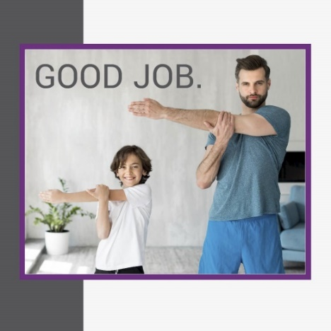
Write text – Caring for you & your smile. Ask Xyzdentistry how to get healthy, straight teeth to go along with your active lifestyle. #orthodontics

2) Week 2 Social Media Post
Facebook/Instagram/Twitter
Insert photo
Write text – Ask Xyzdentistry how to keep your kids smiling! #smilewhisperer

3) Week 3 Social Media Post
Facebook/Instagram/Twitter
Insert photo
Write text – Xyzdentistry is dedicated to your smile. #wearehereforyou #orthodontics

4) Week 4 Social Media Post
Facebook/Instagram/Twitter
Insert photo
Write text – Xyzdentistry brings out your natural smile. #beautifulsmiles #ortho

Bonus Marketing Materials:

Pinterest Social Media Post
Insert photo
Write text – Xyzdentistry, where smiles come alive. #orthodontics

LinkedIn Social Media Post
Insert photo
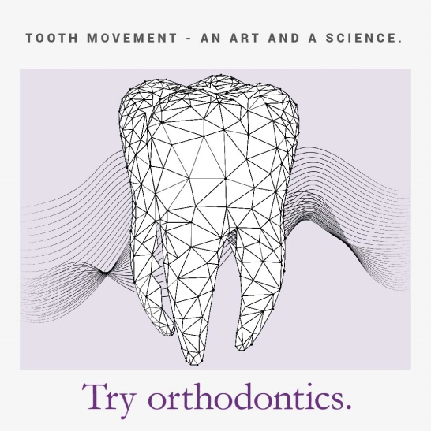
Write text – Xyzdentistry - where science meets art to construct your perfect smile. #orthodontics

Progressive Dental Supply will notify you in the Collaborate section of your www.SmileStream.com account when monthly updates are available for download.

